# Working with virtual environments on your local machine

While working with Django, you must first go to the local directory where you want to create your project and setup a virtual environment.

Ensure pip in installed on your device. The latest version can be installed and upgraded by using the command:

**Windows**

py -m pip install --upgrade pip

Python uses **venv** as the preferred module to create and manage virtual environments. **venv** is also included in the Python standard library and does not require any additional installation.

**venv** (for Python 3) and **virtualenv** (for Python 2) allow you to manage separate package installations for different projects.

In case you want to install **virtualenv** that is used for earlier versions of Python, use the command:

**Windows**

py -m pip install --user virtualenv

You can create a virtual environment in the specific project directory by running a command:

**Windows**

py -m venv env

**Note:**

**env** is the name assigned to the virtual environment and this will create a virtual Python installation in the **env** folder.

## Activate the virtual environment

Next you need to activate the virtual environment. You will put the virtual environment-specific python and pip executables into your shell’s PATH.

You can do this by running a command such as:

**Windows**

.\env\Scripts\activate

## Exit the virtual environment

You can exit the virtual environment by running the command:

**MacOS and Windows**

deactivate

There may be OS specific difficulties you may encounter while installing and using virtual environments.

More information can be found on the official [Python website](https://www.python.org/).

**Note: venv** is not the only option available for creating virtual environments and other options exist such as **pipenv** which is another variation.

However, in this course, the use of **venv** is recommended.

# D1.1

# Project Structure

When installing Django globally or in a virtual environment, Python recommends using isolated environment libraries and other dependencies required for a particular application.

Python's standard library contains the **venv** module.

It installs a command-line utility called Django-admin in the system path and is located in the scripts folder of your current Python environment.

As the name suggests, you use the **django-admin** utility to perform various administrative tasks.

These tasks include creating the project and app, performing  **migrations**to generate database tables, whose structure matches data models, and running a development server.

## What is a project?

When you set out to build a modular, extensible and scalable web application, you need an arrangement that controls the standard features of its various sub-modules.

A Django project is a Python package containing the database configuration used by various sub-modules (Django calls them apps) and other Django-specific settings.

Use the **startproject** command of Django-admin as follows:

(djenv) C:\djenv>django-admin startproject demoproject

The **startproject** is Django’s default project template. It creates the following file structure in the Python environment:

C:\djenv\demoproject

│   manage.py

│

└───demoproject

        asgi.py

        settings.py

        urls.py

        wsgi.py

        \_\_init\_\_.py

If you start VS Code in this folder, the file structure appears in its explorer as shown:

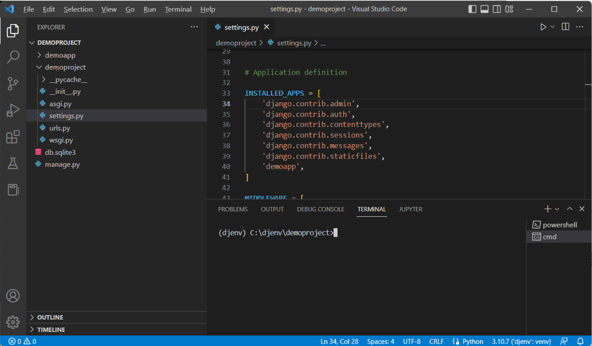

You can see a folder named **demoproject** is created in the Python environment folder.

It contains a script  **manage.py** and another folder of the same name.

You will learn more about the files in the inner folder later.

The **manage.py** script inside the outer **demoproject** has the same role as the **django-admin** utility.

You can use it to perform various administrative tasks. In that sense, it is a local copy of the **django-admin** utility.

**manage.py**

As mentioned above, the manage.py script can perform everything that the **django-admin** utility does. However, using **manage.py** is more straightforward, especially if you are required to work on a single project.

If you have multiple projects, use **django-admin**and specify the settings.

The general usage of **manage.py** is as follows:

**python manage.py <command>**

Let's explore some of the required command options:

**startapp**

As mentioned above, a Django project folder can contain one or more apps. An app is also represented by a folder of a specific file system. The command to create an app is:

**python manage.py startapp <name of app>**

You will explore the structure of an app later.

**makemigrations**

Django manages the database operations with the ORM technique. Migration refers to generating a database table whose structure matches the data model declared in the app.

The following command should be run whenever a new model is declared.

python manage.py makemigrations

**migrate**

This command option of **manage.py** synchronizes the database state with the currently declared models and migrations.

python manage.py migrate

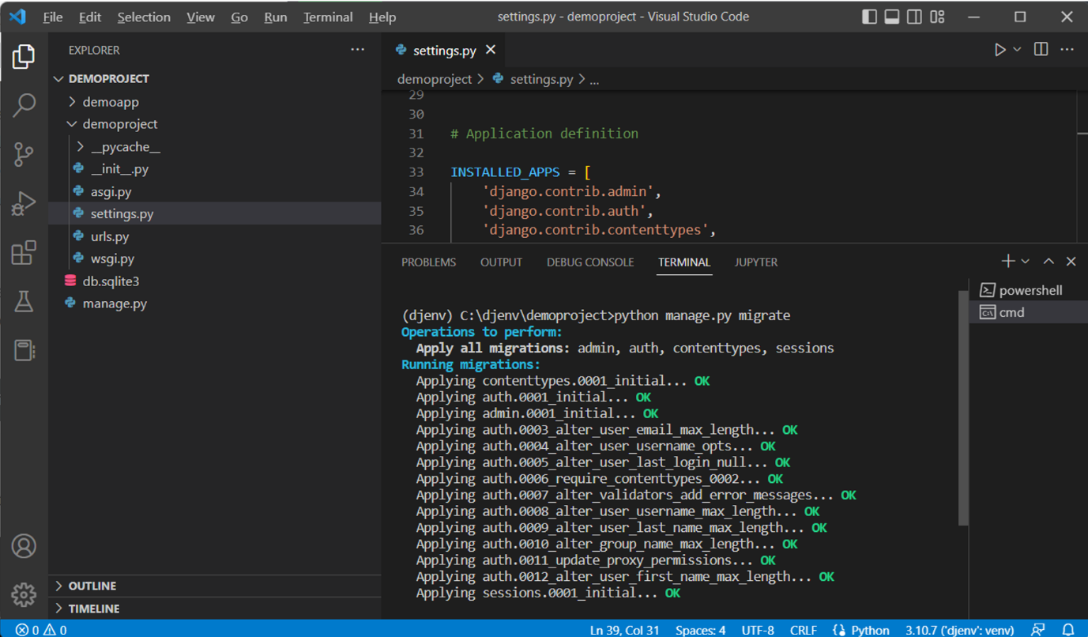

**runserver**

This command starts Django’s built-in development server on the local machine with IP address 127.0.0.1 and port 8000.

python manage.py runserver

It helps if you don't use this development server in the production environment.

**Shell**

This command opens up an interactive Python shell inside the project. This is useful when you are required to perform some quick interactive operations.

python manage.py shell

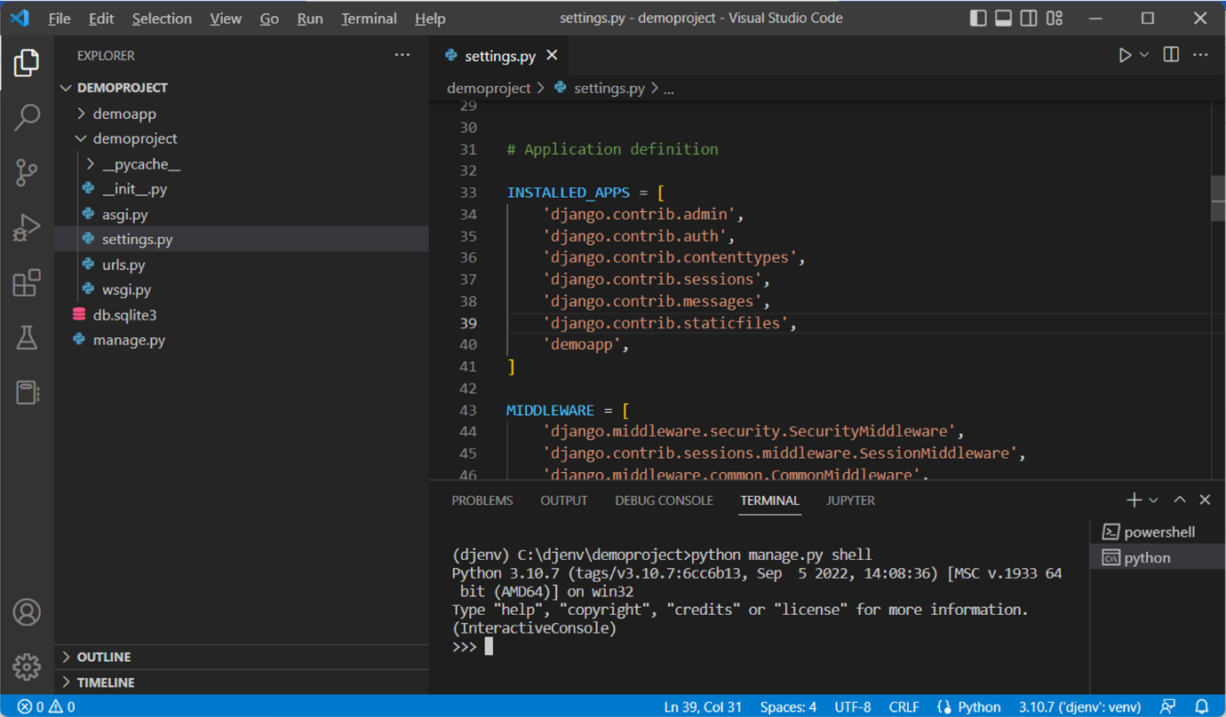

Django prefers **IPython** if it is installed over the standard Python shell.

**Project package**

The **startproject** command option of the Django-admin utility creates the folder of the given name, inside which there is another folder of the same name. For example, the command:

django-admin startproject demoproject

This creates a **demoproject** folder, inside which there’s another **demoproject** folder.

The inner folder is a Python package. For a folder to be recognized by Python as a package, it must have a file **\_\_init\_\_.py**. In addition, the **startproject** template places four more files in the package folder.

**settings.py**

Django configures specific parameters with their default values and puts them in this file.

The django-admin utility and **manage.py** script use these settings while performing various administrative tasks.

**urls.py**

This script contains a list of object **urlpatterns**. Every time the client browser requests a URL, the Django server looks to match its pattern and routes the application to the mapped view.

The default structure of urls.py contains a view mapped to the project’s Admin site.

from django.contrib import admin

from django.urls import path

 urlpatterns = [

    path('admin/', admin.site.urls),

]

**asgi.py**

This file is used by the application servers following the ASGI standard to serve asynchronous web applications.

**wsgi.py**

Many web application servers implement the WSGI standard. This script is the entry point for such WSGI-compatible servers to serve your classical web application.

## settings.py

This file defines the attributes that influence the function of a Django application. The **startproject** template assigns some default values to these attributes. They may be modified as per requirement during the use of the application.

Let us explain some critical settings.

**INSTALLED\_APPS**

This is a list of strings. Each string represents the path of an app inside the parent project folder. The **startproject** template installs some apps by default. They appear in the **INSTALLED\_APPS** list.

INSTALLED\_APPS = [

    'django.contrib.admin',

    'django.contrib.auth',

    'django.contrib.contenttypes',

    'django.contrib.sessions',

    'django.contrib.messages',

    'django.contrib.staticfiles',

]

This list must be updated by adding its name whenever a new app is installed.

For example, if we create a **demoapp** with the following command:

python manage.py startapp demoapp

Then, add the '**demoapp**' string inside the **INSTALLED\_APP** list.

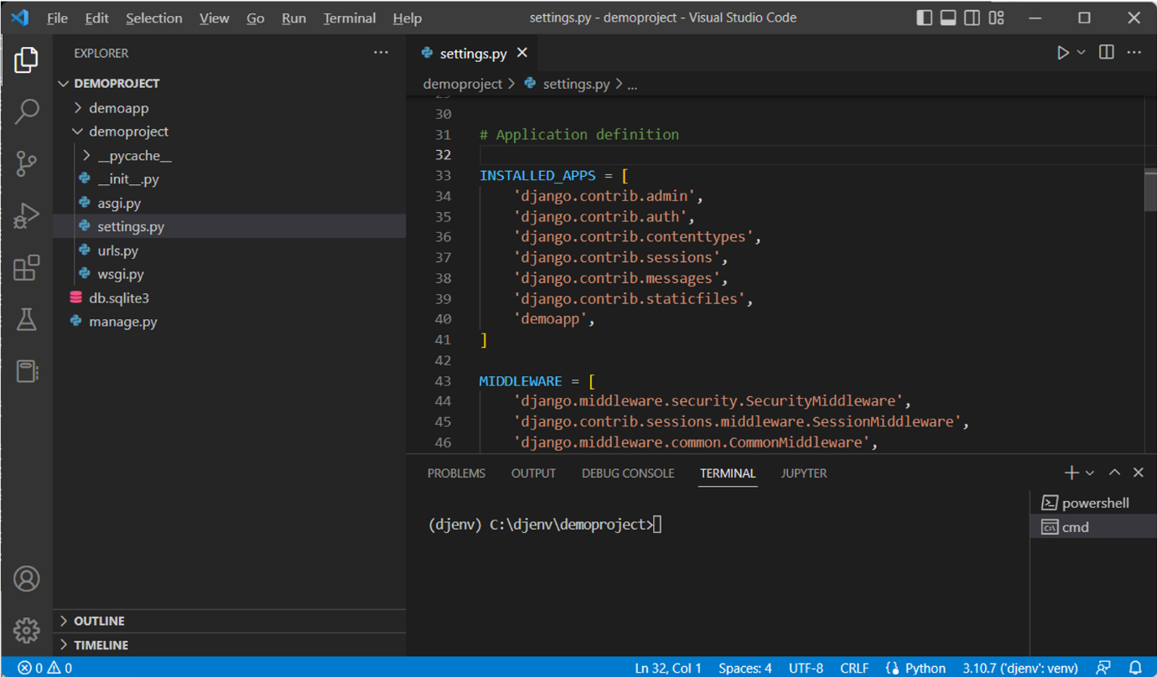

**Databases**

This attribute is a dictionary that specifies the configuration of one or more databases to be used by the current Django application. By default, Django uses the SQLite database. Hence, this setting has a pre-defined configuration for it.

DATABASES = {

    'default': {

        'ENGINE': 'django.db.backends.sqlite3',

        'NAME': BASE\_DIR / 'db.sqlite3',

    }

}

The default name of the SQLite database is db.sqlite3, which is created in the parent project folder.

In place of SQLite, you may choose to use any other. For example, for MySQL, the database settings could be as follows:

DATABASES = {

    'default': {

        'ENGINE': 'django.db.backends.mysql',

        'NAME': 'djangotest',

        'USER': 'root',

        'PASSWORD': 'password',

        'HOST': '127.0.0.1',

        'PORT': '3306',

    }

}

Note here the default port number for MySQL is **3306** as against the default port number **8000** used with SQLite in Django.

**DEBUG = True**

By default, the development server runs in debug mode. This helps develop the application as the server picks up changes in the code and the output can be refreshed without restarting. However, it must be disabled in the production environment.

**ALLOWED HOSTS**

This attribute is a list of strings. By default, it is empty. Each string represents the fully qualified host/domain where this Django site can be served. For example, to make the site running on localhost externally visible, you may add 0.0.0.0:8000 to this list.

**ROOT\_URLCONF**

This setting is a string pointing toward the urls.py module in which the project’s URL patterns are found. In this case, it would be:

ROOT\_URLCONF = 'demoproject.urls'

**STATIC\_URL**

This setting points to the folder where the static files, such as JavaScript code, CSS files and images, are placed. Usually, it is set to '**static/**' corresponding to the folder of this name in the parent project folder.

## Test the installation

After creating the project, to verify that it is built correctly, start the development server with the following command while remaining in the project’s parent folder:

python manage.py runserver

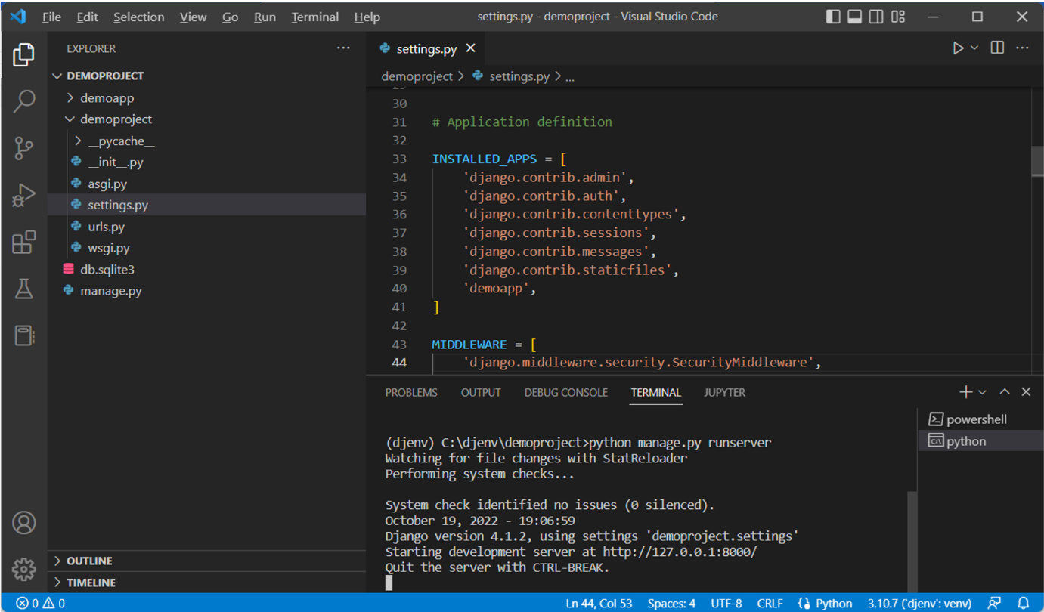

The server starts running at port 8000 of the localhost with IP address 127.0.0.1. Open the browser and enter <http://127.0.0.1:8000/>.

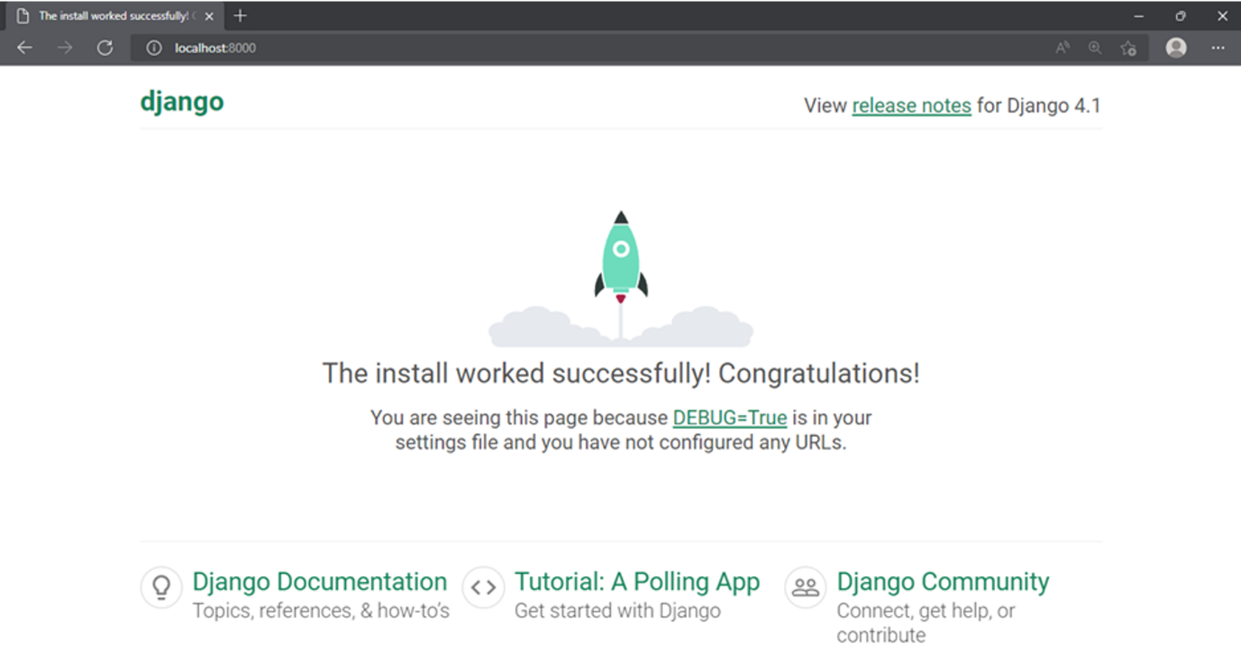

If you get this output, the project has been created successfully.

In this reading, you learned how to create a Django project. The file structure of the project has also been explained here. In the end, the installation of the project has been successfully verified.

# D3.1

# App structures

A Django project is a web application that may consist of one or more sub-modules called apps.

In this reading, you'll learn about the app structure, how to create an app and how to configure project settings to include the app.

## What is a Django app?

As mentioned above, an app is responsible for performing one single task out of the many involved in the complete web application, represented by the Django project.

It implies that a project comprises many independent sub-applications, yet they may communicate among themselves.

For example, a trading organization website may have one app for managing customer data, another for suppliers, and another for stock management. However, the important feature of the Django app is that it is reusable.

Hence, a customer data management app in one project can be linked to the website project for another organization without modification.

For simplicity, you are going to uniformly use one app inside one project throughout the course, but it is good to know the utility of Django framework as a multi-app framework.

When a Django project is created with the **startproject** command, it creates a container folder. Django puts a **manage.py** script and the project package folder in the outer folder.

The **startapp** command option of the **manage.py** script creates a default folder structure for the app of that name.

Here’s how to create a **demoapp** in the **demoproject** folder.

(djenv) C:\djenv\demoproject>python manage.py startapp demoapp

A folder with the app’s name is created inside the parent folder. It has a few Python scripts. The folder structure looks like this:

C:\djenv\demoproject

│   db.sqlite3

│   manage.py

│

├───demoapp

│   │   admin.py

│   │   apps.py

│   │   models.py

│   │   tests.py

│   │   views.py

│   │   \_\_init\_\_.py

│   │

│   └───migrations

│           \_\_init\_\_.py

│

└───demoproject

    │   asgi.py

    │   settings.py

    │   urls.py

    │   wsgi.py

    │   \_\_init\_\_.py

Let's briefly explain the Python scriptscreated in the **demoapp** folder.

## views.py

In Django, a view is a user-defined function that’s called when Django’s URL dispatcher identifies the client’s request URL and matches it with a URL pattern defined in the urls.py file.

The auto-created views file is empty at the beginning.

Let's add a view function called index() in it by saving the following snippet.

from django.http import HttpResponse

def index(request):

    return HttpResponse("Hello, world. This is the index view of Demoapp.")

## urls.py

The project package has a file of this name that defines the URL patterns for the project.

On similar lines, you need to provide the URL routing mechanism for the app.

**One important thing to note here in contrast to the video you have seen earlier is that the urls.py** **file can be configured at both the project and app level. In the example below, the urls.py will be configured at both the project and app-level.**

The app folder doesn’t have a file of this name when created. Hence, you have to create one.

Save the following snippet as **urls.py** in the **demoapp** folder.

from django.urls import path

from . import views

urlpatterns = [

    path('', views.index, name='index'),

]

Next, you need to update the **urlpatterns** list in the project folder’s urls.py and include the app’s URL configurations.

The updated **demoproject/urls.py** should look like this:

from django.contrib import admin

from django.urls import include, path

urlpatterns = [

    path('demo/', include('demoapp.urls')),

    path('admin/', admin.site.urls),

]

## models.py

The data models required for processing in this app are created in this file. It is empty by default. A data model is a Python class based on **django.db.modelsclass**.All the models present here are migrated to the database tables. For now, leave his file as it is without adding any models. You will learn how to work with models later.

## tests.py

You’ll write the tests to be run on the app in this file. Let's keep this file as it is without modifying it.

## Update settings.py

Lastly, you need to update the list of INSTALLED\_APPS in the project’s setting file. This list already contains some pre-installed apps. Add the name of **demoapp** so that it looks like this:

INSTALLED\_APPS = [

    'django.contrib.admin',

    'django.contrib.auth',

    'django.contrib.contenttypes',

    'django.contrib.sessions',

    'django.contrib.messages',

    'django.contrib.staticfiles',

    'demoapp',

]

After Performing the steps explained above, run the Django development server and visit [localhost:8000/demo/](http://localhost:8000/demo/) in the browser.

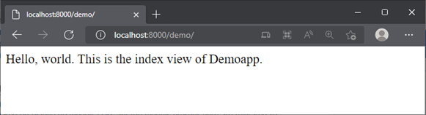

You have successfully created a Django app and added a view to it.

Note here that the files present in the app structure are not limited to this reading. The app directory as you will see also consists of other files such as **forms.py**, **serializers.py** among others.

In this reading, you learned to create an app, update the project settings to include it and add a view function.

# D4.1

# Solution: Creating your first project and app

### Learner Instructions

Ensure you are in the directory where you want to create your project.

This lab mainly deals with the command line inside the VS Code console present. If not open, go to Terminal on your Menu bar at the top of your screen and select 'New Terminal'. Add the commands below inside the command line.

Follow the instructions below and make sure you check the output at every step:

## ****Step 1****

Verify that you are in **/home/coder/project** directory.

pwd

Sample output:



If you are not in the above directory, navigate to the same using:

cd directory\_name # To enter into the specified directory

cd .. # Navigate to the parent directory

## ****Step 3****

Make sure you have Django installed.

python3 -m django --version

Sample output:



If django is not installed, use pip to install the same.

pip3 install django

## ****Step 4****

Run a command to Start/setup a project such as **myproject**.

django-admin startproject myproject

The project should ideally be setup at this point.

## ****Step 5****

Step inside the project directory that you have created.

cd myproject

## ****Step 6****

Create an app called **myapp**.

 python3 manage.py startapp myapp

## ****Step 7****

Run a command to start the server.

python3 manage.py runserver

Sample output:

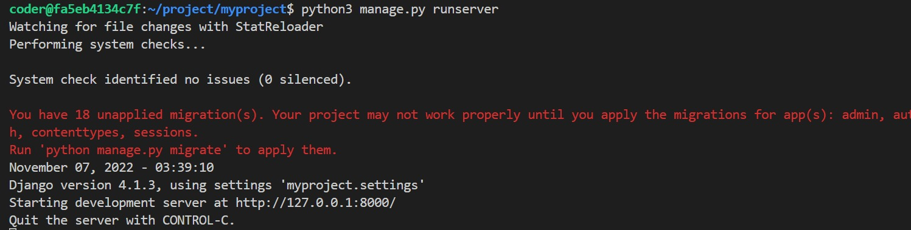

**Step 8**

Click on the 'Browser Preview' option among the left-hand menu options inside Vs Code. You can refer to [this](https://www.coursera.org/teach/django-web-framework/authoringBranch~3KfnFzgAEe2TYhIeB00zEQ/content/item/supplement/b35Pn) reading for more information. Now copy the URL http://127.0.0.1:8000/ or http://localhost:8000 generated above and paste it inside the Browser Window that has opened inside the Vs Code.

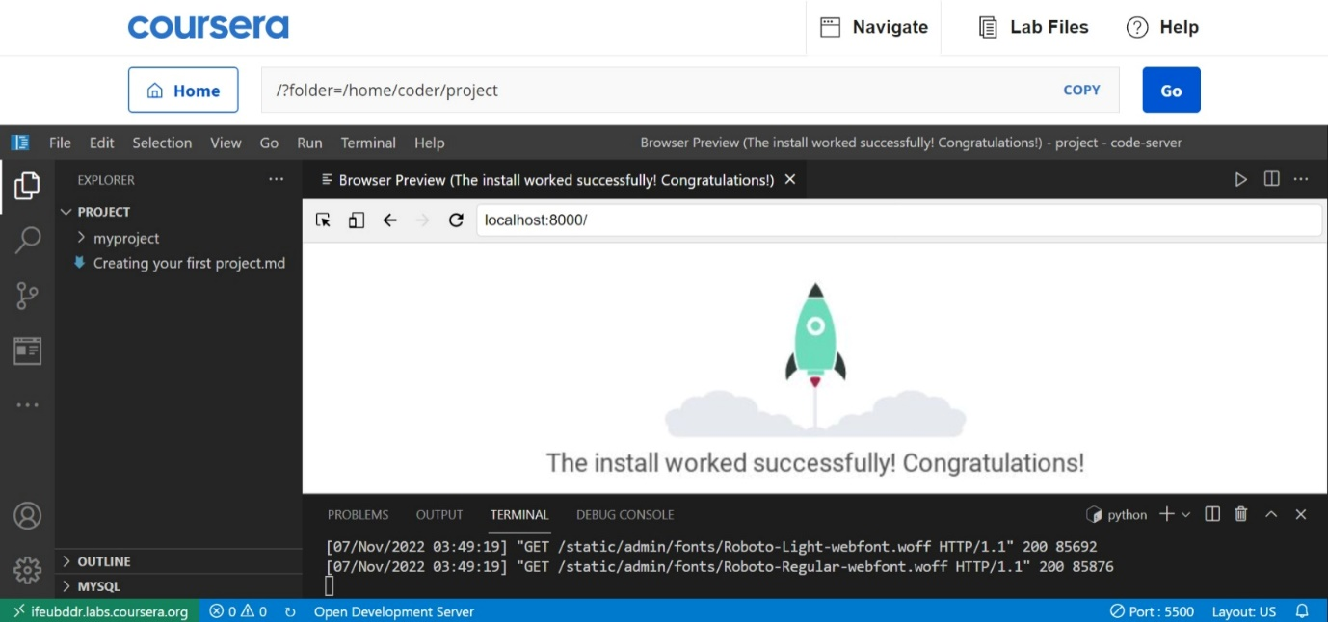

**Additional step**

You can try changing the URL in the browser and add suffix 'admin' to see the Admin console of Django that you will encounter later.

**D5.1**

**MVT Overview**

In this Reading, you will learn about Django's Model, View and Template (MVT) application development pattern.

**Web Framework**

A software framework, in general, is a standard, reusable software platform that facilitates the rapid development of software applications.

The web framework (also called web application framework) provides a generic functionality needed for building web applications, APIs and web services. The main advantage of employing a web framework for development is that it provides "out of the box" support to perform everyday operations in the web development process.

For example, you can easily connect your application to databases. Usually, the framework handles tasks such as session management much more efficiently.

Likewise, it integrates with templating tools to render dynamic content on web pages.

**MVC Architecture**

Most of the web frameworks implement the MVC (Model-View-Controller) architecture.

The MVC design pattern separates the entire web application development process into three layers, Model, View and Controller. The following diagram explains the interplay of these three layers.

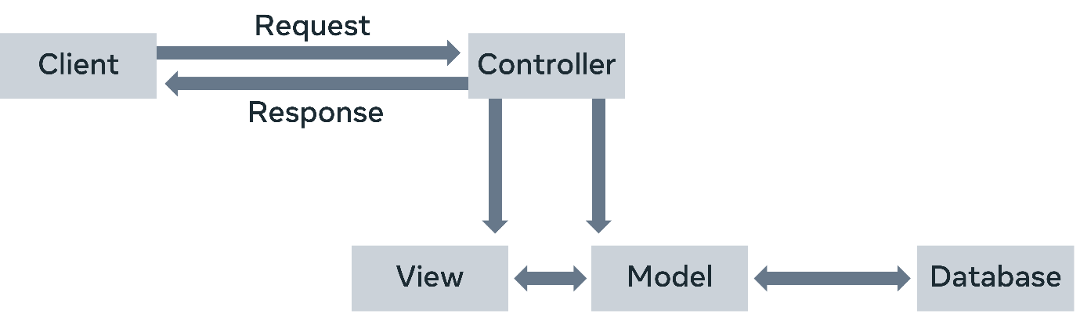

In the MVC approach, the controller intercepts the user requests. It coordinates with the view and model layers to send the appropriate response back to the client.

The model is responsible for data definitions, processing logic and interaction with the backend database. The view is the presentation layer of the application.

It takes care of the placement and formatting of the result and sends it to the controller, which in turn, redirects it to the client as the application's response.

**MVT Architecture**

The Django framework adapts a Model, View and Template (MVT) approach, a slight variation of the MVC approach.

Here too, the model is the data layer of the application. The view is, in fact, the layer that undertakes the processing logic.

The template is the presentation layer.

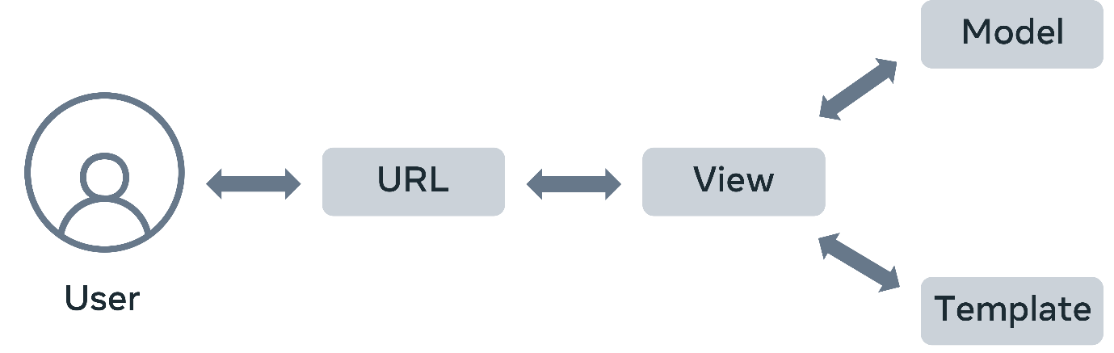

A Django application consists of the following components:

* URL dispatcher
* View
* Model
* Template

**URL dispatcher**

Django's URL dispatcher mechanism is equivalent to the controller in the MVC architecture.

The **urls.py** module in the Django project's package folder acts as the dispatcher.

It defines the URL patterns. Each URL pattern is mapped with a view function to be invoked when the client's request URL is found to be matching with it.

The URL patterns defined in each app under the project are also included. Here’s the **urls.py** file in the app folder.

from django.urls import path

from . import views

urlpatterns = [

    path('', views.index, name='index'),

]

When the server receives a request in the client URL, the dispatcher matches its pattern with the patterns available in the**urls.py**.

It then routes the flow of the application toward its associated view.

## View

The view function reads the path, query, and body parameters included in the client's request If required, it uses this data to interact with the models to perform CRUD operations.

A view can be a user-defined function or a class.

You create View definitions in the **views.py**file of the respective app package folder.

The following code in the **view.py** file defines the **index()** view function.

from django.shortcuts import render

# Create your views here.

from django.http import HttpResponse

def index(request):

    return HttpResponse("Hello, world.")

## Model

A model is a Python class.

An app may have one or more model classes, conventionally put in the **models.py** file.

Django migrates the attributes of the model class to construct a database table of a matching structure.

Django's Object Relational Mapper helps perform CRUD operations in an object-oriented way instead of invoking SQL queries.

The view uses the client's and the model's data and renders its response using a template.

## Template

A template is a web page containing a mix of static HTML and Django Template Language code blocks.

You place Template web pages in **the templates**folder with the **.html** extension.

Django's template processor uses any context data from the view inserted in these blocks to formulate a dynamic response.

The view, in turn, returns the response to the user.

This explains how Django's MVT architecture handles the request-response cycle in a web application.

**D7.1**

**Additional resources**

The links below are helpful as additional references when creating Django apps, expanding upon the differences between the MVC and MVT Frameworks, and following best practices when structuring your Django projects.

[Writing your first Django app – official documentation](https://docs.djangoproject.com/en/4.1/)

[MVT Framework - Django](https://docs.djangoproject.com/en/4.1/faq/general/#django-appears-to-be-a-mvc-framework-but-you-call-the-controller-the-view-and-the-view-the-template-how-come-you-don-t-use-the-standard-names)

[How to structure your Django project](https://docs.djangoproject.com/en/4.1/intro/tutorial01/)

# Module - 02

# V2.1()

Because the file's urls.py file(app level) and views.py file are in the same folder, you only need to provide the name of the file without the.py extension where the view function is located, and then a dot and the name of the view function.

The final step is to set the URL configuration at the project level. This is because the project file

doesn't know where the view function is.

To set this configuration open the urls.py of the project. Beside the keyword path type comma,

and then include to import the include function.

Next, inside the URL patterns list, add another path function. Inside of the parenthesis,

pass an empty string. For the second parameter, use the include function to pass the location of urls.py file of the app. Once again, remember to not add the.py extension.

# View logic

The view plays a pivotal role in Django's MVT architecture. On one side, Django's URL dispatcher invokes a corresponding view function that matches the URL pattern.

On the other side, the view interacts with both the model and template layers.

## What does the view do?

* The primary role of the view function is to fetch the data from the client's request, apply a certain processing logic to it and send an appropriate response back to the client.
* It receives the request data in an object of class **HttpRequest**.
* For simplicity, you can say models are equivalent of a database in Django. The view function interacts with the model in either of two ways. It either fetches all or certain objects from the model such as the database table mapped with the model.
* Or the request parameters are used to add a new instance of the model thereby inserting a new row in the mapped table.
* The client uses the HTTP GET method to provide the data from the model or delete a certain instance. On the other hand, it uses the POST method to indicate that the data in the request is to be used to perform an insert or update operation.
* While you will learn about models soon, it is good to know the fundamentals. In the upcoming modules of this course, you’ll learn how to perform these model operations.

## GET and POST methods

Schematically, this behavior is implemented as below:

from django.shortcuts import render

def myview(request):

    if request.method=='GET':

        #perform read or delete operation on the model

    if request.method=='POST':

        #perform insert or update operation on the model

--------------------------------------------------------------------------------------------------------------------------------------

from django.shortcuts import render

def myview(request):

    if request.method=='GET':

        val = request.GET['key']

        #perform read or delete operation on the model

    if request.method=='POST':

        val = request.POST['key']

        #perform insert or update operation on the model

* At the end of performing any process, you would want to let the user know about the result.
* The return value of the view function is a **HttpResponse** object containing the actual contents of default content\_type as “**text/HTML**” and the status code.
* Additionally, it contains some header information. However, you would also want the view to give a well-formatted response.
* Since the web browser is the client of your web application, the response should be in HTML format as a web page, called a web template.
* The Django view loads the template web page, inserts certain context data at the placeholders marked with tags, and returns it as the response.

## ****View rendering template****

from django.shortcuts import render

def myview(request):

      if request.method=='GET':

            #perform read or delete operation on the model

      if request.method=='POST':

            #perform insert or update operation on the model

            context={ } #dict containing data to be sent to the client

      return render(request, 'mytemplate.html', context)

## ****Class based views****

* In the above discussion, **myview** is a regular Python function.
* Such views are called **function based views**. The processing logic in it is very imperative in nature, hence it may be repetitive.
* Also, it uses conditional blocks for GET and POST requests. Django offers a more concise alternative in the form of a class-based view.
* You create a sub-class of the View class and override its **get()** and **post()** methods to separately and cleanly define GET and POST operations.

From jango.views import View

class MyView(View):

    def get(self, request):

        # logic to process GET request

        return HttpResponse(‘response to GET request’)

    def post(self, request):

        # <logic to process POST request>

        return HttpResponse(‘response to POST request’)

## Generic views

Django makes the view declaration process still easier with its generic class-based views. The **jango.views.generic** module contains several view classes that provide the functionality required to perform tasks such as rendering a template, showing an instance, showing the list of instances, adding a new model instance, updating an instance and so on.

Some generic views are **TemplateView**, **CreateView**, **ListView**, **DetailView**, **UpdateView** to name a few.

You need to subclass the generic view and set the properties like **model** and **template\_name**. Django will internally perform all the heavy lifting which you had to do by yourself in a function-based view.

You will be working with the class based views in a later module of this course. As this is an introductory course, understanding the fundamentals of building views is important with the function based views. Class based views and Generic views are however widely used and an important topic to be understood as you progress with your journey in web development.

**Exercise: Creating a view and URL configuration**

Open Lab

**Instructions**

**Introduction**

So far, you’ve learned how to create a Django project inside a virtual environment, and install an App. In this lab you will create a view function and add URL configuration in Django.

**Goal**

* To create a view, add URL configuration and display contents on a webpage

**Objectives**

* Learn how to create a view inside the **views.py**
* Add URL configurations at the project level using **include()** function

**Scenario**

Now that you have created a Django project and app for the Little Lemon prototype, it’s time to create its first webpage.

In this lab, you’ll create a view function and return a webpage containing some text using the **HttpResponse** object.

**Learner Instructions**

Ensure you are in the directory where you want to create your project.

This lab will require the learner to modify the files:

* **views.py**
* **urls.py(project-level)**
* **urls.py(app-level) and**
* **settings.py**

Additionally, you will run commands inside the VS Code console. If not open, go to **Terminal** on your menu bar at the top of your screen and select **New Terminal**.

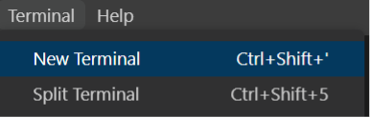

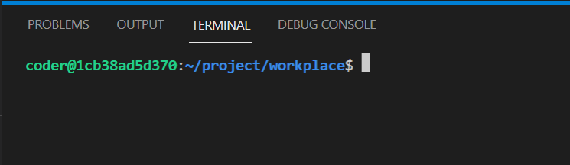

Finally, you will start the development server on the local host and go to the URL to confirm the desired view on the webpage. You have already built the project named **myproject** and added an app inside the project called **myapp**.

Follow the instructions below and ensure you check the output at every step:

**Steps**

**Step 1:**  Make sure you have Django installed. If not installed, use pip to run the command to install Django.

**Tip:** You can check that Django has been successfully installed by checking the version using the following command:

python -m jango –version

**Step 2:**  The project and app are already in place. Run the change directory command to go inside the project directory:

cd workplace/myproject

**Tip:** You can check this was successful if the console prompt has a suffix **myproject**

**Step 3:**  Inside the left explorer panel in VS Code, expand the **myapp** directory and open the file called **views.py**.

**Step 4:**  Inside the **views.py** file, complete the following actions:

* Import **HttpResponse** from the package **jango.http**
* Define a function called **home()** and pass **request** object to it as a parameter

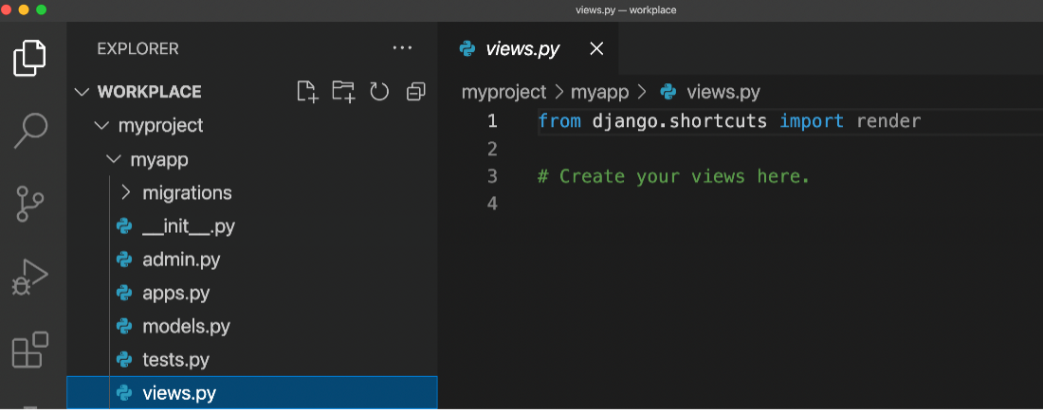

**Step 5:**  Inside the function body of the view function you created, use the return statement to return an **HttpResponse()** object and pass the following string to it:

**<h1> Welcome to Little Lemon! </h1>**

**Step 6:**  Create a file called **urls.py** inside the**myapp** directory.

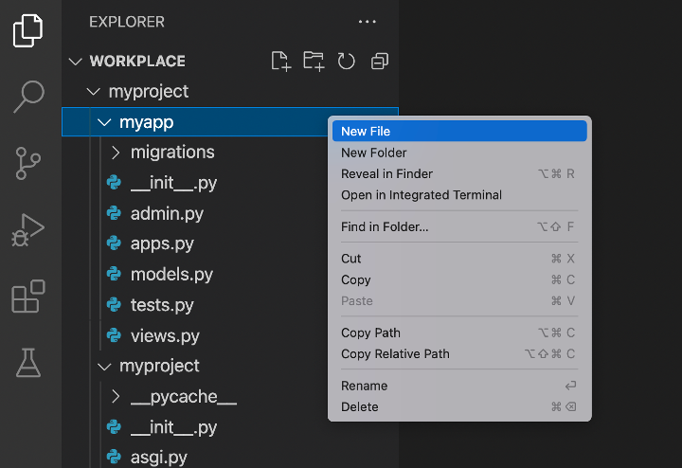

Inside **urls.py**, add the following code inside it.

Urlpatterns = [

    path(‘’, views.home, name=”home”),

]

**Step 7:**  Additionally, you need to add the import packages to use the **path()** function and **home()** function inside the **views.py** file. To do that, add the correct code at the beginning of the file to:

* Import **path** from **jango.urls**
* Import **views** from **.**

**Note:** dot (**.**) here indicates the same working directory as the file.

**Step 8:**  Expand the **myproject** folder on the left panel and open the file **urls.py**.

**Tip:** make sure you open**urls.py** for the project and not the app.

**Step 9:**  Inside the **urls.py** file, import the function: **include**, from the package **jango.urls**.

**Step 10:**  Add a new path function inside the **urlpatterns** list and pass two arguments to it:

* An empty string
* The **include()** function that has **myapp.urls** passed inside it as a string

**Tip:** Don’t forget to add the comma(**,**) after the line of code for the view function and also between the arguments passed to the path function.

**Step 11:**  Open the **settings.py** file and register the app by adding the following string to the option **INSTALLED\_APPS** present inside it: **myapp.apps.MyappConfig**:

INSTALLED\_APPS = [

    ‘django.contrib.admin’,

    ‘django.contrib.auth’,

    ‘django.contrib.contenttypes’,

    ‘django.contrib.sessions’,

    ‘django.contrib.messages’,

    ‘django.contrib.staticfiles’,

    ‘myapp’,

]

**Tip:** Make sure you add a comma (**,**) after the string.

**Step 12:**  Go back to the console in the terminal and run the command to start the development server:

python manage.py runserver

**Step 13:**  The command prompt will generate some text including a link for the local host URL such as [**http://127**](http://127)**.0.0.1:8000/**

Click on the ‘Browser Preview’ option inside VSCode. Copy the URL [**http://127**](http://127)**.0.0.1:8000/** and paste it inside the browser window. Finally, press enter to load the webpage.

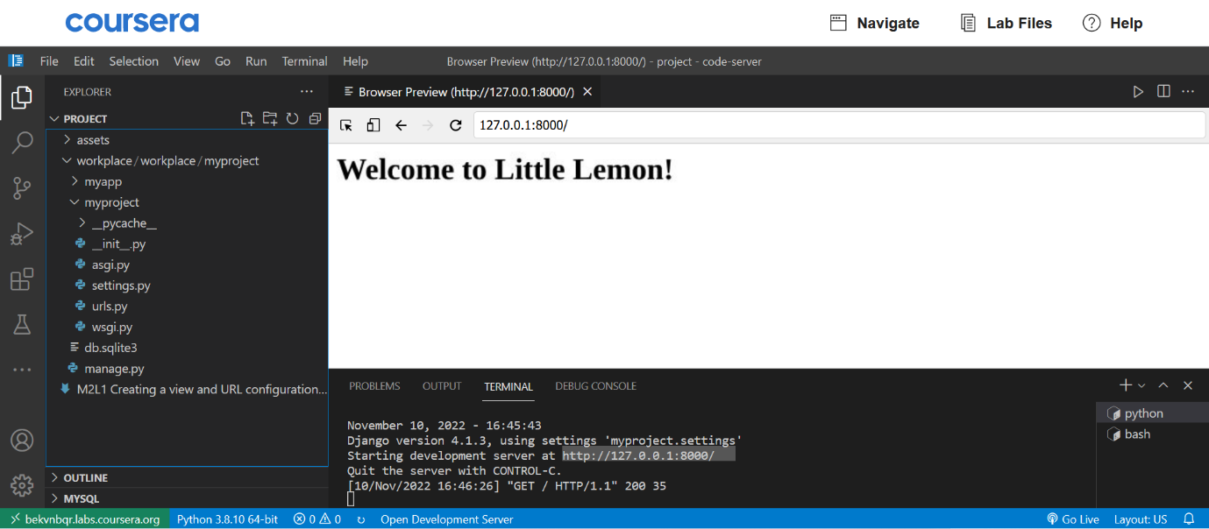

**Concluding Thoughts**

In this lab, you practiced creating a view function and adding URL configuration in Django.

# Solution: Creating a view and URL configuration

Here is the completed solution code for the **views.py**

from jango.shortcuts import render

from jango.http import HttpResponse

# Create your views here.

Def home(request):

    return HttpResponse(“Welcome to Little Lemon!”)

urls.py – App-level

from jango.urls import path

from . import views

urlpatterns = [

        path(‘’, views.home, name=”home”),

]

urls.py – Project-level

from jango.contrib import admin

from jango.urls import path, include

urlpatterns = [

    path(‘admin/’, admin.site.urls),

    path(‘’, include(‘myapp.urls’)),

]

settings.py – INSTALLED\_APPS

INSTALLED\_APPS = [

    ‘myapp.apps.MyappConfig’, # string added.

    # Note: This is effectively the location of MyappConfig class inside the app-level apps.py file

    # Relative path of the app needs to be added. This means, alternatively you could have also added simply the name of the app which is ‘myapp’

    ‘django.contrib.admin’,

    ‘django.contrib.auth’,

    ‘django.contrib.contenttypes’,

    ‘django.contrib.sessions’,

    ‘django.contrib.messages’,

    ‘django.contrib.staticfiles’,

]

# V4.1

# Request and Response Objects

* A web application works on the principle of a request-response cycle in a client-server architecture, following the HTTP protocol.
* Generally, a browser sends the request in the form of a URL. The web application forms a suitable response to the data contained in the request.
* This Reading will provide more detailed information on the Request and Response Objects.
* Django handles the request and response with the help of **HttpRequest** and **HttpResponse** classes in the **django.http** module.
* Django obtains the **HttpRequest** object from the context provided by the server.
* As a client request is received, Django’s URL dispatcher mechanism invokes a view that matches the URL pattern and passes this **HTTPRequest** object as the first argument so that all the request metadata is available to the view for processing.

## HttpRequest Object

The request object is characterized by its attributes and methods. They are used extensively in the processing logic of a Django view.

**request.method**

The view logic uses this attribute to identify how the client has approached the server. A browser submits its request using any HTTP methods or verbs – **POST, GET, DELETE,** and **PUT**.

Inside the view function, different conditional blocks may be executed depending on the value of the method attribute. For example:

if request.method == 'GET':

    do\_something()

elif request.method == 'POST':

    do\_something\_else()

According to the **REST**(Representational State Transfer) principle, the **POST** method creates a new resource on the server.

To fetch one or more resources from the server, the **GET** method is used. Similarly, the **PUT** method is for updating an existing resource, and the **DELETE** method is used to remove a resource from the server.

* **request.GET and request.POST**

The attributes return a dictionary-like object containing GET and POST parameters, respectively.

* **request.COOKIES**

Along with the parameters, the browser also packs the request objects with cookies inserted by the server’s previous interactions. It is a dictionary of string keys and values.

* **request.FILES**

When the user uploads one or more files with a multipart form, they are present in this attribute in the form of UploadedFile objects. By appropriate logic in the view, these uploaded files are saved in the designated folder on the server.

* **request.user**

The request object also contains information about the current user. This attribute is an object of **django.contrib.auth.models.User** class. However, if the user is unauthenticated, it returns **AnonymousUser**. Inside the view, you can lay down separated separate logic for either of them.

if request.user.is\_authenticated():

    # Do something for logged-in users.

else:

    # Do something for anonymous users.

* **request.has\_key()**

This is a method available to the request object. It helps check whether the **GET** or **POST** parameter dictionary has a value for the given key.

Unlike the **HttpRequest** object, which is supplied by the server’s context, the response object of **HttpResponse** class is instantiated inside the view function before it is returned to the client. For example:

from django.http import HttpResponse

def index(request):

    return HttpResponse("Hello World")

Although it is possible to render a hardcoded HTML string as the response, Django offers a better alternative to render a template web page.

from django.http import HttpResponse

from django.template import loader

def index(request):

    template = loader.get\_template('demoapp/index.html')

    context={}

    return HttpResponse(template.render(context, request))

You can pack additional headers or cookies in the response object.

## HttpResponseObject

Some of the main attributes and methods of the **HttpResponse** object are:

* **status\_code**: returns the HTTP status code corresponding to the response
* **content**: returns the byte string of the response.
* **\_\_getitem\_\_()**: method that returns the value of a header
* **\_\_setitem\_\_()**: method used to add a header
* **write()**: This method creates a file-like object.

The following example demonstrates the attributes of the request and response objects. Add the following view function in **views.py** of the Django app.

from django.http import HttpResponse

def index(request):

    path = request.path

    method = request.method

    content='''

<center><h2>Testing Django Request Response Objects</h2>

<p>Request path : " {}</p>

<p>Request Method :{}</p></center>

'''.format(path, method)

    return HttpResponse(content)

Start the server and check the response for <http://localhost:8000/demo/>  as the URL.

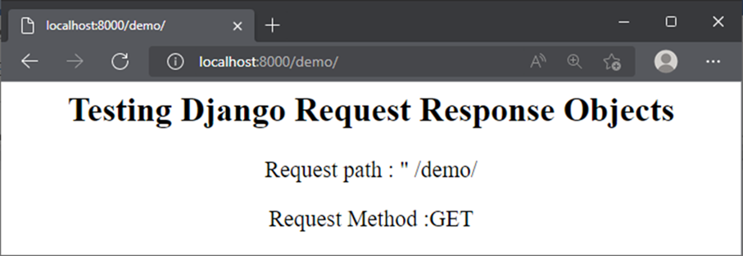

In this Reading, you explored the properties of the **HttpRequest** and **HttpResponse** objects.

# V6.1

# Parameters

In this reading, you’ll explore the different options for using parameters in a web application and showcase how they are related to the GET, PUT, POST and DELETE operations.

You’ll familiarize yourself with the differences between path, query, and body params and how they're associated with HTTP methods such as GET, PUT, POST and DELETE.

The view function in Django is like any other Python function in that it receives its mandatory argument as the request object from the server context. The client may pass additional arguments via different methods.

## Path parameter

The client browser sends data along with the URL itself. For example, a URL such as <http://example.com/customer/5>. Here, the URL endpoint id, **/customer/5**, is the variable parameter (this can be any other number).

The parameter linked to the URL’s endpoint is called a **path** parameter. Note that there may be multiple path parameters in the URL, separated by **/** symbol.

For now, consider that the browser will use the URL [http://localhost:8000/getuser/John/1](http://localhost:8000/myapp/John/1.)

The URL dispatcher should identify John as the **name** parameter and 1 as the **id** parameter.

This pattern is mapped to the **pathview()** function with the following path in the URL patterns list in the app’s **url.py** file.

path('getuser/<name>/<id>', views.pathview, name='pathview'),

Next, add the **pathview()** function in **views.py** file.

from django.http import HttpResponse

def pathview(request, name, id):

    return HttpResponse("Name:{} UserID:{}".format(name, id))

As a result, the parameters in the above URL are parsed as name and id parameters and picked by the **pathview()** function, returning the displayed response.

An important thing to understand here is the parameters added inside the **path()** function in the **urls.py** file must match the arguments added inside the **pathview()** view function associated with it in the **views.py** file.

**Path converters**

The URL pattern treats the identifiers in angular brackets (**<..>**) as the path parameters. By default, it parses the received value to the string type. Other path converters available are:

* **str** - Matches any non-empty string and excludes the path separator, '**/**'. This is the default if a converter isn’t included in the expression.
* **int** - Matches zero or any positive integer and returns an **int**. For example:**/customer/<int:id>**
* **slug** - Matches any slug string consisting of ASCII letters or numbers, including the hyphen and underscore characters.
* **uuid** - Matches a formatted UUID.  For example: **075194d3-6885-417e-a8a8-6c931e272f00** and returns a UUID instance.
* **path** - Matches any non-empty string and includes the path separator, '**/**'.

## Query parameter

The client URL may contain a query string linked to the endpoint, for example, [http://localhost:8000/getuser/?name=John&id=1](http://localhost:8000/myapp/?name=John&id=1)

A query string is a sequence of one or more **key=value** pairs concatenated by the **&** symbol. Each key is the query parameter. The query string ends with the **?** symbol after the URL endpoint.

**Query strings are an alternative approach to URL parameters for adding URL configurations.**

The URL dispatcher doesn’t parse these parameters. They are fetched by the view from the request object it receives. The request object’s **GET** property is a dictionary object.

The key-value pairs in the query string are added to the **request.GET** property. Hence, the name can be obtained with **request.GET[‘name’]** expression.

The next step is to add the following path in the **urls.py** file:

path('getuser/', views.qryview, name='qryview')

Declare the **qryview** function in the **views.py** file.

def qryview(request):

    name = request.GET['name']

    id = request.GET['id']

    return HttpResponse("Name:{} UserID:{}".format(name, id))

Now, start the server and use <http://localhost:8000/myapp/?name=John&id=1> as the URL. The client gets back the response shown above.

## Body parameters

An HTML form sends the data to the URL mentioned in its action attribute using the POST method. The POST method is a more secure way of sending data than the GET method because the data is not revealed in the URL.

Let’s construct a simple form containing two text input elements. Then, save it as **form.html** in the **templates** folder.

<form action="/myapp/getform/" method="POST">

    {% csrf\_token %}

    <p>Name: <input type="text" name="id"></p>

    <p>UserID :<input type="name" name="name"></p>

    <input type="submit">

</form>

The **{% csrf\_token %}** tag is necessary to prevent cross-site forgery attacks. You’ll learn more about this later on in the course.

Next, you’ll need to provide a view that will render this form:

def showform(request):

    return render(request, "form.html")

The URL patterns list must be updated using the following path:

path("showform/", views.showform, name="showform"),

The [http://localhost:8000/myapp/showform/](http://localhost:8000/mushowform/) URL displays this form to the user:

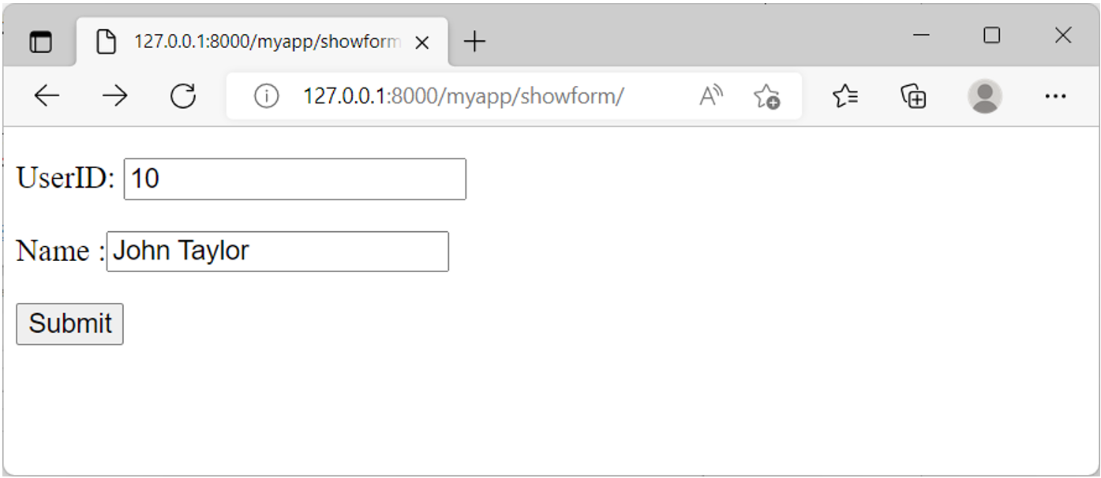

When this is submitted, it goes to the <http://localhost:8000/myapp/getform/> URL. Now, map it to **getform()** function in the **urls.py** file.

path("getform/", views.getform, name='getform'),

The form data that the user posts becomes part of the request body.

Therefore, the name attribute of each form element becomes a body parameter and the data entered becomes its value.

The view function passes these body parameters from the **request.POST** dictionary-like attribute.

def getform(request):

    if request.method == "POST":

        id=request.POST['id']

        name=request.POST['name']

    return HttpResponse("Name:{} UserID:{}".format(name, id))

Complete the form and submit it. The **getform()** function returns the data as its response.

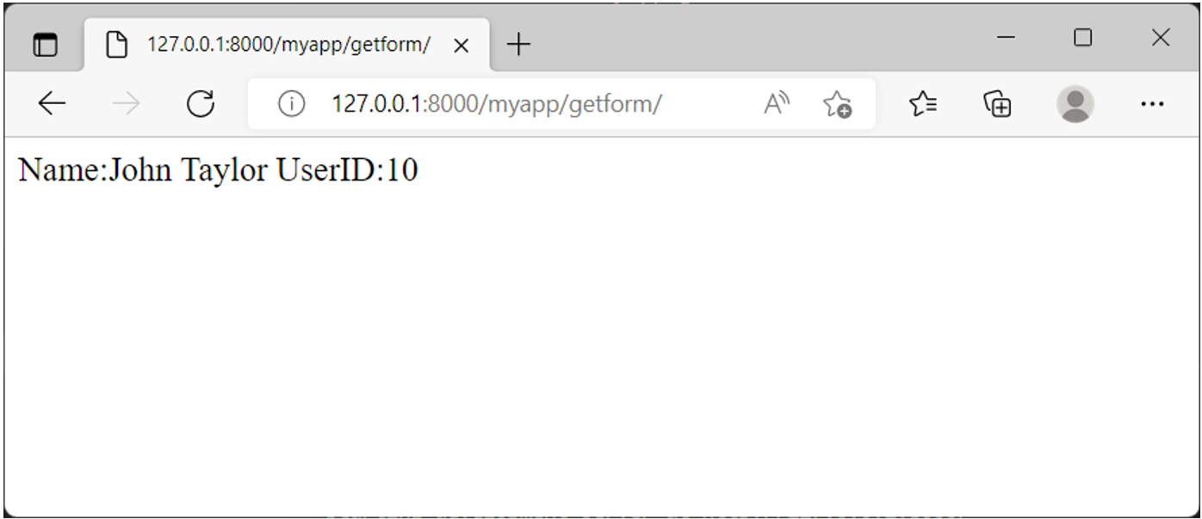

In the real world, the received data may be meaningfully processed, such as storing it in a database table.

You’ll learn how to do this when you explore Models, Forms and Database Connections.

In this reading, you learned about the path, query and body parameters and how to pass and process them using different HTTP methods.

**Exercise: Mapping URLs with Params**

Open Lab

**Instructions**

**Goal**

In this lab, learners will practice working with Django URL dispatcher and how it tries to match URLs to URL patterns.

**Objectives**

* Learner will define dynamic URL paths using path converters to capture a value from the URL, using angle brackets.
* The learner will practice capturing URL paths and print paths as headings on the webpage.

**Introduction**

By now you know how to define URLs and map them to view functions that return webpage content using the **HttpResponse** object.

In this lab, you will practice working with the Django URL dispatcher and how it tries to match URLs to URL patterns.

**Scenario**

Mario, the other owner of Little Lemon is considering ways in which the website can be made attractive for its visitors. One idea that he found interesting was to provide an option of giving detailed information about different menu items by directly entering the item names in the URL. You are assigned to help Mario with this task.

**Learner Instructions**

This lab will require the learner to modify the following files:

* **views.py**
* **urls.py** (app-level)

Additionally, you must start the development server on the local host and go to the URL to confirm the desired view on the webpage.

You have already built the project named **myproject** and added an app inside the project called **myapp**. The settings inside the **settings.py** file is already updated and at the project-level, **urls.py** is updated with reference to the app-level URL configuration.

Follow the instructions below and ensure you check the output at every step.

**Steps**

**Step 1:**  Create a **urls.py** file at the app level, add the **path()** function inside the **urlpatterns** list and pass the following arguments to it:

* A path string beginning with the suffix **'drinks/'** followed by a string path converter that has a variable called **drink\_name**
* The relative path of the view function **drinks()**
* A parameter called **name** with a value of **'drinks'**

The configured path should be as follows:

urlpatterns = [

    path('drinks/<str:drink\_name>', views.drinks, name="drink\_name"),

]

**Tip:** Make sure to use **<>** when defining your path converter.

Also, make sure you have imported the views from the **views.py** file and the path function from **django.urls** package.

**Step 2:**  Inside **views.py**, create a view function called **drinks()** and pass two arguments to it:

* The request object and
* The **drink\_name** variable you created inside **urls.py**

**Tip:** Make sure you have imported **HttpResponse** from **django.http** package

**Step 3:**  Create a dictionary inside the **drinks()** view function called **drink()** that has the following key-value pairs inside it:

* **key 'mocha' with a value 'type of coffee'**
* **key 'tea' with a value 'type of beverage'**
* **key 'lemonade' with a value 'type of refreshment'**

**Step 4:**  Create a variable called **choice\_of\_drink** and assign it the value of the **drink\_name** by passing it inside the **drink** dictionary.

**Step 5:**  At the end of the function, return an **HttpResponse** object and pass the following arguments to it:

* **f"<h2> {drink\_name} </h2>"**
* concatenated by the variable **choice\_of\_drink**

**Note:** **<h2>** here represents an HTML Heading tag.

**Step 6:**  Go back to the console in the terminal and run the command to start the development server:

python manage.py runserver

**Tip:** Make sure you are running the command in the directory containing the **manage.py** file.

**Step 7:**  The command prompt will generate some text including a link for the local host URL such as **http://127.0.0.1:8000/**

Click on the **Browser Preview** option inside VS Code. Now copy the URL **http://127.0.0.1:8000/** that is generated and paste it inside the Browser Window that has opened inside VS Code.

**Step 8:**  Inside the browser, go to the following URL paths and check that you get the expected output.

**http://127.0.0.1:8000/drinks/mocha**

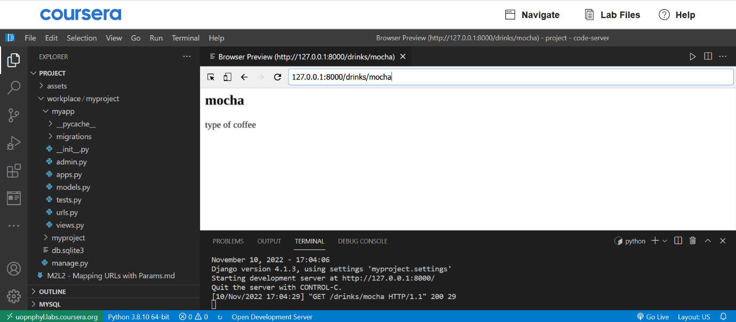

**http://127.0.0.1:8000/drinks/tea**

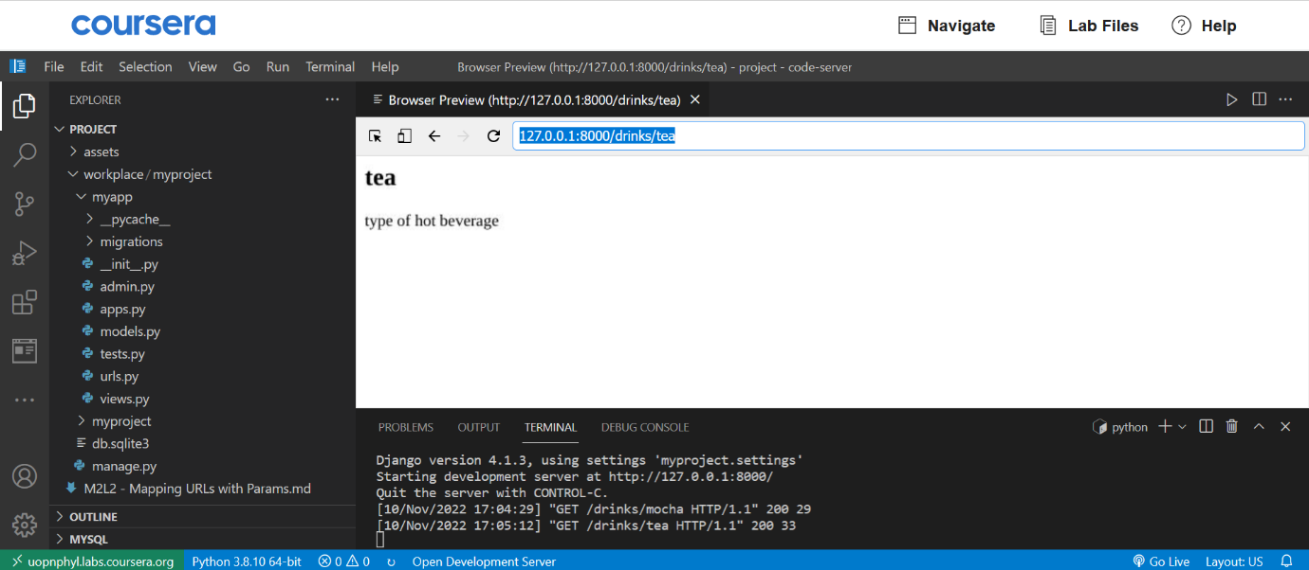

**http://127.0.0.1:8000/drinks/lemonade**

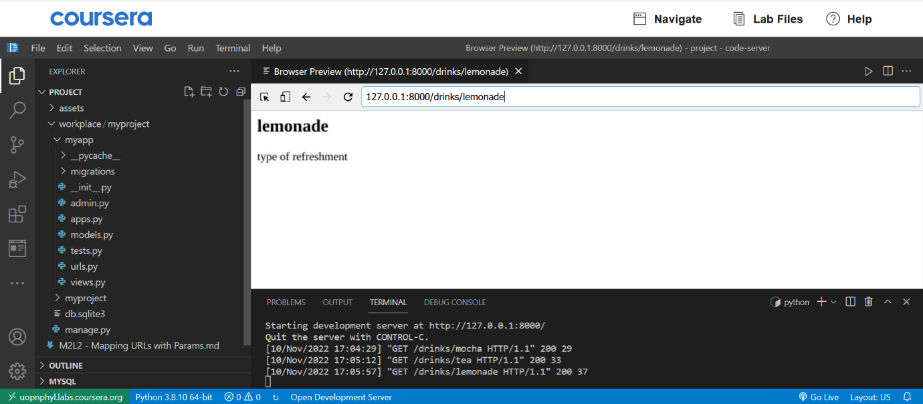

**Additional step:**

* Create a new key-value pair of your choice inside the dictionary
* Run the server again
* Go to the URL with the new value and check the result

**Concluding thoughts**

In this lab, you practiced defining dynamic URL paths using path converters to capture a value from the URL, using angle brackets. You also practiced capturing URL paths and printing paths as headings on the webpage.

# Solution: Mapping URLs with Params

Here is the completed solution code for the **urls.py - App-level** file:

from django.urls import path

from . import views

urlpatterns = [

    path('drinks/<str:drink\_name>', views.drinks, name="drink\_name"),

]

views.py

from http.client import HTTPResponse

from django.shortcuts import render

from django.http import HttpResponse

# Create your views here.

def drinks(request, drink\_name):

    drink = {

        'mocha' : 'type of coffee',

        'tea' : 'type of hot beverage',

        'lemonade': 'type of refreshment'

    }

    choice\_of\_drink = drink[drink\_name]

    return HttpResponse(f"<h2>{drink\_name}</h2> " + choice\_of\_drink)

# Additional resources

Click the links below to learn more about developing in Django.

[Creating views– official documentation](https://docs.djangoproject.com/en/4.1/topics/http/views/)

[Class-based views – Official](https://docs.djangoproject.com/en/4.1/topics/class-based-views/)

[The render() function in Django](https://docs.djangoproject.com/en/4.1/topics/http/shortcuts/#render)

[Getting query parameters from a request in Django](https://docs.djangoproject.com/en/4.1/topics/http/urls/#path-converters)

[The HTTP server responses](https://developer.mozilla.org/en-US/docs/Web/HTTP/Status)

# V8.1

# URL Namespacing and Views

This reading explains the use of named URLs in the **URLconf** of a Django app and how the use of a namespace helps in resolving the same URL name in more than one app.

In each app, there is a **urls.py** file that defines the list of URL patterns for that app. Each pattern is constructed by **django.urls.path()** function. Its arguments are a URL path string, the name of the view function to be mapped to it and an optional argument name.

The following is the **urls.py** of an app:

#demoapp/urls.py

from django.urls import path

from . import views

  urlpatterns = [

    path('', views.index, name='index'),

    path('login/', views.login, name='login')

]

It is included in the project’s **urlpatterns**.

from django.contrib import admin

from django.urls import path, include

  urlpatterns = [

    path('admin/', admin.site.urls),

    path('demo/', include('demoapp.urls')),

]

Normally, the client’s request URL is mapped against the function so that the application flow is directed toward it.

The URL references used internally by the application are hard-coded strings.

For example, a form template’s action attribute points towards **/demoapp/login** URL so that when the form is submitted, the login view mapped to this URL is invoked.

<form action='/demoapp/login', method='POST>

    # ...

</form>

## reverse() function

However, the hard-coded URLs make the application less scalable and difficult to maintain as the project grows. In such a case, you can obtain the URL from the name parameter used in the **path()** function.

Start the Django shell.

python manage.py shell

Django’s **reverse()** function returns the URL path to which it is mapped.

>>> from django.urls import reverse

>>> reverse('index')

'/demo/'

The problem comes when the view function of the same name is defined in more than one app. This is where the idea of a **namespace** is needed.

## Application namespace

The application namespace is created by defining **app\_name** variable in the application’s **urls.py** and assigning it the name of the app. In the **demoapp/urls.py** script, make the change using the following code:

#demoapp/urls.py

from django.urls import path

from . import views

app\_name='demoapp'

urlpatterns = [

    path('', views.index, name='index'),

]

The **app\_name** defines the application namespace so that the views in this app are identified by it.

To obtain the URL path of the **index()** function, call the **reverse()** function by prepending the namespace to it.

>>> reverse('demoapp:index')

'/demo/'

To appreciate the advantage of defining a namespace, add another app in the project, for example, **newapp**. Provide an **index()** view function in it and define **app\_name** in its **URLConf** file (that is **urls.py**).

#newapp/urls.py

from django.urls import path

from . import views

app\_name='newapp'

urlpatterns = [

    path('', views.index, name='index'),

]

Update the project’s **urls.py**.

from django.contrib import admin

from django.urls import path, include

urlpatterns = [

    path('admin/', admin.site.urls),

    path('demo/', include('demoapp.urls')),

    path('newdemo/', include('newapp.urls')),

]

The **reverse()** function is executed for index view in **newapp** namespace.

>>> reverse('newapp:index')

'/newdemo/'

You can see that Django differentiates between same-named URLs in multiple apps with application namespace.

## Instance namespace

You can also use the namespace parameter in the **include()** function while adding an app’s **urlpattern** to that of a project.

#in demoproject/urls.py

urlpatterns=[

    # ...

    path('demo/', include('demoapp.urls', namespace='demoapp')),

    # ...

]

This namespace is called the **instance namespace**.

## Using namespace in view

Suppose you want the user to be conditionally redirected to the login view from inside another view. You need to obtain the URL of the login view and send the control to it with **HttpResponsePermanentRedirect**.

from django.http import HttpResponsePermanentRedirect

from django.urls import reverse

def myview(request):

    ....

    return HttpResponsePermanentRedirect(reverse('demoapp:login'))

## namespace in the url tag

An HTML form is submitted to the URL specified in the action attribute.

<form action="/demoapp/login" method="post">

#form attributes

<input type='submit'>

</form>

The form will then be processed by the view mapped to this URL. However, as mentioned above, a hard-coded URL is not desired. Instead, use the **url** tag of the Django Template Language. It returns the absolute path from the named URL.

Use the **url** tag to obtain the URL path dynamically, as shown below:

<form action="{% url 'login' %}" method="post">

#form attributes

<input type='submit'>

</form>

Again, the login view may be present in multiple apps. Use the named URL qualified with the namespace to resolve the conflict.

<form action="{% url 'demoapp:login' %}" method="post">

#form attributes

<input type='submit'>

</form>

The browser shows the login form as below:

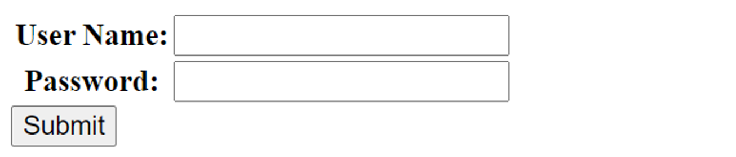

Thus, the concept of namespace helps in resolving the conflict arising out of multiple apps under the same project having views of the same name.

You have covered some of the concepts here in line with the use of form templates in Django. If you have difficulty understanding some things, be assured it will be much more clear once you cover the topic of templates in this course.

In this reading, you further explored the concept of URL Namespacing and Views in Django.

**Exercise: Creating URLs and Mapping to Views**

Open Lab

**Instructions**

**Goal**

* To create more than one view, add their respective URL configurations and display contents on a webpage.

**Objectives**

* Add URL configurations at the app level for multiple views
* Learn how to create multiple views inside the **views.py**

**Introduction**

In this lab, you will learn how to create multiple views and map their respective URLs for the Little Lemon website consisting of four pages.

You will create four view functions to represent the pages Home, About, Menu and Booking. You will define four unique URLs and map each to its associated view function in the **urls.py** file of the app.

**Scenario**

You are assigned the task of creating four views for the Little Lemon website that Adrian, owner of Little Lemon, wants to create.

These views will be visible on four different URL paths in the browser.

To preview the web pages, you will need to start the development server and navigate to the suggested URL to confirm the expected view is visible in the browser.

This lab will require you to modify the following files:

* **views.py**
* **urls.py** (app-level)

Additionally, you are required to use the command line console inside the terminal of VS Code.

If not open already, go to **Terminal** on the Menu bar at the top of your screen and select **New Terminal**.

You have already built the project named  **myproject**  and added an app inside the project called **myapp**.

Follow the instructions below and ensure you check the output at every step and update the necessary files to create different views.

**Steps**

**Note:** The lab files in some cases may appear similar to an earlier lab. They may have the same starting point for the respective lab files from the earlier lab.

**Step 1:**  The project and app are already in place. The **settings.py** and project-level **urls.py** file has configurations updated for the project.

Ensure the current working directory is **workplace** and run the change directory command inside the command prompt to go inside the project directory by typing the following command:

cd myproject

**Tip:** you can check this was successful if the console prompt has a suffix **myproject**.

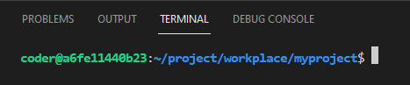

**Step 2:**  Inside the left explorer panel in VS Code, expand the **myapp** directory and open the file called **views.py**.

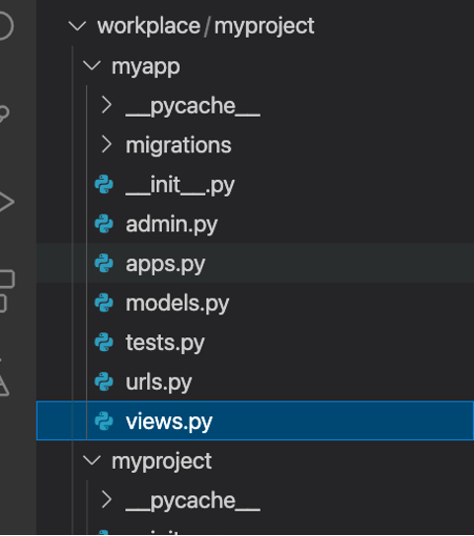

**Note:** You can also expand the **myproject** directory and have an overview of the files present inside the project.

**Step 3:**  Inside the **views.py** file, define a function called **home()** and pass the **request** object to it.

**Tip:** Make sure you have imported **HttpResponse** from **django.http** .

**Step 4:**  Inside the function body, use the return statement to return an **HttpResponse()** object and pass the following string to it:

**Welcome to Little Lemon!**

**Step 5:**  Similar to steps 3 and 4, create three more views with the function names and strings as follows:

| **Function name** | **String output** |
| --- | --- |
| about | About us |
| menu | Menu |
| book | Make a booking |

**Step 6:**  Create a file inside the **myapp** directory called **urls.py**. Add the following code inside it:

urlpatterns = [

        path('', views.home, name="home"),

]

The **urlpatterns** now has one path function that has an empty string and relative path for the **home()** view function inside the **views.py** file.

**Step 7:**  Now, add three more path functions inside the **urlpatterns** list. Each function must contain a URL string and the relative path for the associated view function. The string value associated with the path passed inside the path function must be the same as names given to the view functions such as: **'about/'**

**Tip:** Ensure you add a comma (**,**) after every path function added inside the **urlpatterns** list sequence.

**Step 8:**  Inside the **urls.py** file, make sure you have imported the functions: **path()**, from the **django.urls** package.

**Tip:** Also make sure you have imported the required views.

**Step 9:**  Go back to the console in the terminal and run the command to start the development server:

python manage.py runserver

**Step 10:**  The command prompt will generate some text including a link for the localhost URL such as **http://127.0.0.1:8000/**.

Click on the **Browser Preview** option among the left-hand menu options inside VSCode. Now copy the URL **http://127.0.0.1:8000/** that is generated and paste it inside the **Browser Window** that has opened inside the VSCode.

**Step 11:**  Inside the browser go to the paths below and ensure you get the expected output:

**http://127.0.0.1:8000/**

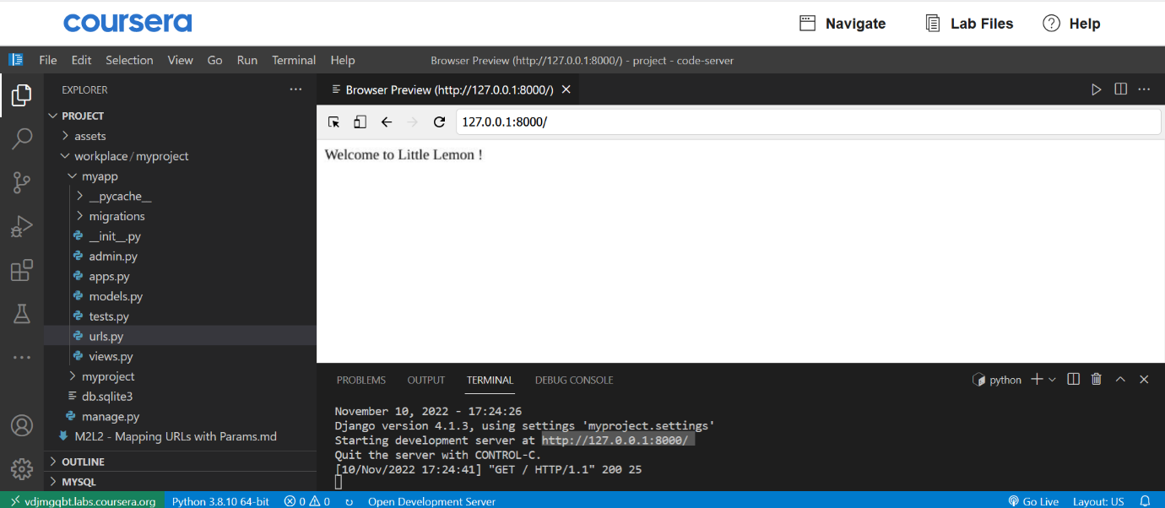

**http://127.0.0.1:8000/about/**

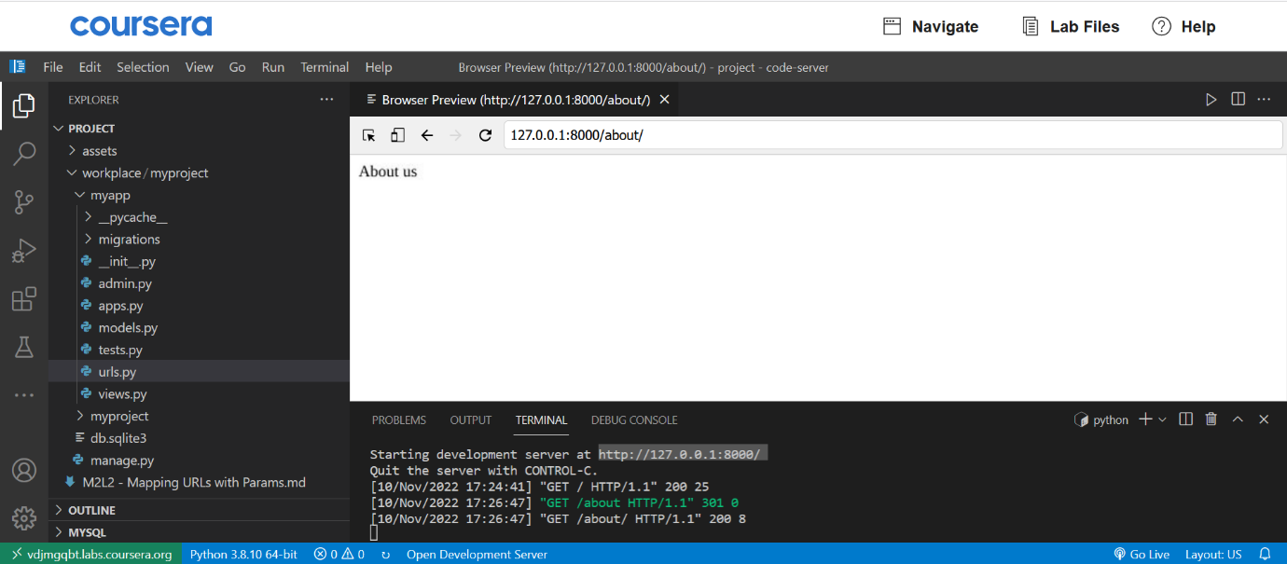

**http://127.0.0.1:8000/menu/**

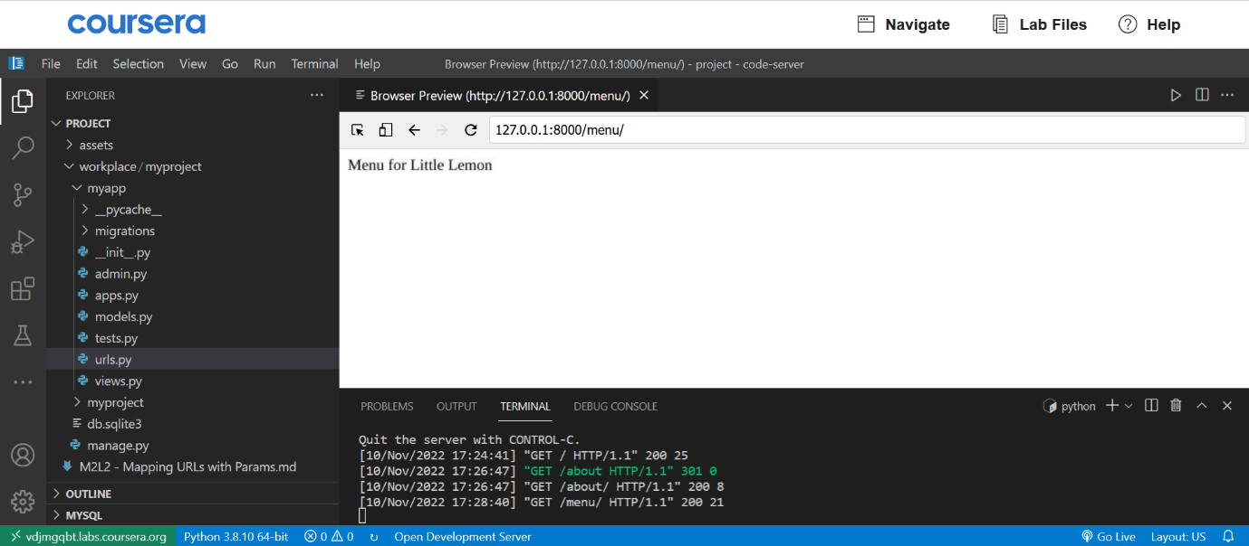

**http://127.0.0.1:8000/book/**

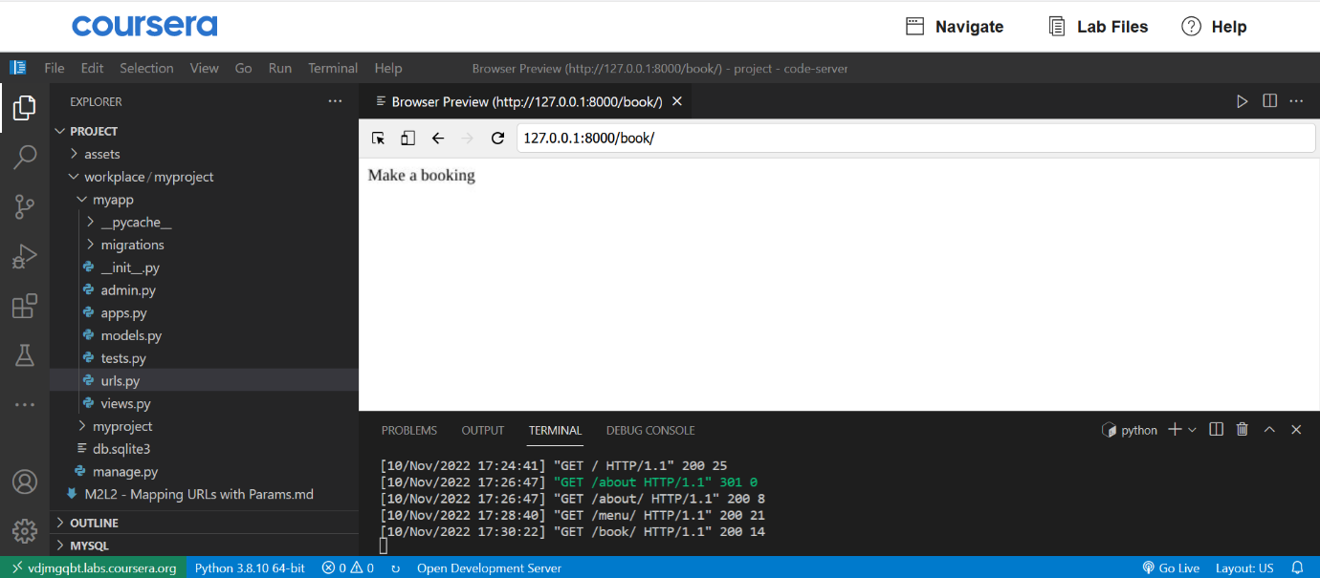

**Note:** Setting the same string values to define the URL path and the view is a good practice, not a rule. For example, for the about view, you could set the URL path to **aboutus/** instead of **about**.

**Additional step:**

Change the URL path string for the about view inside **urls.py** from **'about/'** to **'aboutus/'** and run the server again.

Go to the URL **http://127.0.0.1:8000/aboutus** and check if the About page renders at this URL.

Additionally, ensure that the about page will not render on the URL **http://127.0.0.1:8000/about**.

**Concluding thoughts**

In this lab, you practiced creating multiple views and mapping their respective URLs for the Little Lemon website containing four pages.

# Solution: Creating URLs and Mapping to Views

Here is the solution code for the **urls.py - App-level** file:

from django.urls import path, include

from . import views

urlpatterns = [

        path('', views.home, name="home"),

        path('menu/', views.menu, name="menu"),

        path('about/', views.about, name="about"),

        path('book/', views.book, name="book"),

]

Here is the solution code for the views.py file.

from django.shortcuts import render

from django.http import HttpResponse

# Create your views here.

def home(request):

    return HttpResponse("Welcome to Little Lemon !")

def about(request):

    return HttpResponse("About us")

def menu(request):

    return HttpResponse("Menu for Little Lemon")

def book(request):

    return HttpResponse("Make a booking")

# v9.1

# Handling Errors in Views

In a Django application, a view function is where all the processing is done.

It receives the request and formulates the response.

In this Reading, you’ll learn how Django handles runtime errors or exceptions.

The response from the view is an object of **HttpResponse**. Its contents are also associated with a respective status code.

For example, status code **404** implies that the resource requested by the client cannot be found. Django has a generic **HttpResponseNotFound** class. You can return its object to convey the appropriate message.

from django.http import HttpResponse, HttpResponseNotFound

def my\_view(request):

    # ...

    if condition==True:

        return HttpResponseNotFound('<h1>Page not found</h1>')

    else:

        return HttpResponse('<h1>Page was found</h1>')

You can also return a **HttpResponse** with the status code denoting the type of error.

from django.http import HttpResponse

def my\_view(request):

    # ...

    if condition==True:

        return HttpResponse('<h1>Page not found</h1>', status\_code='404')

    else:

        return HttpResponse('<h1>Page was found</h1>')

The main difference in using **HttpResponseNotFound** as opposed to **HttpResponse** that must be understood is that Django internally sends an error code **404.** The appropriate page for 404 can then be configured and rendered, else the browser displays its default **404** view.

A common cause of the **404** status code is the user entering an incorrect URL.

Django makes it easy to work with this error code.

Put a string argument inside the **HttpResponseNotFound()** to view the error message. Instead, raise **Http404**. Django displays a standard error page with the status.

(Instead, raise **Http404** exception).

Consider the following scenario, where you have a **Product** model in the app.

The user wants the details of a product with a specific Product ID.

In the following view function, **id** is the parameter obtained from the URL.

It tries to determine whether any product with the given id is available. If not, the **Http404** exception is raised.

from django.http import Http404, HttpResponse

from .models import Product

def detail(request, id):

    try:

        p = Product.objects.get(pk=id)

    except Product.DoesNotExist:

        raise Http404("Product does not exist")

    return HttpResponse("Product Found")

Just like the HttpResponseNotFound, there are a number of other predefined classes such as **HttpResponseBadRequest**, **HttpResponseForbidden** and so on.

**Custom error pages**

If you want to show your own error page whenever the user encounters a **404** error, you must create a **404.html** page and put it in the project/templates folder.

You will learn more about how to do this later when you explore templates.

**Displaying error messages in the browser**

Usually, the Django development server is in **DEBUG** mode, which shows the error's traceback instead of the exception.

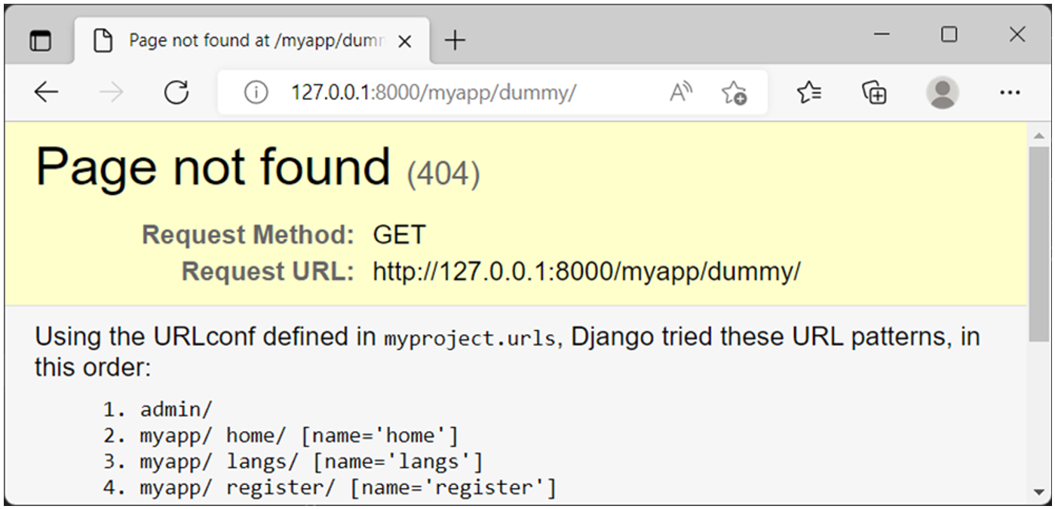

To render the custom exception message, the DEBUG variable in the project’s settings should be set to False.

#settings.py

# SECURITY WARNING: don't run with debug turned on in production!

DEBUG=FALSE

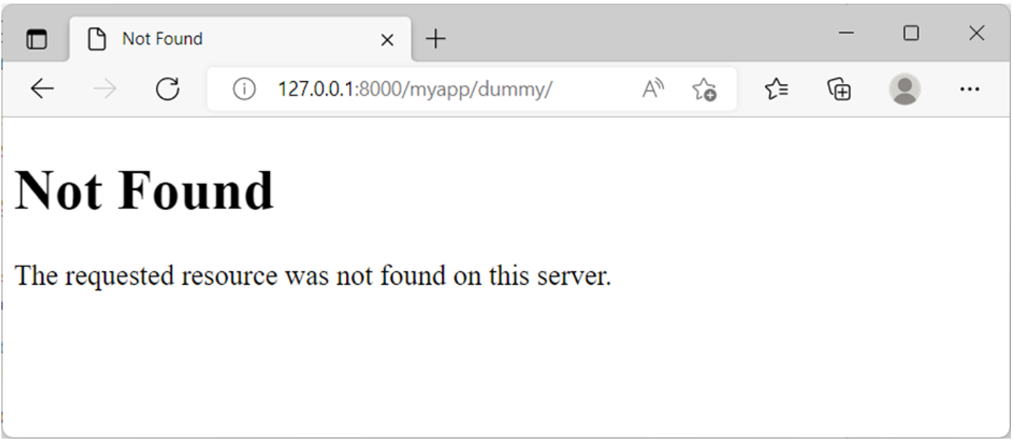

**Exception classes**

Django’s exception classes are defined in the **django.core.exceptions** module.

Some important exception types are:

* **ObjectDoesNotExist**: All the exceptions of the **DoesNotExist** are inherited from this base exception.
* **EmptyResultSet**: This exception is raised if a query does not return any result.
* **FieldDoesNotExist**: This exception is raised when the requested field does not exist.

try:

    field = model.\_meta.get\_field(field\_name)

except FieldDoesNotExist:

    return HttpResponse("Field Does not exist")

* **MultipleObjectsReturned**: When you expect a certain query to return only a single object, however multiple objects are returned. This is when you need to raise this exception.
* **PermissionDenied**: This exception is raised when a user does not have permission to perform the action requested.

def myview(request):

    if not request.user.has\_perm('myapp.view\_mymodel'):

        raise PermissionDenied()

    return HttpResponse()

* **ViewDoesNotExist**: This exception is raised by **django.urls** when a requested view does not exist, possibly because of incorrect mapping defined in the **URLconf**.

When a certain view is called with a **POST** or **PUT** request, the request body is populated by the form data.

Django’s Form API defines various fields specific to the type of data stored. For example, you have **EmailField**, **FileField**, **IntegerField**, **MultipleChoiceField**.

These fields have built-in validators. The **is\_valid()** method returns **True** if the validations are passed. You can raise an exception if it returns False.

def myview(request):

    if request.method == "POST":

        form = MyForm(request.POST)

        if form.is\_valid():

            #process the form data

        else:

                return HttpResponse("Form submitted with invalid data")

In addition to the exceptions defined in the core module, you can process the standard Python exceptions and the database-related exceptions.

In this reading, you learned how to handle errors inside the Django view.

# Additional resources

Here is a list of additional resources that may be helpful as you continue your learning journey.

[The django.urls functions for use in URLconfs - official documentation](https://docs.djangoproject.com/en/4.1/ref/urls/)

[URL dispatcher](https://docs.djangoproject.com/en/4.1/topics/http/urls/#url-dispatcher)

[URLs - Official](https://docs.djangoproject.com/en/4.1/topics/http/urls/#how-django-processes-a-request)

[Regular Expressions](https://docs.djangoproject.com/en/4.1/topics/http/urls/#using-regular-expressions)

[Django URL mapping](https://docs.djangoproject.com/en/4.1/topics/http/views/#mapping-urls-to-views)

[Get URL parameters in Django](https://docs.djangoproject.com/en/4.1/topics/http/urls/#how-django-processes-a-request)

[Render HTML Forms – GET and POST in Django](https://docs.djangoproject.com/en/4.1/topics/forms/)

[HTTP Request Response object](https://docs.djangoproject.com/en/4.1/ref/request-response/)

# V1.1 Mod3

# Model relationships

In this reading, you will explore the different types of relationships between Django models.

## Primary key

In a relational database, each table that represents an entity has one column that has a unique value for each row. Such a column or field is known as the **Primary Key**.

If the primary key of one table appears as one of the fields in another table while having its own primary key, then it is called a **Foreign Key**.

For example, in a Products table, the **ProductID** field is its primary key.

In the Customers’ table, the **ProductID** field, which refers to the product purchased by the customer, becomes the foreign key.

The idea behind designing related tables is to avoid **data redundancy** unnecessary repetition of the same data in many rows and ensure **data integrity.**

If the unique **ProductID** in the Customers’ table is replaced by a longer naming convention for the product field, it will have to be entered every time a customer buys the product. This can lead to typing errors.

Similarly, if a product's ID is referred to in the Customers' table and is removed, other product details, such as price, will not be available.

Relational databases have a mechanism to prevent the deletion of the primary key if it is being used in the related table so that the data integrity is intact.

Since the Django models are mapped to the corresponding tables in the database, you can define a relationship such as this between the two model fields.

## Types of Relationships

There are three types of relationships that exist:

* One-to-One,
* One-to-Many, and
* Many-to-Many.

Let’s explore these by beginning with a One-to-One relationship.

## One-to-One relationship

If a primary key is in one model, and only one record exists in the other related model, the two models are said to have a one-to-one relationship.

Let's use an example of a college model and a principal model. A college can have only one principal or it can be similarly phrased as one person can be a principal of only one college.

The college model can be described as follows:

class college(Model):

    CollegeID = models.IntegerField(primary\_key = True)

    name = models.CharField(max\_length=50)

    strength = models.IntegerField()

    website=models.URLField()

In the principal model, you must provide the **CollegeID** field as the foreign key. The **on\_delete** option specifies the behavior in case the associated object in the primary model is deleted. The values are:

* **CASCADE:** deletes the object containing the **ForeignKey**
* **PROTECT:** Prevent deletion of the referenced object.
* **RESTRICT:** Prevent deletion of the referenced object by raising **RestrictedError**

The principal model has the following field structure:

class Principal(models.Model):

    CollegeID = models.OneToOneField(

                College,

                on\_delete=models.CASCADE

                )

    Qualification = models.CharField(max\_length=50)

    email = models.EmailField(max\_length=50)

When you run a migration on these models, respective tables are created with equivalent SQL queries:

CREATE TABLE "myapp\_college" ("CollegeID" integer NOT NULL PRIMARY KEY, "name" varchar(50) NOT NULL, "strength" integer NOT NULL, "website" varchar(200) NOT NULL);

CREATE TABLE "myapp\_principal" ("id" integer NOT NULL PRIMARY KEY AUTOINCREMENT, "Qualification" varchar(50) NOT NULL, "email" varchar(50) NOT NULL, "CollegeID\_id" integer NOT NULL UNIQUE REFERENCES "myapp\_college" ("CollegeID") DEFERRABLE INITIALLY DEFERRED);

## ****One-to-Many Relationship****

In a One-to-Many relationship, one object of a model can be associated with one or more objects of another model. For example, a teacher is qualified to teach a subject, but there can be more than one teacher in a college who teaches the same subject.

The subject model is as below:

class Subject(models.Model):

    Subjectcode = models.IntegerField(primary\_key = True)

    name = models.CharField(max\_length=30)

    credits = model.IntegerField()

The teacher model has its own primary key. It has a **Foreignkey** relating this model with the subject model.

class Teacher(models.Model):

    TeacherID = models.ItegerField(primary\_key=True)

    subjectcode=models.ForeignKey(

                Subject,

                on\_delete=models.CASCADE

                  )

    Qualification = models.CharField(max\_length=50)

    email = models.EmailField(max\_length=50)

The following SQL queries will be executed when you run the migration:

CREATE TABLE "myapp\_subject" ("Subjectcode" integer NOT NULL PRIMARY KEY, "name" varchar(30) NOT NULL, "credits" integer NOT NULL, "Qualification" varchar(50) NOT NULL, "email" varchar(50) NOT NULL);

CREATE TABLE "myapp\_teacher" ("TeacherID" integer NOT NULL PRIMARY KEY, "Qualification" varchar(50) NOT NULL, "email" varchar(50) NOT NULL, "subjectcode\_id" integer NOT NULL REFERENCES "myapp\_subject" ("Subjectcode") DEFERRABLE INITIALLY DEFERRED);

CREATE INDEX "myapp\_teacher\_subjectcode\_id\_bef86dea" ON "myapp\_teacher" ("subjectcode\_id");

## Many-to-Many Relationship

In a Many-to-Many relationship, multiple objects of one model can be associated with multiple objects of another model.

Let's redefine the relationship between the subject and teacher models in the above example. If more than one teacher can teach the same subject, a single teacher can teach more than one subject. So, there is a Many-to-Many relationship between the two. Django implements this with a Many-to-Many Field type. Let’s use it in the subject model.

The teacher model is straightforward.

class Teacher(models.Model):

    TeacherID = models.ItegerField(primary\_key=True)

    Qualification = models.CharField(max\_length=50)

    email = models.EmailField(max\_length=50)

The design of the Subject model class reflects the Many-to-Many relationship.

class Subject(models.Model):

    Subjectcode = models.IntegerField(primary\_key = True)

    name = models.CharField(max\_length=30)

    credits = model.IntegerField()

    teacher = model.ManyToManyField(Teacher)

When the migrations are done, the following SQL queries will be executed to establish a many-to-many relationship.

CREATE TABLE "myapp\_teacher" ("TeacherID" integer NOT NULL PRIMARY KEY, "Qualification" varchar(50) NOT NULL, "email" varchar(50) NOT NULL);

CREATE TABLE "myapp\_teacher" ("TeacherID" integer NOT NULL PRIMARY KEY, "Qualification" varchar(50) NOT NULL, "email" varchar(50) NOT NULL);

CREATE TABLE "myapp\_subject" ("Subjectcode" integer NOT NULL PRIMARY KEY, "name" varchar(30) NOT NULL, "credits" integer NOT NULL);

CREATE TABLE "myapp\_subject\_teacher" ("id" integer NOT NULL PRIMARY KEY AUTOINCREMENT, "subject\_id" integer NOT NULL REFERENCES "myapp\_subject" ("Subjectcode") DEFERRABLE INITIALLY DEFERRED, "teacher\_id" integer NOT NULL REFERENCES "myapp\_teacher" ("TeacherID") DEFERRABLE INITIALLY DEFERRED);

CREATE UNIQUE INDEX "myapp\_subject\_teacher\_subject\_id\_teacher\_id\_9b6a3c00\_uniq" ON "myapp\_subject\_teacher" ("subject\_id", "teacher\_id");

CREATE INDEX "myapp\_subject\_teacher\_subject\_id\_e87c76e7" ON "myapp\_subject\_teacher" ("subject\_id");

CREATE INDEX "myapp\_subject\_teacher\_teacher\_id\_359f8cce" ON "myapp\_subject\_teacher" ("teacher\_id");

In this reading, you learned about the various types of relationships between models and how Django handles them.

# V3.1

# How to use migrations

Django translates the models into respective database tables in the backend database with a mechanism known as migration. It also propagates any changes in the model structure such as adding, modifying or removing a field attribute of a model class to the mapped table.

Django’s migration system has the following commands:

* **makemigrations**
* **migrate**
* **sqlmigrate**
* **showmigrations**

Django’s migration is a version control system. Whenever you add a new model or effect changes in an existing model, you need to run the **makemigrations** command. It creates a script for making changes in the mapped table. Every time you run the **makemigrations** command and Django detects the changes, a script with its name and version number is created. To implement the changes according to the migration script, you need to run the **migrate** command.

## Migrating Models of INSTALLED APPS

When you create a Django project with the **startproject**command, certain apps are installed by default. These apps are listed in the **INSTALLED\_APPS** section in the project’s **settings.py** file.

INSTALLED\_APPS = [

    'django.contrib.admin',

    'django.contrib.auth',

    'django.contrib.contenttypes',

    'django.contrib.sessions',

    'django.contrib.messages',

    'django.contrib.staticfiles',

]

Data needs to be stored via these apps for their functionality to work. For example, the **auth** package controls the users, groups, and permissions, so there must be corresponding tables created in the database. Django uses the SQLite database by default. For that purpose, you run the **migrate** command.

python manage.py migrate

Then, the tables required by the **INSTALLED\_APPS** are created.

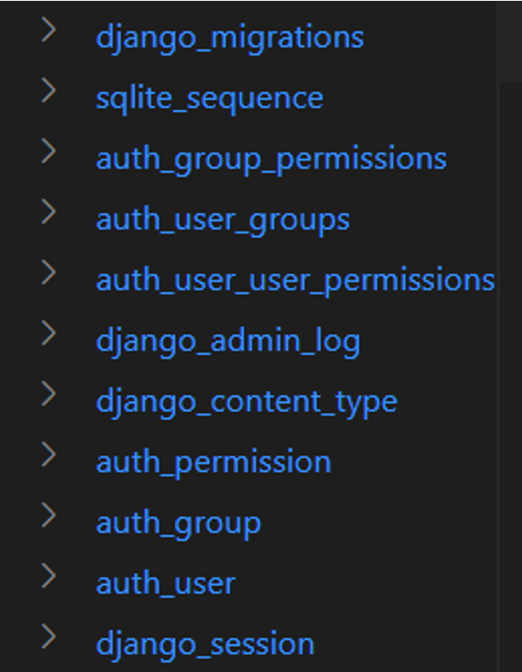

Let’s create an app inside our Django project.

(django) C:\django\myproject> python manage.py startapp myapp

This creates a **myapp** package folder inside the outer **myproject** folder. Inside **myapp**, a **migrations** package is also created, which is empty to begin with.

## Using the makemigrations command

Open the **models.py** file and add a person model to it.

from django.db import models

class Person(models.Model):

    name = models.CharField(max\_length=20)

    email = models.EmailField()

    phone = models.CharField(max\_length=20)

The first step towards creating the Person table in the database is to run the **makemigrations** command.

django) C:\django\myproject>python manage.py makemigrations

Migrations for 'myapp':

  myapp\migrations\0001\_initial.py

    - Create model Person

Notice that in the **migrations** package, a migration script **0001\_initial.py**, is created. It indicates what the script intends to do, which is: **Create model Person**.

If you open the **migration** file, you’ll find a migration class in it.

from django.db import migrations, models

class Migration(migrations.Migration):

    initial = True

    dependencies = [

    ]

    operations = [

        migrations.CreateModel(

            name='Person',

            fields=[

                ('id', models.BigAutoField(auto\_created=True, primary\_key=True, serialize=False, verbose\_name='ID')),

                ('name', models.CharField(max\_length=20)),

                ('email', models.EmailField(max\_length=254)),

                ('phone', models.CharField(max\_length=20)),

            ],

        ),

    ]

As mentioned above, you need to run the **migrate** command to apply the tasks in the **migrations** file to be performed.

(django) C:\django\myproject>python manage.py migrate

Operations to perform:

  Apply all migrations: admin, auth, contenttypes, myapp, sessions

Running migrations:

  Applying myapp.0001\_initial... OK

Have a look at the tables in your database **db.sqlite3**. The person table with three fields can be seen in it.

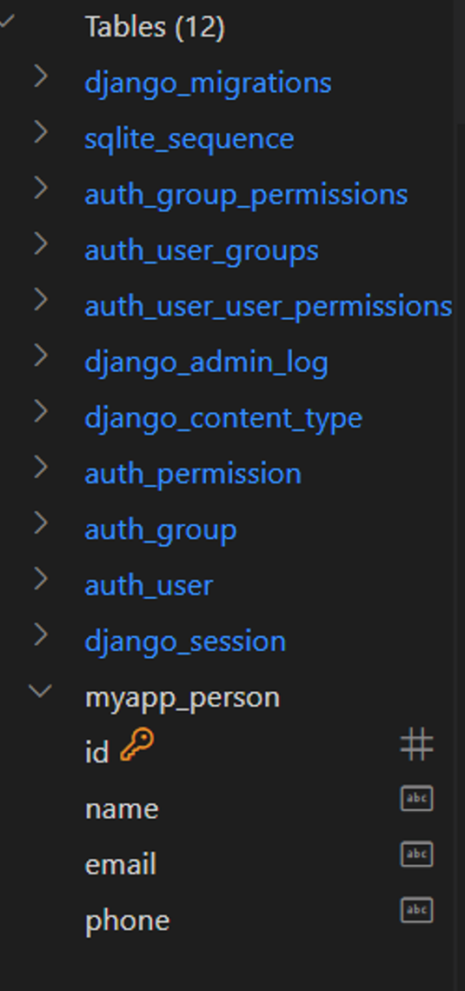

**Version control**

Now, let's modify the person model class by changing the **name**field to **Person\_name** and running **makemigrations** again.

(django) C:\django\myproject>python manage.py makemigrations

Was person.name renamed to person.person\_name (a CharField)? [y/N] y

Migrations for 'myapp':

  myapp\migrations\0002\_rename\_name\_person\_person\_name.py

    - Rename field name on person to person\_name

A second migration script is created in the **migrations** folder. Before finalizing the change, add a new field – age – in the person model and run **makemigrations** again.

(django) C:\django\myproject>python manage.py makemigrations

Migrations for 'myapp':

  myapp\migrations\0003\_person\_age.py

    - Add field age to person

## Showmigrations command

Now there are two unmigrated changes in the model. Run the **showmigrations** command:

(django) C:\django\myproject>python manage.py showmigrations

. . .

. . .

myapp

[X] 0001\_initial

[ ] 0002\_rename\_name\_person\_person\_name

[ ] 0003\_person\_age

. . .

The initial migration (file numbered **0001**) has already migrated. The X mark is indicative of this. However, the next two migrations don’t show the X mark, which means they are pending. If we run the **migrate** command, both modifications will be reflected in the table structure.

(django) C:\django\myproject>python manage.py migrate

Operations to perform:

  Apply all migrations: admin, auth, contenttypes, myapp, sessions

Running migrations:

  Applying myapp.0002\_rename\_name\_person\_person\_name... OK

  Applying myapp.0003\_person\_age... OK

As mentioned earlier, Django’s migration mechanism provides efficient version control. You may want to fall back upon the table structure before adding the **age** field. Run the **migrate** command and specify which migration file to be used so that the migrations after it will be undone or unapplied.

(django) C:\django\myproject>python manage.py migrate myapp 0002\_rename\_name\_person\_person\_name

Operations to perform:

  Target specific migration: 0002\_rename\_name\_person\_person\_name, from myapp

Running migrations:

  Rendering model states... DONE

  Unapplying myapp.0003\_person\_age... OK

## sqlmigrate Command

Lastly, the **sqlmigrate**command shows the SQL query or queries executed when a certain migration script is run. For example, the first migration over the **myapp’s** person model is intended to create the person table. The **sqlmigrate**command for this script shows the **CREATE TABLE** statement for this purpose.

(django) C:\django\myproject>python manage.py sqlmigrate myapp 0001\_initial

BEGIN;

--

-- Create model Person

--

CREATE TABLE "myapp\_person" ("id" integer NOT NULL PRIMARY KEY AUTOINCREMENT, "name" varchar(20) NOT NULL, "email" varchar(254) NOT NULL, "phone" varchar(20) NOT NULL);

COMMIT;

In this reading, you learned about when to use migrations, best practices and that the migration system in Django manages data creation and modification very effectively and efficiently.

**Exercise: Models and migrations**

Open Lab

**Instructions**

**Goal**

To create a model, learn to perform migrations and track changes in the model.

**Objectives**

* The learner will create a model called Drinks
* The learner will perform the steps required to apply migrations

**Introduction**

By now you have learned how to work with the view part of the Model View Template (MVT) pattern.

You can create view functions and map them to URLs.

The labs in this model will focus on the model part of the MVT pattern and in this lab, you will create and migrate a model called **Drinks**.

**Scenario**

The Little Lemon prototype web application is progressing well. Now that you have view function mapped to URLs, it's time to work with the data model.

You are assigned the task of creating a model that will be used as a database for storing the different menu items that are to be displayed on the Little Lemon website. In this scenario, you will design a model for a drinks menu that will list the beverages available at Little Lemon.

**Learner Instructions**

This lab will require you to modify the following files:

* **models.py**
* **admin.py**

Additionally, you are required to use the command line console inside the terminal of VS Code.

If not open already, go to **Terminal** on the Menu bar at the top of your screen and select **New Terminal**.

You have already built the project named **myproject** and added an app inside the project called **myapp**.

Follow the instructions below and ensure you check the output at every step and update the necessary files to create different views.

**Steps**

**Step 1:**  Expand the **myapp** folder in the left explorer panel and open the **models.py** file.

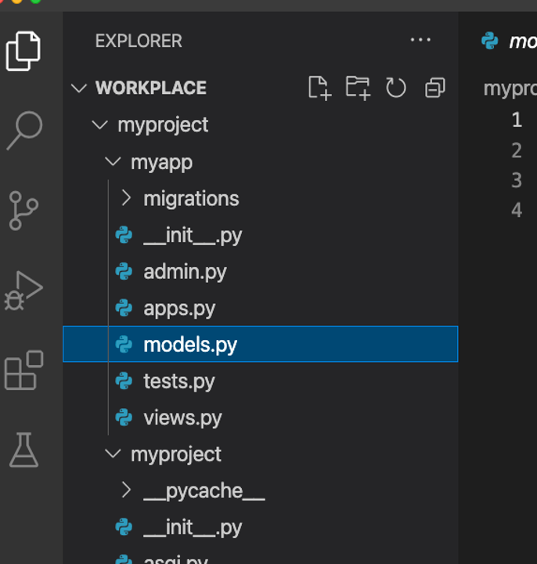

**Step 2:**  Create a class called **Drinks** and pass **models.Model** to it as an argument.

**Step 3:**  Inside the **Drinks** class, create the two attributes that you will require in the model and assign the respective form fields to them.

Additionally, pass the following specified arguments to those form fields:

| **Attribute** | **Form field type** | **Arguments passed** |
| --- | --- | --- |
| drink | **CharField** | max\_length = 200 |
| price | **IntegerField** |  |

**Tip:** Remember that the form fields are present inside the **models** module imported by default.

**Step 4:**  Open the **admin.py** file and register the Model that you created by passing the model name to the function **admin.site.register()**.

**Tip:** Make sure you have imported the **Drinks** model from the **models.py** file.

**Step 5:**  Make sure you are inside the **myproject** directory and run the development server.

**Note:** This generates the **db.sqlite3** database and is used by default in Django.

**Step 6:**  While you're still in the terminal, run the command to make migrations.

**Tip:** The output must look similar to:

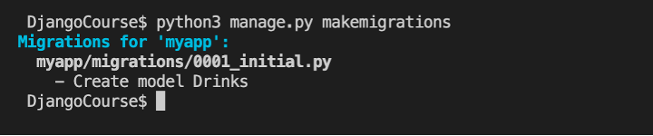

**Step 7:**  Run the command to perform the migration.

**Tip:** Check the information displayed in the command line to make sure that the migrations ran successfully without error. It should look something like the image below:

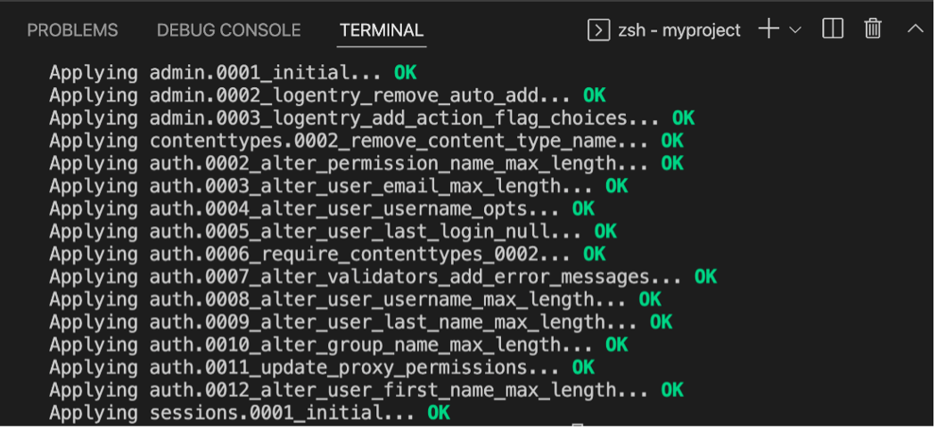

**Step 8:**  Once you are sure that the migrations ran successfully, return to the **models.py** file and modify the attribute name from **drink** to **drink\_name**. Save the **models.py** file.

**Step 9:**  Run both the commands required to perform migrations one more time.

**Note:** A confirmation prompt will appear to confirm the changes. Type **y** to confirm the changes.

**Step 10:**  In the left explorer panel in VS Code, search for the **migrations** folder inside the **myapp** directory. Expand the folder and locate the files **0001\_initial.py** and **0002\_rename...py**. Open the files and explore their contents.

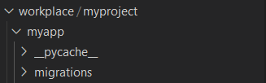

Notice that these files contain a list of operations and dependencies specific to the migration performed.

# Generated by Django 4.1.3 on 2022-11-06 22:32

from django.db import migrations

class Migration(migrations.Migration):

    dependencies = [

        ('myapp', '0001\_initial'),

    ]

    operations = [

        migrations.RenameField(

            model\_name='drinks',

            old\_name='drink',

            new\_name='drink\_name',

        ),

    ]

**Step 11:**  Run the command to show the migration changes. The output should look similar to the following:

admin

 [X] 0001\_initial

 [X] 0002\_logentry\_remove\_auto\_add

 [X] 0003\_logentry\_add\_action\_flag\_choices

auth

 [X] 0001\_initial

 [X] 0002\_alter\_permission\_name\_max\_length

 [X] 0003\_alter\_user\_email\_max\_length

 [X] 0004\_alter\_user\_username\_opts

 [X] 0005\_alter\_user\_last\_login\_null

 [X] 0006\_require\_contenttypes\_0002

 [X] 0007\_alter\_validators\_add\_error\_messages

 [X] 0008\_alter\_user\_username\_max\_length

 [X] 0009\_alter\_user\_last\_name\_max\_length

 [X] 0010\_alter\_group\_name\_max\_length

 [X] 0011\_update\_proxy\_permissions

 [X] 0012\_alter\_user\_first\_name\_max\_length

contenttypes

 [X] 0001\_initial

 [X] 0002\_remove\_content\_type\_name

myapp

 [X] 0001\_initial

 [X] 0002\_rename\_drink\_drinks\_drink\_name

sessions

 [X] 0001\_initial

**Step 12:**  In the left explorer panel in VS Code, right-click on the database **db.sqlite3** that is generated and select **Open Database**.

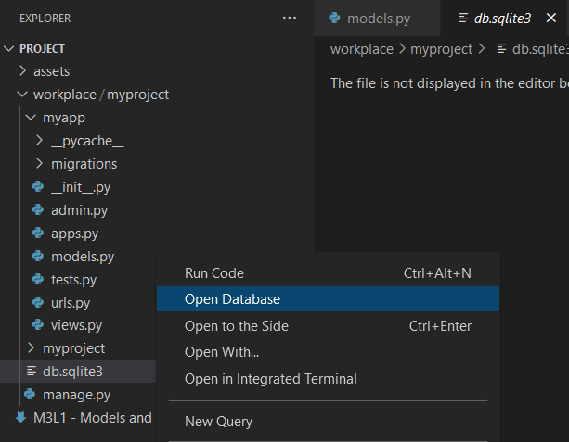

**Step 13:**  Notice that a menu open for **SQLITE EXPLORER** appears at the bottom of the left panel.

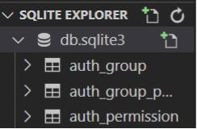

Now go to **SQLITE EXPLORER** and expand the option for **db.sqlite3**.

Scroll down to check if the **myapp\_drinks** table is generated.

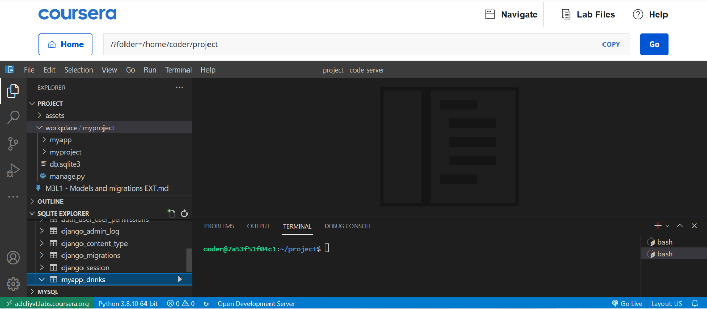

**Note:** You may not see any contents inside the **myapp\_drinks** table as it is empty.

**Concluding Thoughts**

In this lab, you practiced creating a model (Drinks) and ran the migrations to create the associated database tables.

# Solution: Ungraded Lab – Models and migrations

Here is the solution code for **models.py - Initial migration**

from django.db import models

# Create your models here.

class Drinks(models.Model):

    drink = models.CharField(max\_length=200)

    price = models.IntegerField()

Here is the solution code for models.py - Second migration

from django.db import models

# Create your models here.

class Drinks(models.Model):

    drink\_name = models.CharField(max\_length=200)

    price = models.IntegerField()

Here is the solution code for admin.py

from django.contrib import admin

from .models import Drinks

# Register your models here.

admin.site.register(Drinks)

Shell commands for performing migrations

# Commands to perform migrations

python3 manage.py makemigrations

python3 manage.py migrate

**xercise: Models using Foreign Keys**

Open Lab

**Instructions**

**Goal**

The learner will learn how to use the Foreign Key between two Models in Django.

**Objectives**

* The learner will create a model called **DrinksCategory**
* The learner will create a second model called **Drinks** to pass the argument for the foreign key in model attributes before performing migrations.

**Introduction**

The labs in this model will focus on the model part of the MVT pattern and in this lab, you will create two models and assign a one-to-many relationship using foreign keys.

**Scenario**

So far, the data model of the Little Lemon prototype uses single isolated models. However, you know that as requirements change, so does the complexity of the data model. For example, when describing a Menu, all the food items cannot fall under the same category. Instead, these items such as Desserts, Appetizers, and Entrée will each have their own categories.

Adrian has expressed an interest in creating a webpage that displays the drinks available at the restaurant in order of category.

Your task is to implement this request by making the necessary changes to the data model. You will need to create two new models to represent the **drinks** and **drinks category** tables. Additionally, these tables need to be linked in via a one-to-many relationship, because many drinks can belong to one category.

To implement this relationship, use your understanding of creating model relationships in Django, by implementing functionality that is similar to foreign keys in SQL.

**Learner Instructions**

Initial Lab Instructions:

This lab will require you to modify the following files:

* **models.py**
* **admin.py**

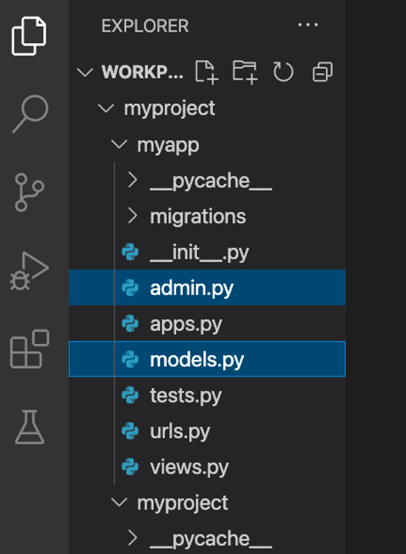

Additionally, you are required to use the command line console inside the terminal of VS Code.

If it is not open already, go to **Terminal** on the Menu bar at the top of your screen and select **New Terminal**.



You have already built the project called **myproject** and added an app inside the project called **myapp**.

**Note:**

Follow the instructions below and ensure you check the output at every step and update the necessary files to create different views.

**Steps**

**Step 1:**

Expand the **myapp** folder from the explorer panel on the left and open the **models.py** file.

**Step 2:**

Create a class called **DrinksCategory** and pass **models.Model** to it as an argument.

**Step 3:**

Add the following attributes and pass their respective form field types and arguments.

| **Attribute** | **Form field type** | **Arguments** |
| --- | --- | --- |
| **category\_name** | **CharField** | **max\_length = 200** |

**Step 4:**

Create another class called **Drinks** and pass **models.Model** to it as an argument.

**Step 5:**  Add the following attributes and pass their respective form field types and arguments.

| **Attribute** | **Form field type** | **Arguments** |
| --- | --- | --- |
| **drink** | **CharField** | **max\_length = 200** |
| **price** | **IntegerField** |  |

**Step 6:**  Inside the class **Drinks**, create a third attribute called **category\_id**, in addition to **drink** and **price**. Assign it the value of **models.ForeignKey** and define the following arguments inside it:

* The name of the first Model **DrinksCategory**
* The argument **on\_delete** with the value **models.PROTECT** assigned to it.
* The argument **default** with a value equal to **None**

**Step 7:**  Go to the **admin.py** file under the project directory and register both models by passing them individually to the function **admin.site.register**.

**Tip:** Make sure you have imported both the models inside the **admin.py** file from **models.py**

**Step 8:**  In the terminal run the command to make migrations.

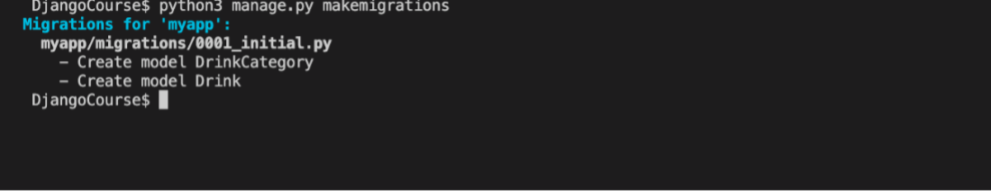

**Step 9:**  Run the command to perform the migrations.

**Step 10:**  Inside the explorer pane in the left panel of VS Code, Right click on the database **db.sqlite3** that is generated and select **Open Database**.

**Step 11:**  Go to **SQLITE EXPLORER** and click the arrow to expand it. Select **db.sqlite3** and scroll down to check if **myapp\_drinks** and **myapp\_drinkscategory** tables are generated.

Click on the **Play** button, or right-click and choose **Show Table**.

**Note: If the table is empty, no results will be displayed.**

**Additional step:** You can add entries to these tables with the help of commands you have learned using the Django shell or the Django admin panel.

You will learn how to use the Django admin panel later. For now let's add some database entries using the Django shell.

**Step 12:** To enter inside the Django shell, run the following command in the terminal:

python manage.py shell

Once inside the Django shell, import the **DrinksCategory** model.

from myapp.models import DrinksCategory

**Tip:** To ensure you are inside the Django shell, make sure the symbols **>>>** are placed at the start of your commands.

Next, create a variable and instantiate it using keyword arguments to the model class:

cat = DrinksCategory(category\_name='coffee')

Finally, use the **save()** method to save to the database.

cat.save()

In the **SQLITE EXPLORER**, locate the table **myapp\_drinkscategory**, right-click and choose **show table**.

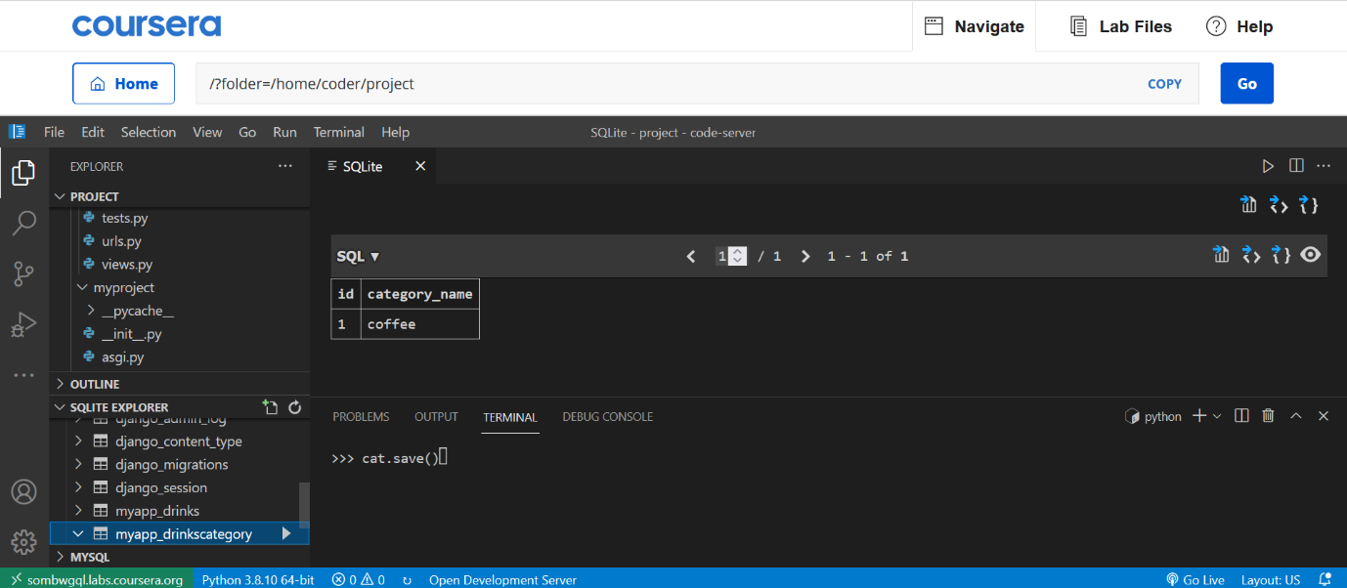

**Step 13:** Now an entry is created in the **DrinksCategory** table, create a drink in the **Drinks** table that uses a foreign key from the **DrinksCategory** table.

Still in the Django shell, import the **DrinksCategory** model.

from myapp.models import DrinksCategory, Drinks

Create a variable **fk** to store the foreign key, and retrieve it using the **objects.get()** method.

fk = DrinksCategory.objects.get(pk=1)

**Note:** The **objects.get()**method retrieves the value from the **DrinksCategory** model.

Next, create another variable **Drink** and instantiate it using keyword arguments to the model class:

drink = Drinks(drink='mocha', price=7, category\_id=fk)

Finally, use the **save()** method to save to the database.

drink.save()

In the **SQLITE EXPLORER**, locate the table **myapp\_drinks**, right-click and choose **show table**.

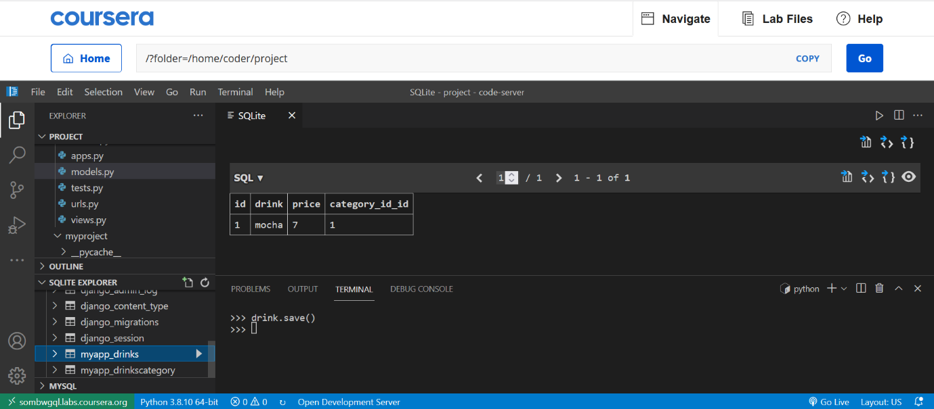

**Concluding Thoughts**

In this lab, you practiced creating a one-to-many relationship using models and foreign keys.

# Solution: Models using Foreign Keys

models.py

from django.db import models

# Create your models here.

class DrinksCategory(models.Model):

    category\_name = models.CharField(max\_length=200)

class Drinks(models.Model):

    drink = models.CharField(max\_length=200)

    price = models.IntegerField()

    category\_id = models.ForeignKey(DrinksCategory, on\_delete=models.PROTECT, default=None)

admin.py

from django.contrib import admin

from .models import Drinks

from .models import DrinksCategory

# Register your models here.

admin.site.register(Drinks)

admin.site.register(DrinksCategory)

Commands for running migrations:

python3 manage.py makemigrations

python3 manage.py migrate

# v6.1

# Object Relationship Mapping - ORM

## What is ORM

Usually, the type of system used in an Object-Oriented language such as Python contains types that are non-scalar and every time, they cannot be represented only in primitive types such as integers and strings.

On the other hand, data types in tables of a relational database are of primary types, that is integer and string.

Therefore, the program needs to convert objects in scalar data to interact with a backend database.

Object-oriented programming languages use Object Relation Mapping (ORM) to interact with Structured Query Language (SQL), both of which are incompatible.

The ORM layer maps a class to a table in a relational database, with its attributes matching the table's field structure.

The ORM library lets you perform the database operations in an object-oriented way instead of executing raw SQL queries.

This allows you to focus more on the programming logic than the backend database operations.

Object Relational Mapping or ORM is the ability to create a SQL query using object-oriented programming language such as Python. This enables a quick turnaround time in fast production environments that need constant updates.

Each model is a Python class that subclasses **django.db.models.Model**

Each attribute of the model represents a database field. Essentially you can think of a model as a Python object, and models help developers create, read, update and delete objects, commonly called the CRUD operations.

Django has its own ORM layer. Its migration mechanism propagates the models in database tables.

You need to construct a **QuerySet** via a Manager of your model class to retrieve objects from your database.

## QuerySet

Let's try to understand how **QuerySet** is constructed and handled with an example. To begin with, add the following models in the Django app named **demoapp**.

from django.db import models

class Customer(models.Model):

    name = models.CharField(max\_length=255)

class Vehicle(models.Model):

    name = models.CharField(max\_length=255)

    customer = models.ForeignKey(

        Customer,

        on\_delete=models.CASCADE,

        related\_name='Vehicle'

    )

The idea is to create two tables, Customer and Vehicle, with a one-to-many relationship. Apply the migrations and you will see these two tables in the project's database.

Next, open the Interactive shell.

It is important to know that these commands are the same if you are on Windows or Mac.

## (djenv) C:\djenv\demoproject>python manage.py shell

Create an object of the Customer class. Give a string parameter to the constructor. The **save()** method of the **models.Model** class creates a row in the Customer table.

>>> from demoapp.models import Customer

>>> c=Customer(name="Henry")

>>> c.save()

## Adding a model object

The **Customer.objects** gives the Manager of the model. It handles all the CRUD operations on the database table. For example, an object can also be created with the **create()** method as follows:

>>> Customer.objects.create(name="Hameed")

<Customer: Customer object (2)>

The **create()** method actually performs the **INSERT** operation of SQL.

Now, let us add two objects to the Vehicle model. Note that one of the fields in the Vehicle model refers to an object of the Customer table as **ForeignKey**. Fetch the Customer object with a primary key = 2.

>>> from demoapp.models import Customer, Vehicle

>>> c=Customer.objects.get(pk=2)

>>> c.name

'Hameed'

This object is used as the value of the customer attribute in the Vehicle object.

>>> v=Vehicle(name="Honda", customer=c)

>>> v.save()

>>> v=Vehicle(name="Toyota", customer=c)

>>> v.save()

Similarly, add two vehicles for Customer "Henry".

>>> c=Customer.objects.get(name="Henry")

>>> Vehicle.objects.create(name="Ford", customer=c)

<Vehicle: Vehicle object (3)>

>>> Vehicle.objects.create(name="Nissan", customer=c)

<Vehicle: Vehicle object (4)>

## Fetch model objects

A **QuerySet** represents a collection of objects from your database. It represents a **SELECT** query. To fetch all the objects, use the **all()** method of the Manager.

model.objects.all()

The **all()** method returns a list of objects. You can iterate over it with the usual for loop or list comprehension technique.

>> lst=Customer.objects.all()

>>> [c.name for c in lst]

['Henry', 'Hameed']

You can apply filters to the data fetched from the model. This is used to fetch objects satisfying the given criteria. In SQL terms, a **QuerySet** equates to a **SELECT** statement, it is like applying a **WHERE** clause.

model.objects.filter(criteria)

For example, use the following statement to retrieve all the customers with names starting with '**H**'.

mydata = Customer.objects.filter(name\_\_startswith='H')

Similarly, you can retrieve the objects of the Vehicle model. Remember that the Vehicle object refers to a customer object. You can retrieve the attributes of the related customer as follows:

>>> lst=Vehicle.objects.all()

>>> for v in lst:

...     print (v.name, " : ", v.customer.name)

...

Honda :  Hameed

Toyota :  Hameed

Ford :  Henry

Nissan :  Henry

## Updating and removing a model object

To update an object, such as changing the Customer's name from Henry to Helen, assign a new value to the name attribute and save.

>>> c=Customer.objects.get(name="Henry")

>>> c.name="Helen"

>>> c.save()

Similarly, the **delete()** method of the model manager physically removes the corresponding row in the model's mapped table.

>>> c=Customer.objects.get(pk=4)

>>> c.delete()

(1, {'demoapp.Customer': 1})

This way, you can perform the CRUD operations on a database table using the **QuerySet** API instead of executing raw SQL queries.

# Additional resources

The following resources will be helpful you learn more about different concepts related to Models and Migrations.

[Models – official documentation](https://docs.djangoproject.com/en/4.1/topics/db/models/)

[Migrations – official documentation](https://docs.djangoproject.com/en/4.1/topics/migrations/)

[Other Model Instance methods (including the String Dunder method)](https://docs.djangoproject.com/en/dev/ref/models/instances/#model-instance-methods)

[Using Models – Mozilla](https://developer.mozilla.org/en-US/docs/Learn/Server-side/Django/Models)

[Detailed overview of Migrations](https://docs.djangoproject.com/en/4.1/topics/migrations/)

[Migration operations](https://docs.djangoproject.com/en/4.1/ref/migration-operations/)

[Understanding ORM](https://docs.djangoproject.com/en/4.1/ref/models/class/)

# V8.1

# Django fields

In this reading, you will learn about different field types in a model class.

## Model

A model in Django is like any normal Python class. The ORM layer maps this model to a database table in the Django project. Each attribute of a model class represents a field in the table.

The Django ORM enables storing and retrieving data in tables, not by executing raw SQL queries, but by invoking the model methods.

A model class subclasses the **django.models.Model** class. A typical definition of a model class is done inside the app's **models.py** file.

from django.db import models

class Person(models.Model):

    first\_name = models.CharField(max\_length=20)

    last\_name = models.CharField(max\_length=20)

When you migrate this model (you need to include your app in the **INSTALLED\_APPS** setting), the **myapp\_person** table will be created as would be done by the **CREATE TABLE** query:

CREATE TABLE Person (

    id         INTEGER      PRIMARY KEY,

    first\_name VARCHAR (20),

    last\_name  VARCHAR (20)

)

Note that the **first\_name** and **last\_name** are the class attributes corresponding to the fields in the table.

Django automatically names the table as **appname\_modelname**, which you can override by assigning the desired name to **db\_table** parameter of the Meta class, to be declared inside the model class.

class Student(CommonInfo):

    # ...

    class Meta(CommonInfo.Meta):

        db\_table = 'student\_info'

You should choose the model field type appropriate for the data stored in the mapped field.

The types are defined in **django.forms** module. The choice of type determines the HTML widget to use when the form field is rendered. For example, for a **CharField**, HTML's text input type will be used.

Django also auto-creates the form based on model definitions (it is called **ModelForm**), using field types.

## Field properties

A Field object has common properties in addition to the field-specific properties.

**primary\_key**

This parameter is False by default. You can set it to True if you want the mapped field in the table to be used as its primary key.

It's not mandatory for the model to have a field with a primary key. In its absence, Django, on its own, creates an **IntegerField** to hold a unique auto-incrementing number.

**default**

You can also specify any default in the form of a value or a function that will be called when a new object is created.

class Person(models.Model):

    name = models.CharField(max\_length=50)

    address = models.CharField(max\_length=80, default='Mumbai')

**unique**

If this parameter in the field definition is set to True, it will ensure that each object will have a unique value for this field.

tax\_code = models.CharField(

                    max\_length = 20,

                    unique = True

                    )

**choices**

If you want to create a drop-down from which the user should select a value for this field, set this parameter to a list of two-item tuples.

SEMESTER\_CHOICES = (

    ("", "Civil"),

    ("2", "Electrical"),

    ("3", "Mechanical"),

    ("4", "CompSci"),

)

# declaring a Student Model

class Student(models.Model):

      semester = models.CharField(

        max\_length = 20,

        choices = SEMESTER\_CHOICES,

        default = '1'

        )

## Field types

The **django.models** module has many field types to choose from.

**CharField:**

This is the most used field type. It can hold string data of length specified by **max\_lenth** parameter. For a longer string, use **TextField**.

**IntegerField:**

The field can store an integer between -2147483648 to 2147483647. There are **BigIntegerField**, **SmallIntegerField** and **AutoField**types as well to store integers of varying lengths.

**FloatField:**  It can store a floating-point number. Its variant **DecimalField** stores a number with fixed digits in the fractional part.

class Student(Model):

    grade = models.DecimalField(

                         max\_digits = 5,

                         decimal\_places = 2)

**DateTimeField**

Stores the date and time as an object of Python's **datetime.datetime** class. The **DateField** stores **datetime.date** value.

**EmailField**

It’s actually a **CharField** with an in-built **EmailValidator**

**FileField**

This field is used to save the file uploaded by the user to a designated path specified by the **upload\_to** parameter.

**ImageField**

This is a variant of **FileField**, having the ability to validate if the uploaded file is an image.

**URLField**

A **CharField** having in-built validation for URL.

## Relationship fields

There can be three types of relationships between database models:

* one-to-one
* one-to-many
* many-to-many

The **django.models** module has the following fields for establishing relationships between models.

**ForeignKey**

It is used to establisha **one-to-many** relationship between two models. It requires two positional arguments - the model with which it is related, and the **on\_delete** option to define the behavior of the delete operation.

Suppose you have a **Customer** and **Vehicle** model with a one-to-many relationship. A customer can have more than one vehicle.

class Customer(models.Model):

    name = models.CharField(max\_length=255)

class Vehicle(models.Model):

    name = models.CharField(max\_length=255)

    customer = models.ForeignKey(

        Customer,

        on\_delete=models.CASCADE,

        related\_name='Vehicle'

    )

The **on\_delete** option specifies the behavior in case the associated object in the primary model is deleted. The values are:

**CASCADE**: deletes the object containing the **ForeignKey**

**PROTECT**: Prevent deletion of the referenced object

**RESTRICT**: Prevent deletion of the referenced object by raising **RestrictedError**

Now let’s expand upon these values in more detail:

### CASCADE

If the **on\_delete** parameter is set to **CASCADE**, deleting the reference object will also delete the referred object. Suppose a vehicle belongs to a customer. When the Customer is deleted, all the vehicles that reference the customer will be automatically deleted.

### ****PROTECT****

The effect of the **PROTECT** option is the opposite of **CASCADE**. It prevents the deletion of a referenced objectif it has an object referencing it in the database. Suppose a vehicle belongs to a customer.

If a customer has vehicles, it cannot be deleted. It’s important to know that if you forcefully delete the customer, Django raises the **ProtectedError**.

### RESTRICT

The difference between **PROTECT** and **RESTRICT** is that when you delete the referenced object, the **on\_delete** option raises the **RestrictedError**.

The deletion of the referenced object is allowed if it also references a different object that is being deleted in the same operation, but via a **CASCADE** relationship.

Let’s use the example of an Artist model – a **CASCADE** relationship with an Album and Song model. The Artist model, in turn, has a **RESTRICT** relationship with the song model.

class Artist(models.Model):

    name = models.CharField(max\_length=10)

class Album(models.Model):

    artist = models.ForeignKey(Artist, on\_delete=models.CASCADE)

class Song(models.Model):

    artist = models.ForeignKey(Artist, on\_delete=models.CASCADE)

    album = models.ForeignKey(Album, on\_delete=models.RESTRICT)

Next, you can create a few instances of these models:

>>> artist1 = Artist.objects.create(name='Danny')

>>> artist2 = Artist.objects.create(name='John')

>>> album1 = Album.objects.create(artist=artist1)

>>> album2 = Album.objects.create(artist=artist2)

>>> song1 = Song.objects.create(artist=artist1, album=album1)

>>> song\_two = Song.objects.create(artist=artis1, album=album2)

You can safely delete the **artist1** instance. If you try to delete artist2, the **RestrictedError** is raised.

### ****OneToOneField****:

This field in one of the models establishes a one-to-one relationship between the two models.

Although a **ForeignKey** field with **unique=True** setting, behaves similarly, the reverse side of the relationship will always return a single object.

The following model definition demonstrates a one-to-one relationship between the **college** model and a **principal** model.

A college can have only one principal and one person can be a principal of only one college.

class college(Model):

    CollegeID = models.IntegerField(primary\_key = True)

    name = models.CharField(max\_length=50)

    strength = models.IntegerField()

    website=models.URLField()

class Principal(models.Model):

    CollegeID = models.OneToOneField(

                College,

                on\_delete=models.CASCADE

                )

    Qualification = models.CharField(max\_length=50)

    email = models.EmailField(max\_length=50)

**anyToManyField**:

This field helps in setting a many-to-many relationship between two models.

Here, multiple objects of one model can be associated with multiple objects of another model.

For example, in the case of **Subject** and **Teacher** models, a subject is taught by more than one teacher.

Similarly, a teacher can teach more than one subject. This is represented in the following model definitions:

class Teacher(models.Model):

    TeacherID = models.ItegerField(primary\_key=True)

    Qualification = models.CharField(max\_length=50)

    email = models.EmailField(max\_length=50)

class Subject(models.Model):

    Subjectcode = models.IntegerField(primary\_key = True)

    name = models.CharField(max\_length=30)

    credits = model.IntegerField()

    teacher = model.ManyToManyField(Teacher)

In this reading you learned about the different fields to be used as the type of attributes in a model class.

# V8.2

# Form API

In this reading item, you’ll explore the important features of the Form class defined in **django.forms** module.

## HTML Form

Almost every web application collects certain data from the user by presenting them with a form to fill out and submit. A form is a document wherein the user enters their responses at certain labeled placeholders. For example, a form that is used to register on a certain site, or the one used to fill your travel details for booking a ticket, or a job application form.

You can construct a form using HTML’s form tag and its various input elements (such as text, radio, and checkboxes, dropdowns and lists).

<form action="/form/" method="POST">

    <label for="Name">Name of Applicant</label>

    <input type="text" id="name" name="name">

    <label for="Address">Address</label>

    <input type="text" id="add" name="add">

    <label for="Post">Post</label>

    <select id="Post" name="Post">

      <option value="Manager">Manager</option>

      <option value="Cashier">Cashier</option>

      <option value="Operator">Operator</option>

    </select>

    <input type="submit" value="Submit">

  </form>

HTML has very little validation support for these elements. Hence, you need to use JavaScript functions to validate the data before submitting it to the server.

## Django Form

Django framework includes a Form class, its attributes, and methods in the **django.forms** module. This class is used as a base for a user-defined form design.

from django import forms

class ApplicationForm(forms.Form):

   pass

The attributes of the form are Field class objects. The forms module has a collection of Field types. These fields correspond to the HTML elements they eventually render on the user’s browser. For example, the **forms.CharField** is translated to HTML’s text input type. Similarly, the **ChoiceField** is equivalent to **SELECT** in HTML. The Django form class representing the above Application form would be:

from django import forms

class ApplicationForm(forms.Form):

    name = forms.CharField(label='Name of Applicant', max\_length=50)

    address = forms.CharField(label='Address', max\_length=100)

    posts = (('Manager', 'Manager'),('Cashier', 'Cashier'),('Operator', 'Operator'))

    field = forms.ChoiceField(choices=posts)

By convention, the user-defined form classes are stored in a forms.py file in the app’s package folder. So, if you have a Django app called **myapp**, the above code is kept in **myapp/forms.py**.

## Django Form Fields

Out of the many available form field types, some of the most frequently used are as follows:

**CharField**: Translates to input **type=text** HTML form element. If you want to accept a longer multiline text, set its widget property to **forms.Textarea**

forms.CharField(label="Enter first name",max\_length=50)

**IntegerField**: Similar to a CharField but customized to accept only integer numbers. You can limit the value entered by setting **min\_value** and **max\_value** parameters.

age = forms.IntegerField(min\_value=20, max\_value=60)

**FloatField**: A text input field that validates if the input is a valid float number. Its variant **DecimalField** accepts a float number of specified decimal places.

price = forms.FloatField()

**FileField**: Presents an input **type=file** element on the HTML form.

upload = forms.FileField(upload\_to ='uploads/')

**ImageField**: Similar to **FileField**with added validation to check if the uploaded file is an image. The pillow library must be installed for this field type to be used.

**EmailField**: A **CharField** that can validate if the text entered is a valid email ID.

email = forms.EmailField(max\_length = 254)

**ChoiceField**: Emulates the HTML’s SELECT element. Populates the drop-down list with a choice parameter whose value should be a sequence of two item tuples.

gender = forms.CharField(max\_length=1, choices=GENDER\_CHOICES)

The instance of the Form class translates to the HTML script of a form. When returned to the browser, the form is rendered.

Let us open the Django shell and check what the form object returns.

>>> from myapp import forms

>>> f = ApplicationForm()

>>> print(f)

You’ll see the following HTML script:

<tr>

    <th><label for="id\_name">Name of Applicant:</label></th>

    <td>

        <input type="text" name="name" maxlength="50" required id="id\_name">

    </td>

</tr>

<tr>

    <th><label for="id\_address">Address:</label></th>

    <td>

        <input type="text" name="address" maxlength="100" required id="id\_address">

    </td>

</tr>

<tr>

    <th><label for="id\_field">Field:</label></th>

    <td>

        <select name="field" id="id\_field">

            <option value="Manager">Manager</option>

            <option value="Cashier">Cashier</option>

            <option value="Operator">Operator</option>

        </select>

    </td>

</tr>

## Form Template

The form object thus translates to HTML script of form – minus the **<form>** as well as the **<table>** tag. To render it on a browser, youhave to first write an HTML template and put the form object in **jinja2** tag. Let us save the following **form.html** file in the project’s templates folder.

<html>

<body>

    <form action="/form" action="POST">

        {% csrf\_token %}

        <table>

            {{ f }}

        </table>

</body>

<html>

Let there be a following view in the app’s **views.py** file which renders the **forms.html** template and sends the **ApplicationForm** object as a context.

from .forms import ApplicationForm

def index(request):

    form = ApplicationForm()

    return render(request, 'form.html', {'form': form})

Inside the template, the form can be rendered in different ways. Instead of a tabular presentation of the form elements you can use the following variations:

* **{{ form.as\_table }}** will render them as table cells wrapped in**<tr>** tags. The form is rendered as a table by default.

<table>

    <tr>

        <th><label for="id\_name">Name of Applicant:</label></th>

        <td>

            <input type="text" name="name" maxlength="50" required id="id\_name">

        </td>

    </tr>

    <tr>

        <th><label for="id\_address">Address:</label></th>

        <td>

            <input type="text" name="address" maxlength="100" required id="id\_address">

        </td>

    </tr>

    <tr>

        <th><label for="id\_field">Field:</label></th>

        <td>

            <select name="field" id="id\_field">

                <option value="Manager">Manager</option>

                <option value="Cashier">Cashier</option>

                <option value="Operator">Operator</option>

            </select>

        </td>

    </tr>

</table>

<input type="submit">

Output:

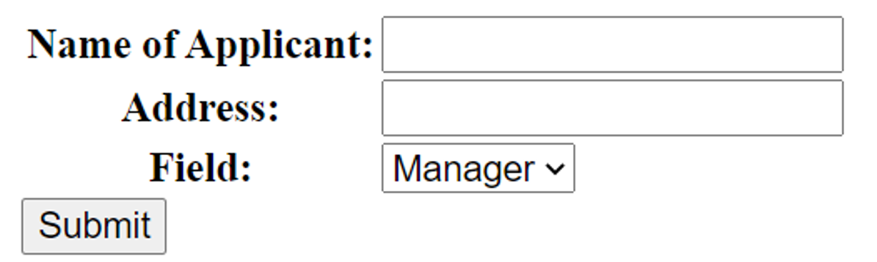

* **{{ form.as\_p }}** will render them wrapped in**<p>** tags.

<!-- HTML rendered in the browser -->

<p>

    <label for="id\_name">Name of Applicant:</label>

    <input type="text" name="name" maxlength="50" required id="id\_name">

</p>

<p>

    <label for="id\_address">Address:</label>

    <input type="text" name="address" maxlength="100" required id="id\_address">

</p>

<p>

    <label for="id\_field">Field:</label>

    <select name="field" id="id\_field">

        <option value="Manager">Manager</option>

        <option value="Cashier">Cashier</option>

        <option value="Operator">Operator</option>

    </select>

</p>

The form is displayed in the browser:

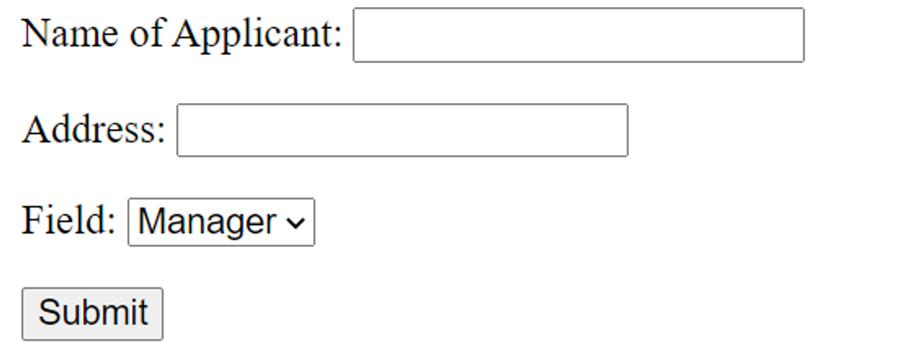

* **{{ form.as\_ul }}** will render them wrapped in **<li>** tags.

<li>

    <label for="id\_name">Name of Applicant:</label>

    <input type="text" name="name" maxlength="50" required id="id\_name">

</li>

<li>

    <label for="id\_address">Address:</label>

    <input type="text" name="address" maxlength="100" required id="id\_address">

</li>

<li>

    <label for="id\_field">Field:</label>

    <select name="field" id="id\_field">

        <option value="Manager">Manager</option>

        <option value="Cashier">Cashier</option>

        <option value="Operator">Operator</option>

    </select>

</li>

<input type="submit">

The form is renders in the browser:

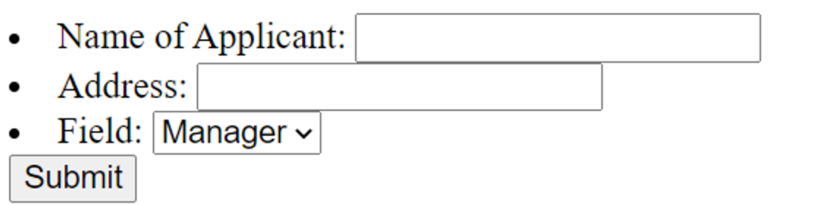

* **{{ form.as\_div }}** will render them wrapped in **<div>** tags.

<div>

    <label for="id\_name">Name of Applicant:</label>

    <input type="text" name="name" maxlength="50" required id="id\_name">

</div>

<div>

    <label for="id\_address">Address:</label>

    <input type="text" name="address" maxlength="100" required id="id\_address">

</div>

<div>

    <label for="id\_field">Field:</label>

    <select name="field" id="id\_field">

        <option value="Manager">Manager</option>

        <option value="Cashier">Cashier</option>

        <option value="Operator">Operator</option>

    </select>

</div>

<input type="submit">

The form is renders in the browser:

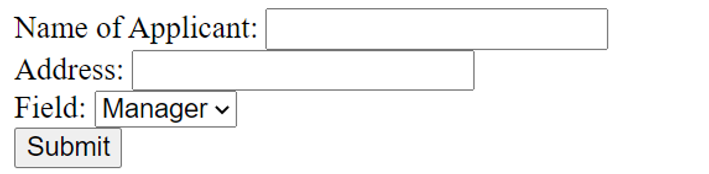

**Reading Form Contents**

Note that the form’s action attribute is set to **"/form"** path. So, you’ll provide a **form()**view mapped to this URL. This function fetches the data submitted by the user. It may be used to add a new row in the database table, or for any other processing.

Inside the view, populate the form object with the POST data and check it is valid. The Form class provides **is\_valid()** method. It runs validation on each field and returns True if all field validations are passed.

from .forms import ApplicationForm

def index(request):

   if request.method == 'POST':

        form = ApplicationForm(request.POST)

        # check whether it's valid:

        if form.is\_valid():

            # process the data

            # ...

            # ...

            return HttpResponse('Form successfully submitted')

Once the Form instance is validated, you can now access the data in individual field via the **cleaned\_data** attribute. It ensures that the field contains the output in consistent form. In our example, the three values in the three input elements are parsed to Python variables like this:

name = form.cleaned\_data['name']

add = form.cleaned\_data['address']

post = form.cleaned\_data['posts']

In this reading item on Forms API, you learned about Django Form and form fields. You also learned how the form is rendered and processed.

**Exercise: Working with Forms**

Open Lab

**Instructions**

**Goal**

* Learner will create a **ModelForm** called **BookingForm** using the Booking model.

**Objectives**

* The Learner will practice creating a **ModelForm** using a model.
* The Learner will add form fields to the form as per the instructions.
* The Learner will populate a database table with data entered from a form on a webpage.

**Introduction**

In this lab, you will create a model form to accept user input on the Booking page.

The model form will be based on a model to connect with the database for storing the reservation requests received on the Little Lemon website.

**Scenario**

Adrian at Little Lemon would like to test the possibility of using a booking form on the website for online reservations. The purpose of the form will be to take a reservation request and store that request in a table in the database. Later it is hoped that a member of staff will be able to access and view this request from the Django administration control panel.

Before that functionality can be created, the first step is to build a proof of concept for the booking form on the website. And you have been assigned this task.

This lab will require you to modify the following files:

* **models.py**
* **forms.py**
* **admin.py**

Additionally, you are required to use the command line console inside the terminal of VS Code.

If not open already, go to **Terminal** on the Menu bar at the top of your screen and select **New Terminal**.

You have already built the project named **myproject** and added an app inside the project called **myapp**.

Follow the instructions below and ensure you check the output at every step and update the necessary files to create different views.

**Steps**

**Step 1:**  Open the **models.py** file and create a class called **Booking** inside it and pass **models.Model** to it.

**Step 2:**  Create the five attributes you will require in the model and assign the respective form fields to them.

Additionally, pass the following arguments to those form fields:

| **Attribute** | **Form field type** | **Arguments** |
| --- | --- | --- |
| **first\_name** | **CharField** | **max\_length = 200** |
| **last\_name** | **CharField** | **max\_length = 200** |
| **guest\_count** | **IntegerField** |  |
| **reservation\_time** | **DateField** | **auto\_now=True** |
| **comments** | **CharField** | **max\_length = 1000** |

**Step 3:**  Go to the **admin.py** file and register the Model you created by passing the model name to the function **admin.site.register()**. Import the model in **admin.py**

**Tip:** Make sure you have imported the model **Booking** inside the **admin.py** file.

**Step 4:**  Create a file in the **myapp** directory called **forms.py** and add the following:

* Import the **Booking** model from the file **models.py**
* Import the module **forms** from the package **django**

**Step 5:**  Still inside the **forms.py** file, create a class called **BookingForm** and pass the **forms.ModelForm** as an argument to it.

**Step 6:**  Inside the class **BookingForm**, create another class called **Meta** and declare the following attributes inside it:

1. model with the value **Booking**
2. fields with the value **"\_\_all\_\_"**

**Step 7:**  Open the **urls.py** file. Notice that the code to create the URL configuration is already created.

**Step 8:**  Open the **views.py** file and remove all the comments from the code. Notice that the code to create the view function is already created. You may notice a function called render. You will learn more about this later when working with templates.

**Step 9:**  In the terminal run the command to make the migrations.

**Step 10:**  Run the command to perform the migrations.

The view is rendered using the template file which can be found under **myapp > templates >** **booking.html**. Open the file and explore the contents.

**Note:** The template used in this lab is required for you to preview the form. Don't worry about how it functions yet. For now, focus on the process of how to work with forms in Django. You will learn how to work with templates in a later module.

**Step 11:**  Run the command to run the server and launch the browser with the localhost URL.

**Step 12:**  In the browser address bar, type the URL that will render the view that is configured to render the model form.

**http://127.0.0.1:8000/booking**

The view should appear as below:

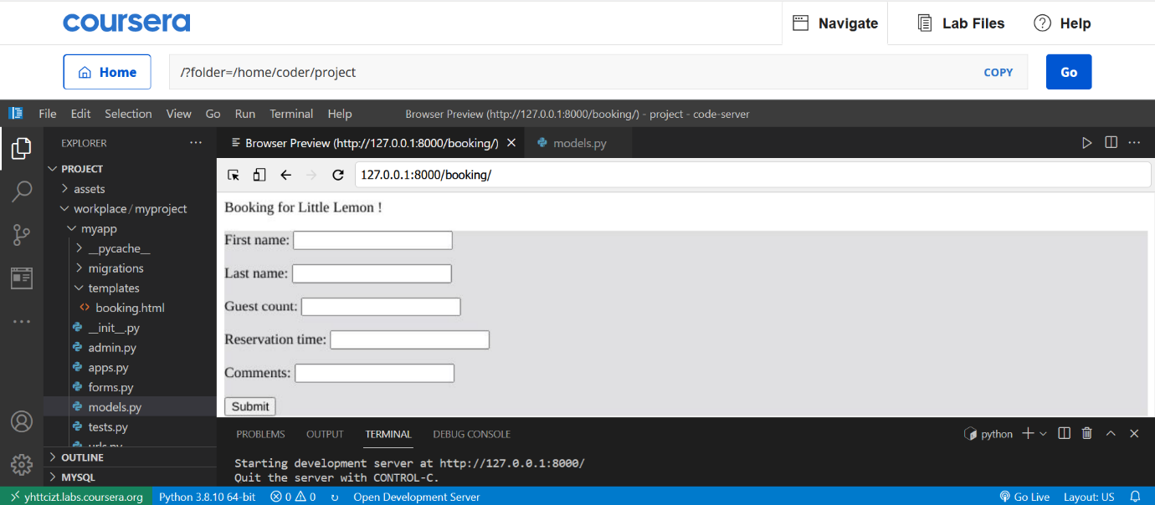

**Note:** The **DateField** attribute has the parameter **auto\_now** set to **True** and will not be displayed inside the form on the webpage. **auto\_now** inside the **DateField** automatically set the field to the current date every time the object is saved.

**Step**  **13:** Check that the form is rendered correctly on the webpage. Fill out the form with the following details.

| **First name** | **Jason** |
| --- | --- |
| Last name | Murphy |
| Guest count | 5 |
| Reservation time | 12-01-2022 |
| Comment | Prefer indoors |

**Step 14:**  Inside the explorer pane in the left panel of VS Code, Right click on the database **db.sqlite3**that is generated and select **Open Database**.

**Step 15:**  Go to **SQLITE EXPLORER** which appears in the directory structure and click the arrow to expand it.

Select **db.sqlite3** and scroll down to check if **myapp\_booking** table is generated.

Click on the **Show Table** button, or right-click and choose **Show Table**.

**Step 16:**  Check the data entered in the form is created in the database:

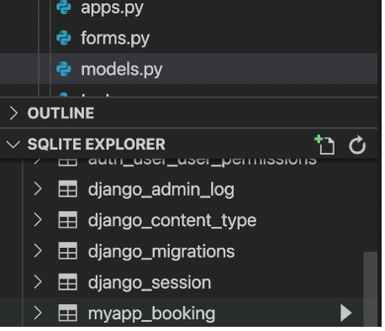

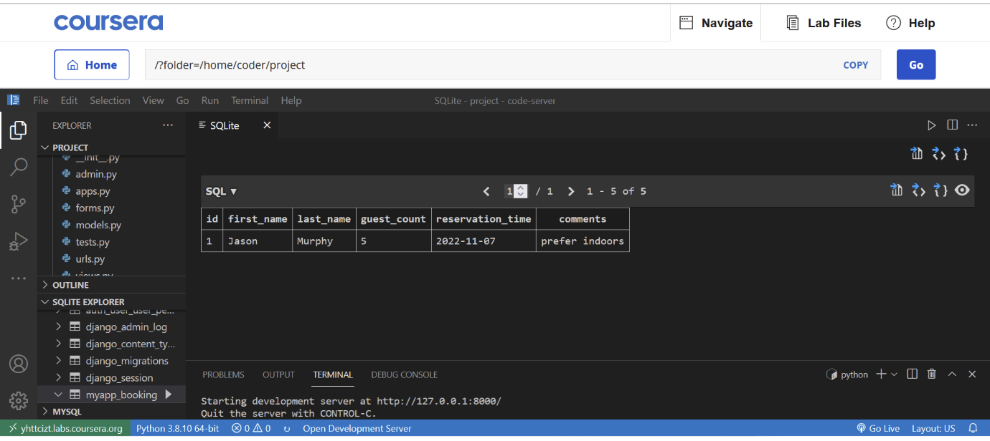

**Note:** The **DateField** attribute has the parameter **auto\_now** set to **True** and will not be displayed inside the form on the webpage.

**Concluding Thoughts**

In this lab, you practiced creating a Model Form using a model. You also populated a database table with data entered from a form on a webpage.

# Solution: Working with Forms

* Here is the completed solution code for the **forms.py**.

from django import forms

from .models import Booking

class BookingForm(forms.ModelForm):

    class Meta:

        model = Booking

        fields = '\_\_all\_\_'

* models.py

from django.db import models

# Create your models here.

class Booking(models.Model):

    first\_name = models.CharField(max\_length = 200)

    last\_name = models.CharField(max\_length = 200)

    guest\_count = models.IntegerField()

    reservation\_time = models.DateField(auto\_now=True)

    comments = models.CharField(max\_length=1000)

* admin.py

from django.contrib import admin

from .models import Booking

# Register your models here.

admin.site.register(Booking)

# Additional resources

The following resources will be helpful as additional references in dealing with different concepts related to the topics you have covered in this module.

[Models – official documentation](https://docs.djangoproject.com/en/4.1/topics/db/models/)

[Migrations – official documentation](https://docs.djangoproject.com/en/4.1/topics/migrations/)

[Using Models – Mozilla](https://developer.mozilla.org/en-US/docs/Learn/Server-side/Django/Models)

[Detailed overview of Migrations](https://docs.djangoproject.com/en/4.1/topics/migrations/#module-django.db.migrations)

[Migration operations:](https://docs.djangoproject.com/en/4.1/ref/migration-operations/)

**V11.1**

**Managing users in Django Admin**

Django’s authorization and authentication system are provided by **django.contrib.admin** app, which is installed by default. It can be seen in the **INSTALLED\_APPS** in the project’s **settings.py** file.

A super user has the privilege to add or modify users and groups. As you log in as a super user, the admin interface appears as below:

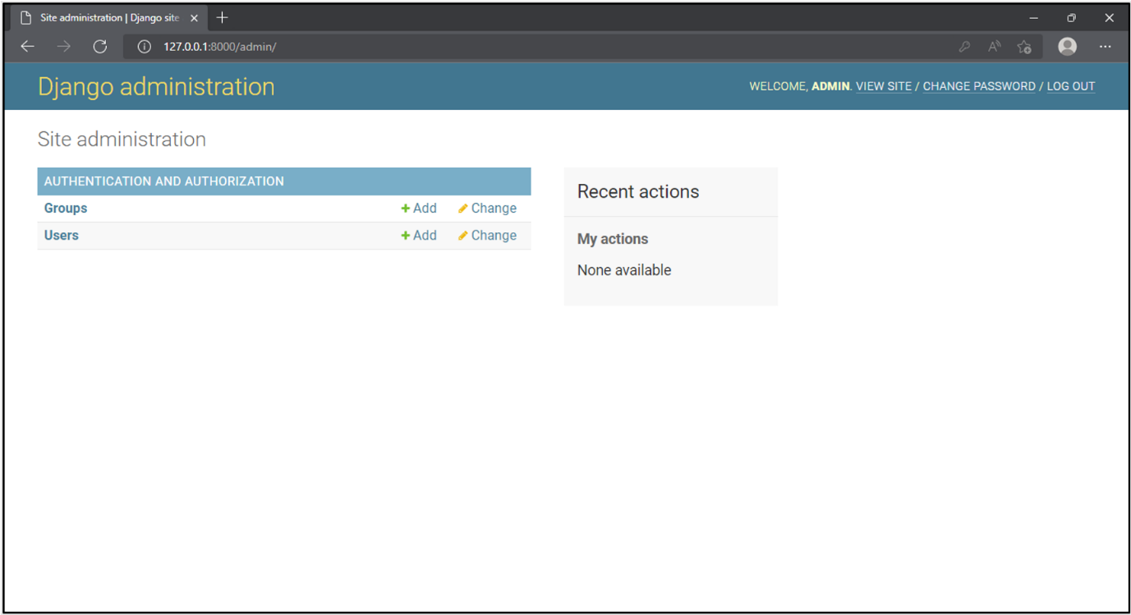

One can add users through the interface, which is straightforward. It’s as easy as following the onscreen instructions.

A user without permission to perform any task is virtually useless. Different permissions can be granted to the user individually or by creating a group with a set of permissions. Users can be added to the group so that a set of users with common permissions is created.

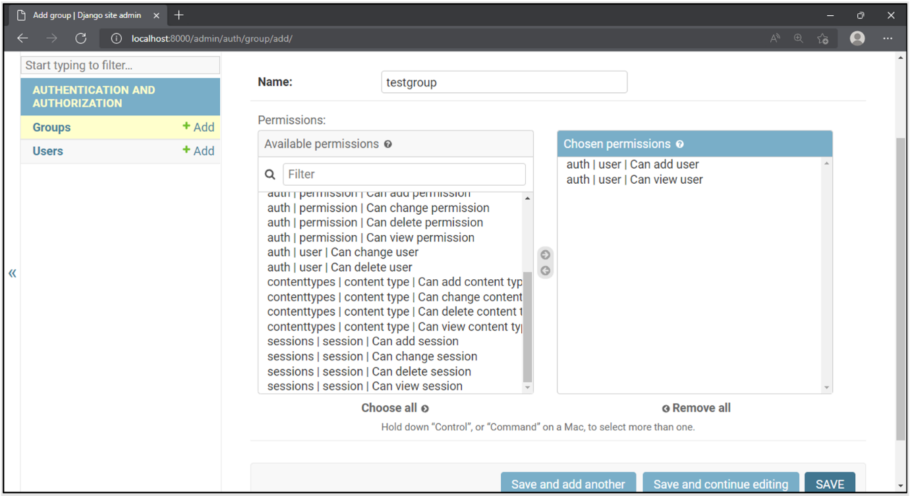

If a user’s **is\_staff** property is set to True, it can log in to the admin interface.

Django admin’s user management system is very efficient, yet it can be tricky. Unless you grant the permissions to the users very judiciously, the system might be put at considerable risk.

Even though Django’s admin site provides a very easy-to-use interface to add and modify users and groups, there are no real restrictions as the User admin.

For example, a user with a staff status can manage the other users. But they can also edit their own permissions, which is not warranted. A staff user can also allocate superuser rights. The out-of-box implementation of the admin site doesn’t prevent this.

So, what do you do to resolve this?

Let’s assume that the Django site has a superuser named **Admin** and a user named **test123** with staff status enabled.

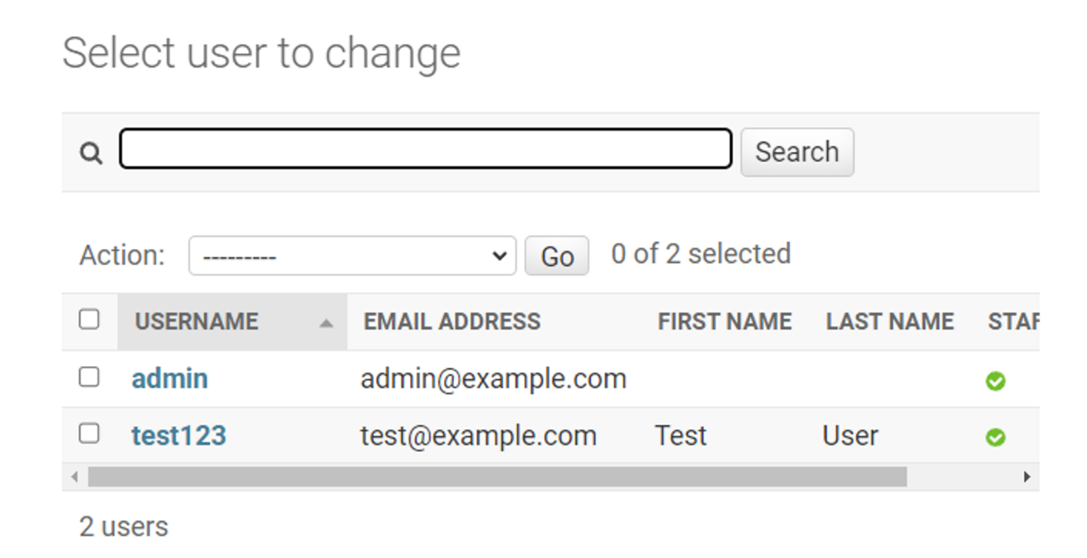

To customize the User Admin, first, unregister the existing user profile and register a new one.

Use the following steps to unregister a user:

Add the following statements in the app’s **admin.py**.

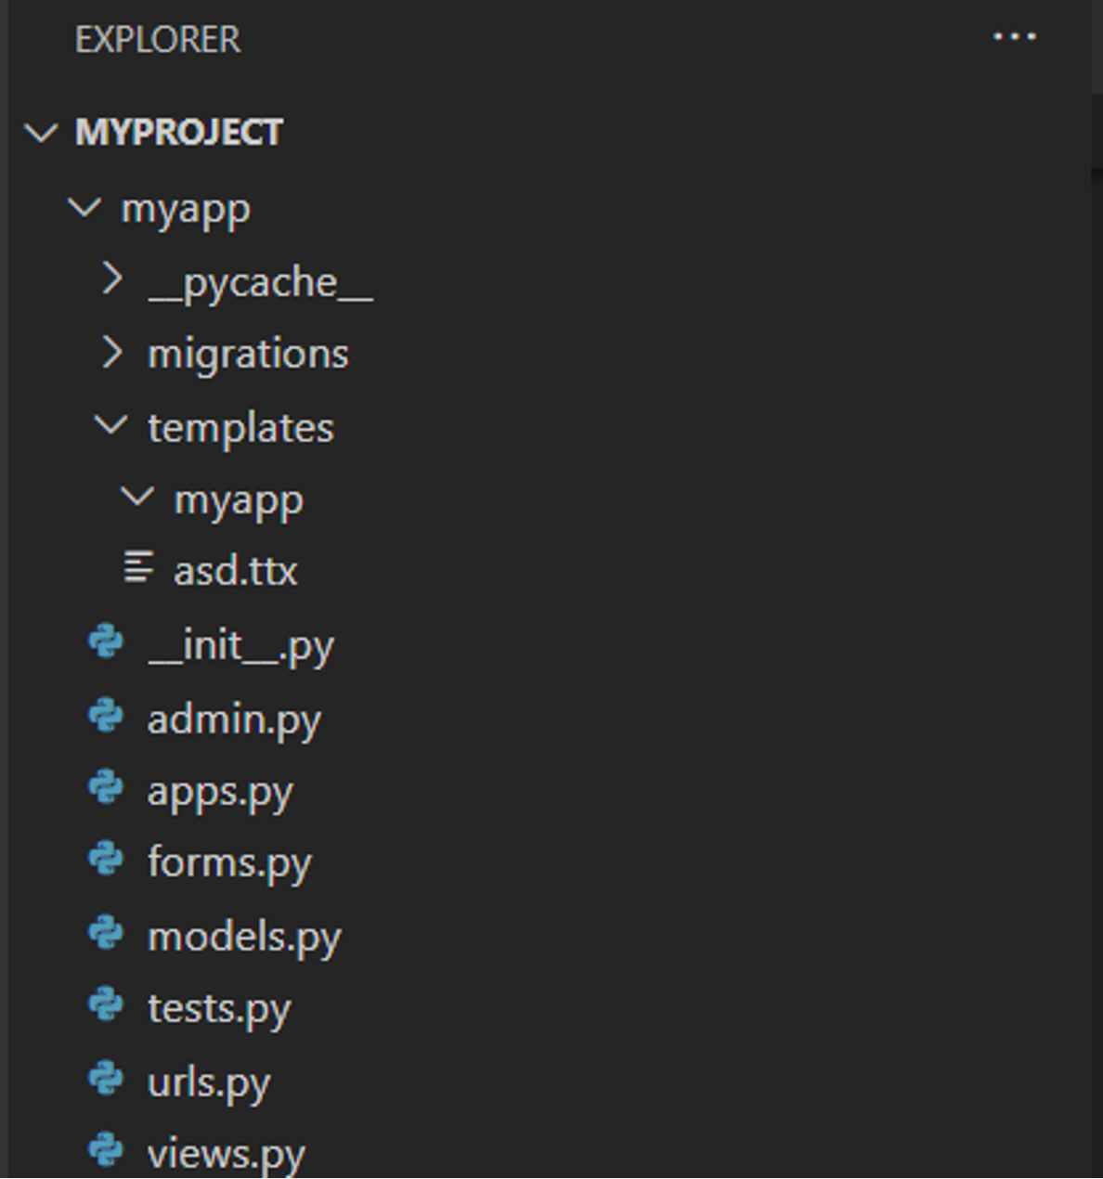

from django.contrib, import admin

# Register your models here.

from django.contrib.auth.models, import User

# Unregister the provided model admin:

admin.site.unregister(User)

To register our own admin, use **@admin.register()** decorator. Give the user a model as the argument. Decorate a sub-class of **UserAdmin** class.

from django.contrib.auth.admin import UserAdmin

@admin.register(User)

class NewAdmin(UserAdmin):

    pass

You can now add some customizations to how the User Admin functions. At this point, though, if you log in with the super user credentials, there’s no change in the interface.

Next, you’ll explore how to prevent any admin user from changing the content of one or more fields of a model.

The **UserAdmin** class has a property called **readonly\_fields**. You can specify a list of fields that you want the user (or a super user) to be prevented from modifying.

The user model has a field **date\_joined**. Suppose you want that its value given at the time of creating a new user should never be changed. So, keep this field in the **readonly\_fields** list.

Modify the app’s admin.py by changing the **NewAdmin** class as follows. Include this at the end of **admin.py**.

from django.contrib.auth.admin import UserAdmin

@admin.register(User)

class NewAdmin(UserAdmin):

    readonly\_fields = [

        'date\_joined',

    ]

Django Admin’s change form will show **date\_joined** field as disabled, thereby, it will not be editable.

Instead of restricting all the staff users from changing the value of a certain field, it is possible to allow it for some users and prevent others.

For example, the user model has a username field. If any user accidentally modifies the username field of the other user, it may create many problems. Like the other user may not be able to log in. The ideal solution for this situation is to rest this privilege only with the super user and nobody else.

Now, explore how this is done:

The **UserAdmin** class (the base class for **NewAdmin** class that you have registered in the admin site) has a method known as **get\_form()**. You need to override it to disable the username field in it.

def get\_form(self, request, obj=None, \*\*kwargs):

        form = super().get\_form(request, obj, \*\*kwargs)

It generates the change form for a model.

Next, verify if the current user is a super user. If yes, disable the username field in the form.

is\_superuser = request.user.is\_superuser

        if not is\_superuser:

            form.base\_fields['username'].disabled = True

The **NewAdmin** class that is registered as admin will now look like this:

from django.contrib.auth.admin import UserAdmin

@admin.register(User)

class NewAdmin(UserAdmin):

    def get\_form(self, request, obj=None, \*\*kwargs):

        form = super().get\_form(request, obj, \*\*kwargs)

        is\_superuser = request.user.is\_superuser

        if not is\_superuser:

            form.base\_fields['username'].disabled = True

        return form

If you now log in as a staff user and try to modify the username of another user, it will not be allowed.

Now, let’s customize the view of models from the apps added to the project.

Add a Django app named as **myapp**. Then, register this app in the **INSTALLED\_APPS** list of the project’s **settings.py**.

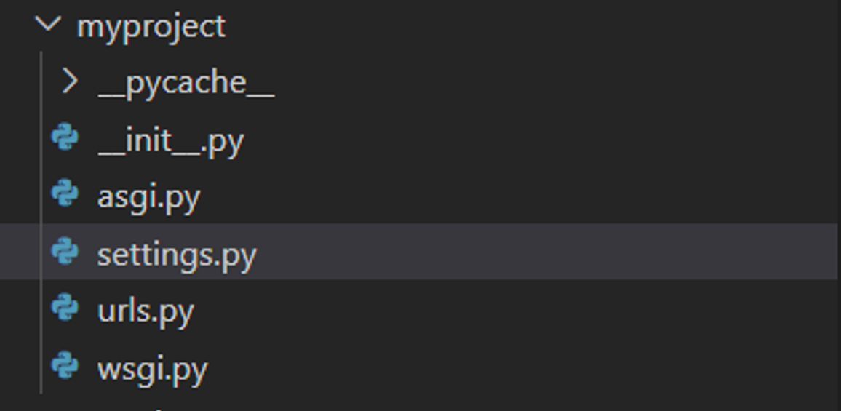

INSTALLED\_APPS = [

    'django.contrib.admin',

    'django.contrib.auth',

    'django.contrib.contenttypes',

    'django.contrib.sessions',

    'django.contrib.messages',

    'django.contrib.staticfiles',

    'myapp.apps.MyappConfig',

]

Let us add a person model. Add the following code in the **models.py** file, in the **myapp** folder.

From django.db import models.

class Person(models.Model):

    last\_name = models.TextField()

    first\_name = models.TextField()

You need to register this model in the **admin.py** code.

From django.contrib import admin.

# Register your models here.

from .models import Person

admin.site.register(Person)

Log in with the super user username and password. You’ll now see the models from **myapp**.

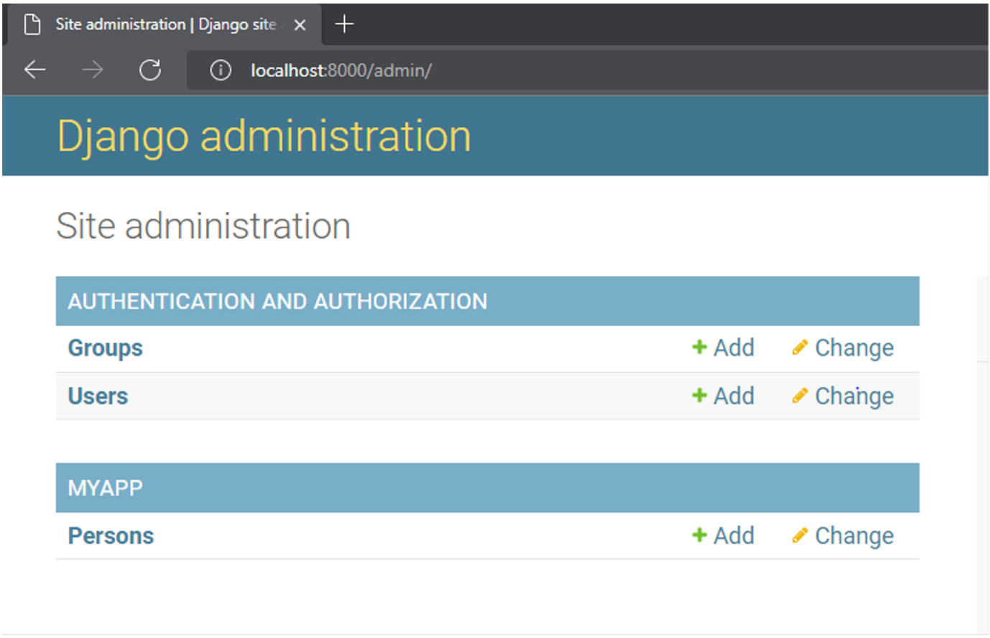

Let’s add a Person object. The following view shows that the one-person object is added.

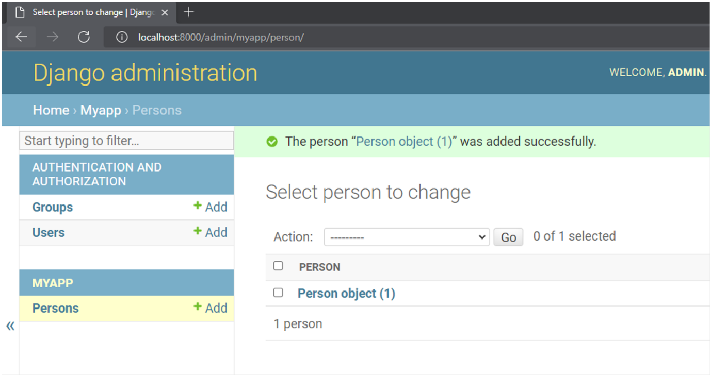

Instead of the count of objects currently present, you would like to have a more meaningful output. To do that, add **\_\_str\_\_()** method to Person class. The string representation of the object will show the first and last name in concatenated form.

From django.db import models.

class Person(models.Model):

    last\_name = models.TextField()

    first\_name = models.TextField()

    def \_\_str\_\_(self):

        return f"{self.last\_name}, {self.first\_name}"

Refresh the model page. It now shows the display as desired.

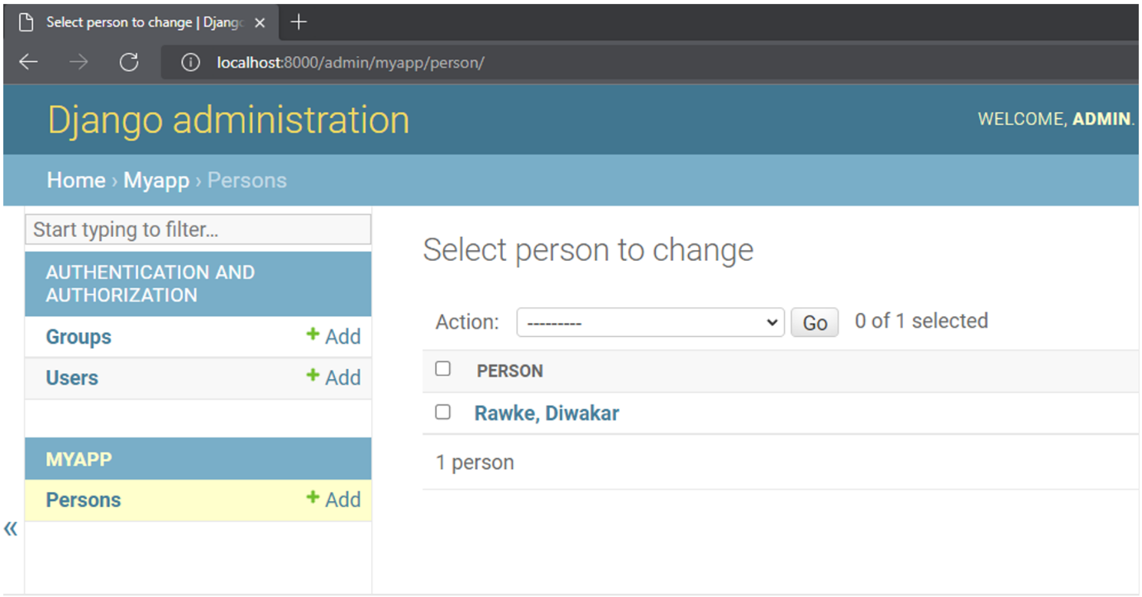

To further customize how the models are displayed in the admin interface, decorate a subclass of **ModelAdmin** and register it with **@admin.register()** decorator (just as you did with **UserAdmin**). Set the **list\_display** attribute of this class to display the fields in columns.

From django.contrib import admin.

from .models import Person

@admin.register(Person)

class PersonAdmin(admin.ModelAdmin):

    list\_display = ("last\_name", "first\_name")

The person model is displayed in the interface with the first and last names in two columns. The columns are clickable so that the object can be edited.

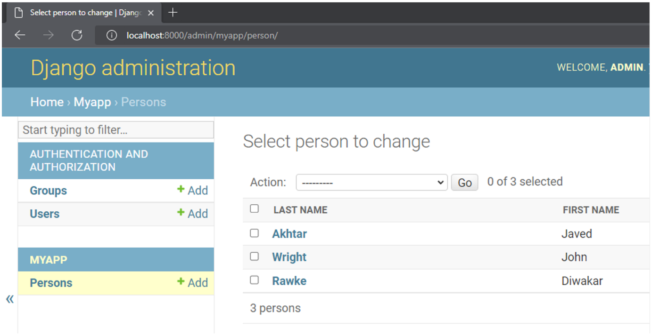

Further, you can provide a search field so that the objects satisfying the filter will be displayed only. Here, the filter is applied to the first name starting with the given letter.

From django.contrib import admin.

# Register your models here.

from .models import Person

@admin.register(Person)

class PersonAdmin(admin.ModelAdmin):

    list\_display = ("last\_name", "first\_name")

    search\_fields = ("first\_name\_\_startswith", )

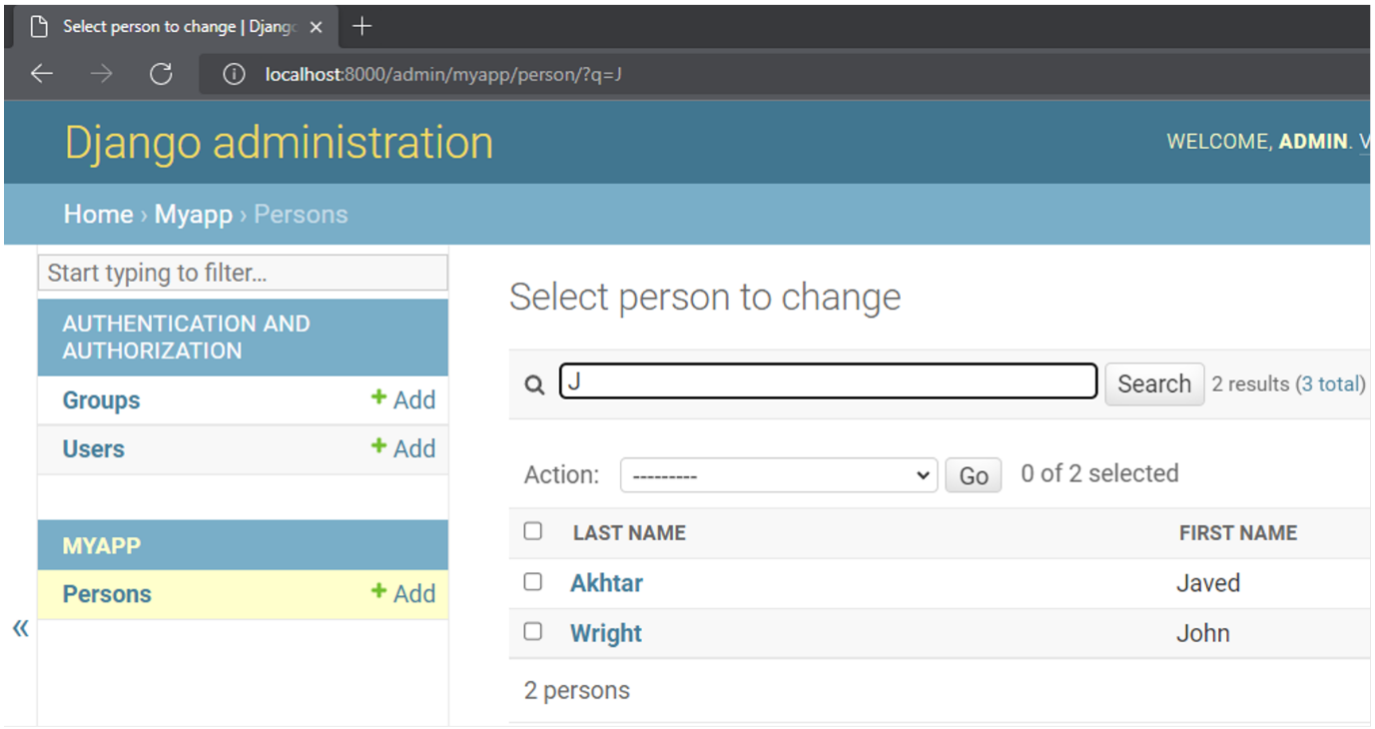

In this reading, you learned how to manage users by creating individual user profiles and user groups using Django’s Admin panel.

# V13.1

# Enforcing Permissions

The Django Admin interface makes it possible to grant and enforce permissions to access the model data. By default, all users get the Add, Change, View and Delete permissions on all models.

If a model requires a user to gain access through special permissions, this can be granted through Django Admin.

## Model Permissions in Admin Interface

Let’s assume that there is a Product model in a Django app named **myapp**. Here, a custom permission called **change\_category** has been defined.

class Product(models.Model):

    ProductID: models.IntegerField()

    name : models.TextField()

    category : models.TextField

    class Meta:

        permissions = [('can\_change\_category', 'Can change category')]

This name of permission will be visible in the list of available user permissions when a new user is added or an existing group is edited.

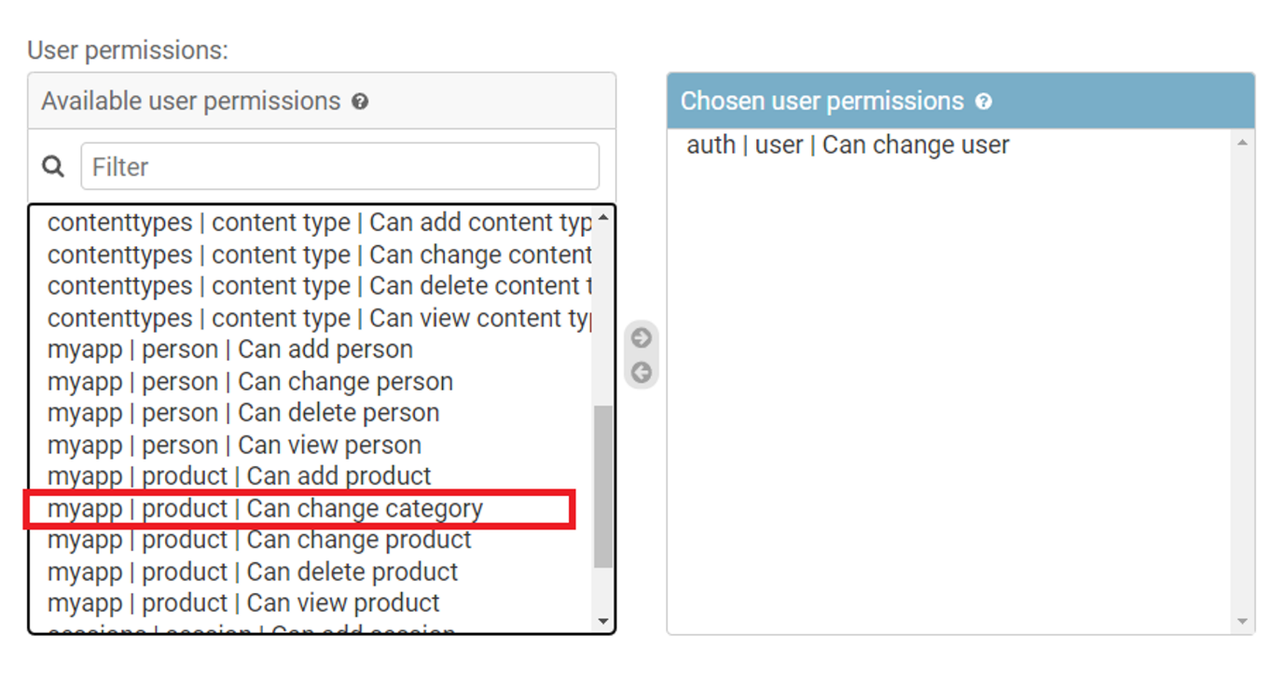

However, outside of the admin environment, the Django models by themselves don't have a mechanism to enforce permissions because it is unaware of the user identity that is performing the action.

The Django app receives user information through the **request** context. Often, permissions are enforced at the view layer. However, you can do so from inside **templates**, **URLs** and function-based and class-based views.

**Enforcing permissions at the view level**

If a user has logged in and has been authenticated, its details are available to the view function in the form of **request.user object**. If not, the value of **request.user** is an instance of **AnonymousUser**. In that case, the permission to call a view can be denied as follows:

from django.core.exceptions import PermissionDenied

def myview(request):

    if request.user.is\_anonymous():

        raise PermissionDenied()

Alternatively, you can decorate the view with a **login\_required** decorator. It only allows access for logged users.

from django.http import HttpResponse

from django.contrib.auth.decorators import login\_required

 @login\_required

def myview(request):

    return HttpResponse("Hello World")

Another way of restricting access to a view is by using the **@user\_passes\_test()**decorator. It takes one mandatory argument, which is a function returning True or False. If True is returned, the decorated view function defined below it is invoked.

Let’s define a function **testpermission()**. It returns True if the user is authenticated and has a **change\_category** permission.

def testpermission(user):

    if user.is\_authenticated() and user.has\_perm("myapp.change\_category"):

        return True

    else:

        return False

This function is then used as an argument to the **@user\_passes\_test()** decorator. The view function defined below it will be invoked if the **testpermission()** function returns True.

from django.contrib.auth.decorators import user\_passes\_test

@user\_passes\_test(testpermission)

def change\_ctg(request):

    # Logic for making change to category of product model instance

The **user\_passes\_test()** can be given an additional argument – login\_url. The user will be redirected to this URL if the **testpermission()** function returns False. Typically, it is mapped to a view that renders a login page.

Another method to enforce permission at the view level is with the **@permission\_required()** decorator. Unless the user possesses the permission mentioned as an argument, the view function won’t be called.

from django.contrib.auth.decorators import permission\_required

@permission\_required("myapp.change\_category")

def store\_creator(request):

    # Logic for making change to category of product model instance

The above example enforces the permission on a function-based view. Django framework also has a class-based view mechanism.

To enforce permissions on a class-based view, you need to use **PermissionRequiredMixin** and set the **permission\_required** attribute of the view class to the permission you want to enforce.

Here is an example:

Assuming that a product model is present in **models.py**. The ProductListView class view renders a list of products only if the user has view permission on this model.

from django.contrib.auth.mixins import PermissionRequiredMixin

from django.views.generic import ListView

from .models import Product

class ProductListView(PermissionRequiredMixin, ListView):

    permission\_required = "myapp.view\_product"

    template\_name = "product.html"

    model = Product

## Enforcing permissions in Template

To generate dynamic content on the web page, Django uses its own template language. Along with conditional and iterative statements (**if** and **for**), the special variables user and perms are available inside the template language blocks.

These variables are passed into the template context by the view function. Then, you can check various user attributes, such as **is\_authenticated** and render the information on the web page accordingly. A typical template looks like this:

<html>

<body>

{% if user.is\_authenticated %}

         {#  to be rendeed if the user has been authenticated  #}

    {% endif %}

<body>

</html>

Similarly, the available permissions can be checked inside the template with **perms.name syntax**.   For example:

<html>

<body>

{% if perms.myapp.change\_category %}

  {#  To be rendered for users having required permission #}

   {% endif %}

<body>

</html>

## Enforcing permissions in URL patterns

This method is especially useful when there’s a view function to intercept the request and the URL directly sends the control to a static page.

To configure the pattern, you use the **url()** function, in which the permission decorators can be used.

from django.conf.urls import url

from django.contrib.auth.decorators import login\_required, permission\_required

urlpatterns = [

    url(r'^users\_only/', login\_required(myview)),

    url(r'^category/', permission\_required('myapp.change\_category', login\_url='login')(myview)),

]

In this reading, you learned about the various available methods to enforce permissions. It can be done through the admin site, at the view level, inside the template as well as while defining URL patterns.

**Exercise: Using Django Admin**

Open Lab

**Instructions**

**Goal**

* Learner will learn to use the Django admin panel.

**Objectives**

* Learner will create a super user that will have administrative rights.
* Learner will create an entry for a specific user and create another new user and assign specific permissions to it using the admin panel of Django.

**Introduction**

In this lab, you will create a model called **Employees** and learn how to use the Django admin panel for creating users and assigning permissions to those users.

**Scenario**

The owners Adrian and Mario feel there is a better way to track their employees' hours and responsibilities and have created a database of their employees. While the commands in the Django shell can be used for making changes, neither of the owners have a technical background and prefer an easier way to address this. You have been assigned the task of providing a user interface to Adrian and Mario by setting up the Admin panel.

This lab will require you to modify the following files:

* **models.py**
* **admin.py**

Additionally, you are required to use the command line console inside the terminal of VS Code.

If not open already, go to **Terminal** on the Menu bar at the top of your screen and select **New Terminal**.

You have already built the project named **myproject** and added an app inside the project called **myapp**.

Follow the instructions below and ensure you check the output at every step:

**Steps**

**Step 1:**  Create a class called **Employees** inside the file **models.py**. Inside it, pass **models.Model** as a parameter.

**Step 2:**  Create the four attributes that you are going to require in the model and assign the respective form fields to them. Additionally pass the specified arguments to those form fields:

| **Attribute** | **Form field type** | **Arguments** |
| --- | --- | --- |
| **first\_name** | **CharField** | **max\_length = 200** |
| **last\_name** | **CharField** | **max\_length = 200** |
| **role** | **CharField** | **max\_length = 100** |
| **shift** | **IntegerField** |  |

**Step 3:**  Go to the file **admin.py** and register the Model that you created by passing the model name to the function **admin.site.register()**.

Tip: Make sure you have imported the Employee model inside the **admin.py** file.

**Step 4:**  Open the file **settings.py** and make sure the app configurations are present inside **INSTALLED\_APPS** list.

**Tip:** They can look either like **'myapp'** or **'myapp.apps.MyappConfig'**.

**Step 5:**  In the terminal run the command to make migrations using both required commands.

Tip: Ensure you are in the directory that contains the **manage.py** file.

Note: The output of the first command will look similar to the screenshot below:

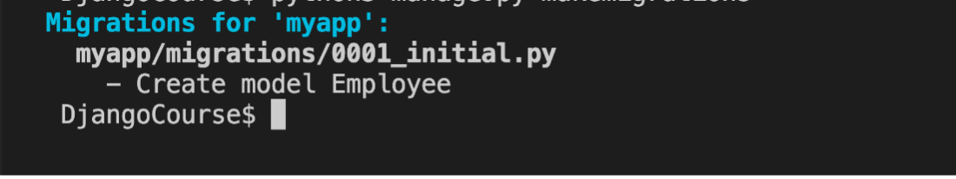

**Step 7:**  Run the command to create a super user using the script from **manage.py**.

**Tip:** Recall the use of keyword **createsuperuser**

**Step 8:**  Add the following details for username, email, password, and password confirmation.

| **Username** | **admin** |
| --- | --- |
| Email | admin@littlelemon.com |
| Password | lemonAdmin@3! |
| Password confirmation | lemonAdmin@3! |

**Note:** After addressing all the prompts on the screen, you should get a message such as:



**Step 9:**  Run the command to run the server and launch the browser at the localhost URL.

**Step 10:**  In the browser address bar, type the URL that will render the administration login page.

**Tip:** It will mean adding the suffix for the admin page to the localhost URL.

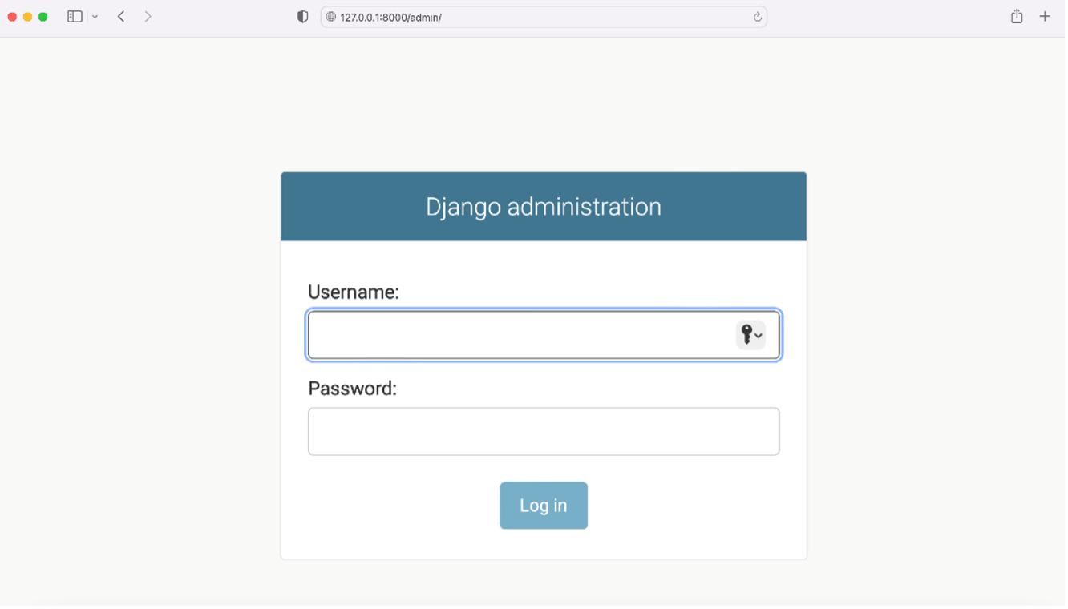

**Step 11:**  Enter the login credentials you just created in the form that appears and log in to the admin panel.

**Step 12:**  Go to the Employees table under the **myapp** section and click on the **Add Employee** button.

**Step 13:**

Add the following details for the employee:

* First name: Priya
* Last name: Giti
* Role: Chef
* Shift: 1

Save the details by clicking the **Save** button. Notice that the **Employee object(1)** will be created.

**Step 14:**  Now keep the server running and Django admin open, go back to the file **models.py**. Inside the Employee class, add the following code at the bottom:

def \_\_str\_\_(self) -> str:

    return self.first\_name

Save the **models.py** file.

Go back to the **Admin** page in the browser and refresh the **Employee** page on the screen.

Notice that the **Employee object(1)** now changes to **Priya**.

**Step 13:**  Next go to the Users section and add a new user by first clicking **Add user**. Next enter the details requested for username, password, and password confirmation.

| **Username** | **jason\_chef** |
| --- | --- |
| Password | lemonChef@123! |
| Password confirmation | lemonChef@123! |

**Step 14:**  Make sure a notification for adding user such as **jason\_chef** is visible on the screen.

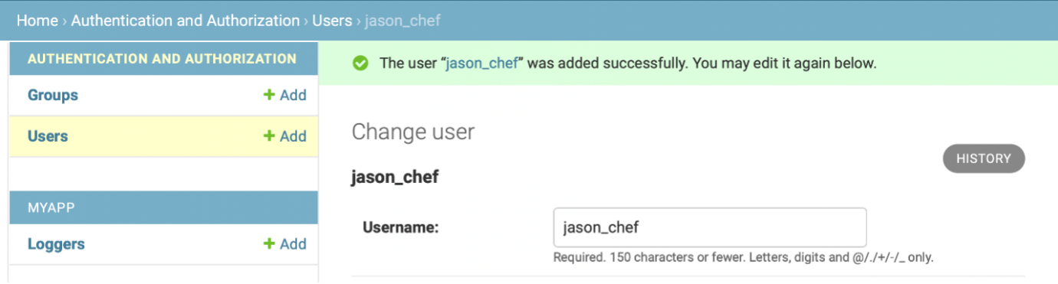

**Step 15:**  Select the new user created under the **Users** tab and update the Staff status **Permissions** to the new user.

Assign all the user permissions for **admin | log entry** to the new user. From the table **Available user permissions**, select the specific permissions by clicking on the right arrow button to move them to the Chosen user permissions table.

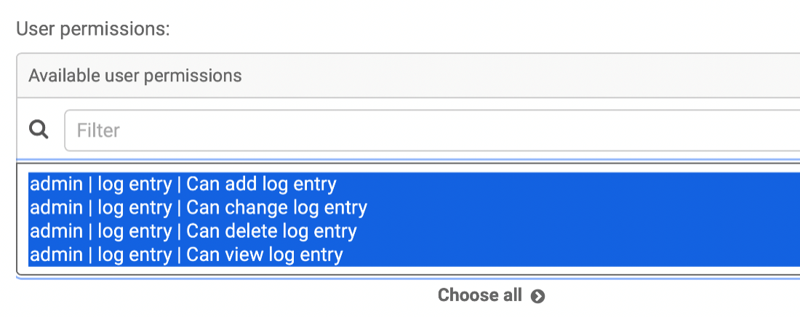

Finally, go to the bottom of the screen and click on the **SAVE** button.

**Note:** The visibility of **Chosen user permissions** on the screen is subjective to the screen resolution.

**Concluding Thoughts**

In this lab, you practiced creating a super user that has administrative rights to use the Django administration panel. You also practiced creating an entry for a specific user and assigning permissions using the admin panel of Django.

# Solution: Using Django Admin

**models.py**

from django.db import models

# Create your models here.

class Employee(models.Model):

    first\_name = models.CharField(max\_length=200)

    last\_name = models.CharField(max\_length=200)

    role = models.CharField(max\_length=100)

    shift = models.IntegerField()

    def \_\_str\_\_(self):

        return self.first\_name

**admin.py**

from django.contrib import admin

from .models import Employee

# Register your models here.

admin.site.register(Employee)

**Commands for running migrations:**

# Command to perform migrations

python3 manage.py makemigrations

python3 manage.py migrate

# Command to run server

python3 manage.py runserver

# Command to create a super user

python3 manage.py createsuperuser

# Additional resources

The following resources will be helpful as additional references in dealing with different concepts related to Django admin, Django-admin and manage.py commands and permissions.

[django-admin and manage.py – official documentation](https://docs.djangoproject.com/en/4.1/ref/django-admin/)

[Using the Django authentication system](https://docs.djangoproject.com/en/4.1/topics/auth/default/)

[Django Admin site – MDN web docs](https://developer.mozilla.org/en-US/docs/Learn/Server-side/Django/Admin_site)

[Django Admin-site – Comprehensive](https://docs.djangoproject.com/en/4.1/ref/contrib/admin/)

[Django permissions – TestDriven](https://docs.djangoproject.com/en/4.1/topics/auth/customizing/)

# V15.1

# Configuring MySQL Connection

By default, Django uses the SQLite database for storage and retrieval of the app data, as Python has built-in support for it. However, you can use any of the following databases supported by Django:

* PostgreSQL
* MariaDB
* MySQL
* Oracle
* SQLite

In this Reading, you’ll learn the steps to enable a MySQL connection with a Django application.

## Advantage of MySQL

The SQLite database has a lot of limitations. It is serverless and doesn't have a user management system. It is useful for smaller applications and for the development of a prototype to be upgraded eventually for databases that are scalable and support client-server architecture.

MySQL is an open-source database and has a lot of advantages over SQLite, such as scalability and authentication.

## Install MySQL

To install the MySQL server, download the installer appropriate for your operating system from <https://www.mysql.com/downloads/>. For Windows, use the **mysql-installer-web-community-8.0.30.0.msi** and follow the wizard-based installation steps.

 Start the MySQL command line client with the following command:

mysql -u root -p

You will be prompted to enter the password set at the time of installation. In the command terminal, you will get the MySQL prompt. You can now enter any SQL statement in it.

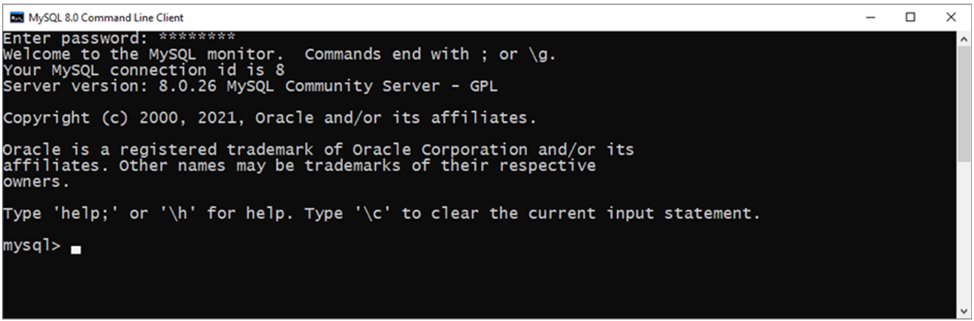

Start by creating a database with the following command:

Create database mydatabase;

The **show databases;** command will show the list of currently available databases.

### Install MySQL DB API Driver

To interface a Python program with MySQL, ensure you have a DB API-compliant driver. There are a number of Python drivers for MySQL available. Django recommends **mysqlclient**to be used. Install it with pip installer.

pip3 install mysqlclient

## Enable MySQL

To be able to use MySQL, the **DATABASES** variable in the Django project’s settings file must be properly configured. By default, it is set to the connection parameters for SQLite. Remove those statements. You have to add MySQL-specific settings in their place.

You must configure at least one database in the **DATABASES** variable. For the configuration of the first database, its name should be **‘default’**.

The settings include the **database engine**, name of the database, username, and password, along with the host IP address. This defaults to the localhost 127.0.0.10 and the port defaults to 3306.

### #Settings.py

DATABASES = {

    'default': {

        'ENGINE': 'django.db.backends.mysql',

        'NAME': 'mydatabase',

        'USER': 'root',

        'PASSWORD': '',

        'HOST': '127.0.0.1',

        'PORT': '3306',

        'OPTIONS': {

            'init\_command': "SET sql\_mode='STRICT\_TRANS\_TABLES'"

        }

    }

}

The other optional parameters include:

* **sql\_mode**: The session SQL mode will be set to the given string. It defaults to **'STATIC\_TRANS\_TABLES'** to prevent invalid or missing values from being stored in the database.
* **default-character-set**: The character set to be used. Default is utf8.
* **read\_default\_file**: MySQL configuration file to read.
* **init\_command**: Initial command to issue to the server upon connection.

## Create database tables

The **startproject**template installs some Django apps by default. Some examples include admin, auth and sessions.

Remember that you need to create the necessary database tables for these apps.

Run the migrate command to use the models in these apps and build their respective table structure in the current **mysql** database.

python manage.py migrate

Inside the MySQL terminal, run the following commands:

use mydatabase;

Show tables;

It shows all the tables created by the migration.

Instead of viewing the data in the MySQL terminal, add a MySQL extension from VS Code extension library

**VS Code extension for MySQL**

From the VS Code extension marketplace, search for MySQL and install the extension.

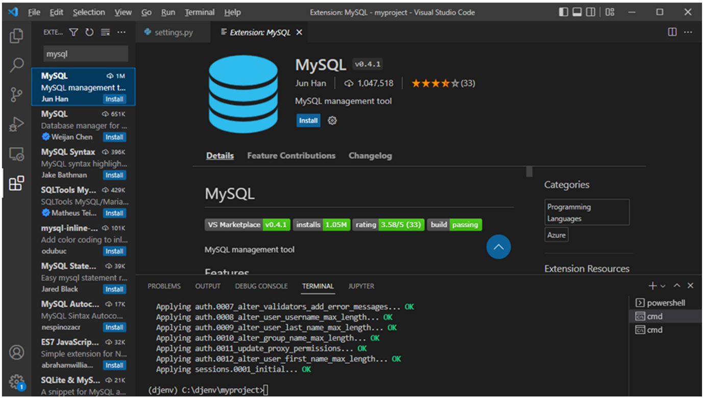

MySQL appears in the explorer.

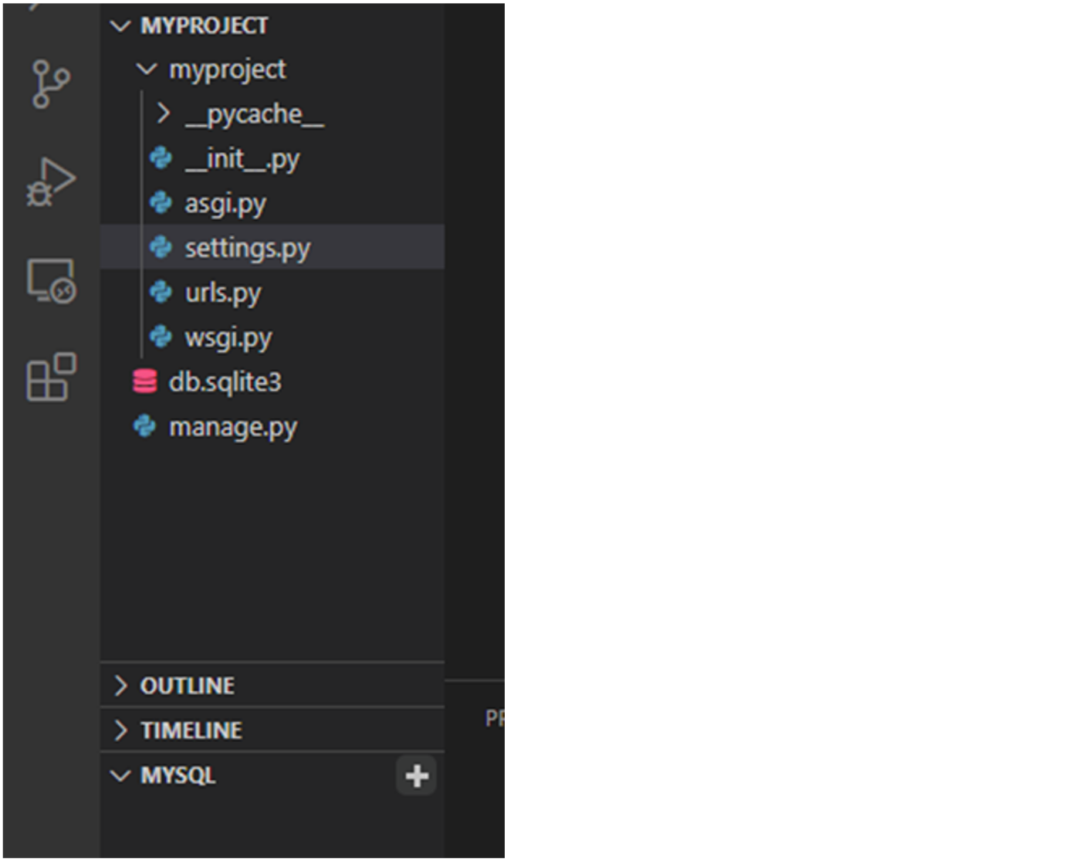

Click on the **+** button and enter the following details:

**domain name: localhost**

**user:root**

**password=''.**

**Note:** Some users may encounter an error such as: **Client does not support authentication protocol requested by server; consider upgrading MySQL client**

* This usually indicates a user privilege issue. In such cases first run a command such as:

**ALTER USER 'root'@'localhost' IDENTIFIED WITH mysql\_native\_password BY 'password';**

* Then refresh privileges by running a command such as:

**flush privileges;**

Now, the localhost appears in the explorer bar.

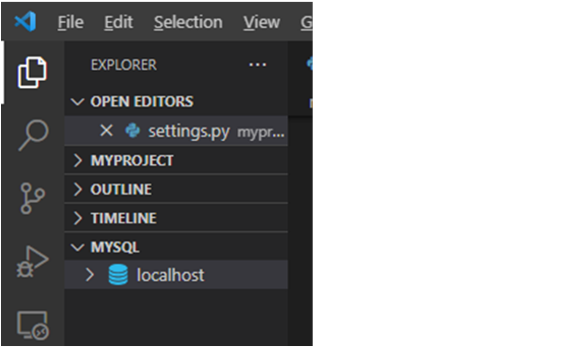

Expand the section by selecting the drop-down arrow and choose **mydatabase**. All the tables required for the **INSTALLED\_APPS** will be visible.

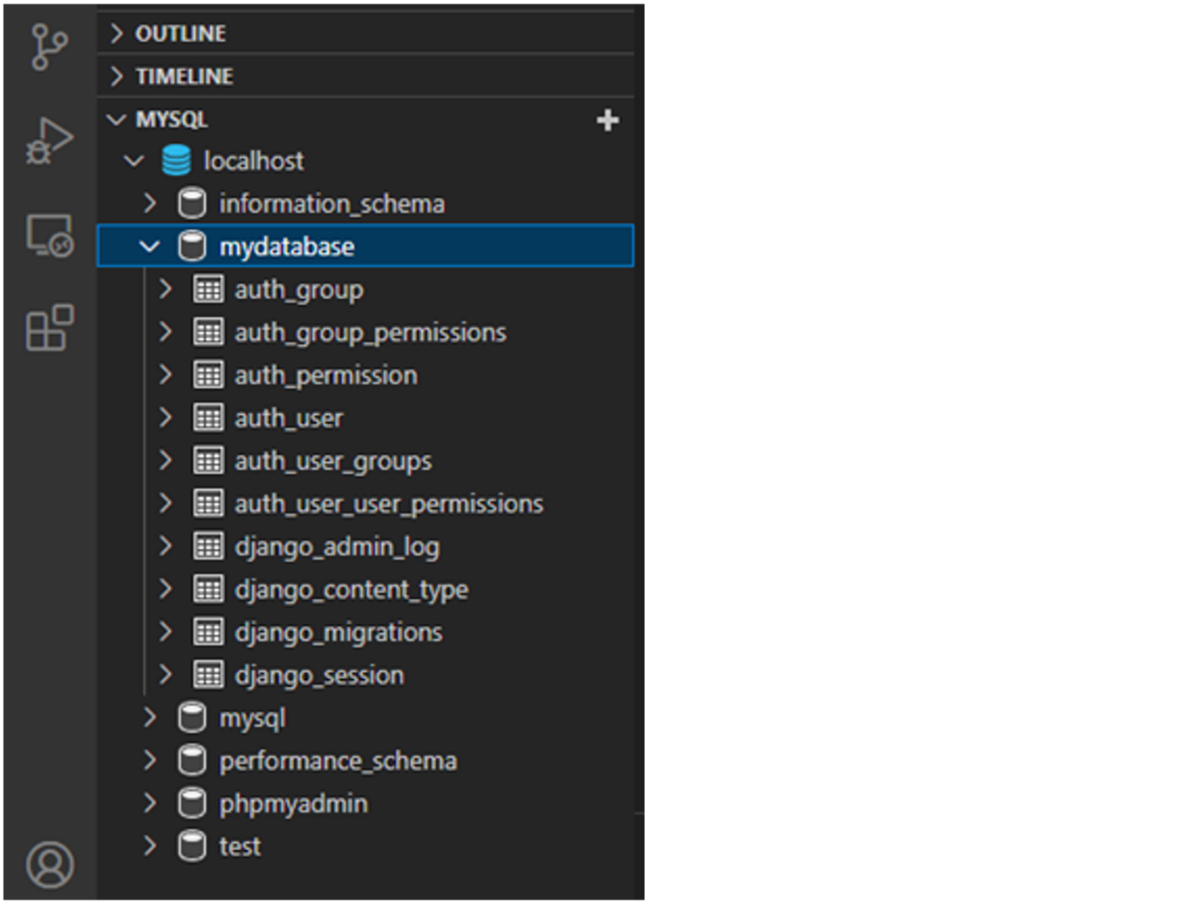

In this reading, you have explored how to connect MySQL database with Django.

**Exercise: Connecting to a Database**

Open Lab

**Instructions**

**Goal**

* Learner will create and connect to a MySQL database that can be used inside a Django project.

**Objectives**

* Learner will create new MySQL database.
* Learner will update the project settings in Django to enable connection with MySQL.

**Introduction**

So far, you've learned how to work with the default SQLite database inside your Django project.

In this lab you will create and connect to an external MySQL database that can be used inside a Django project.

**Scenario**

The owners of Little Lemon are appreciative of the feedback they receive from their customers.

While the scale of the website is relatively small, they still want to have the ability to scale quickly should the business expand.

For example, Adrian has expressed interest in building eCommerce functionality for an online shop and implementing an entire online reservation system for table bookings in the future.

As demand increases and functionality expands, the project may require the use of other database solutions instead of the SQLite database provided by default.

You are tasked with using your existing database creation and connection knowledge to accommodate these requests.

You are required to complete the settings for MySQL database connection with the Django project in place.

**Initial lab instructions:**

This lab will require you to modify the following files:

* **settings.py**

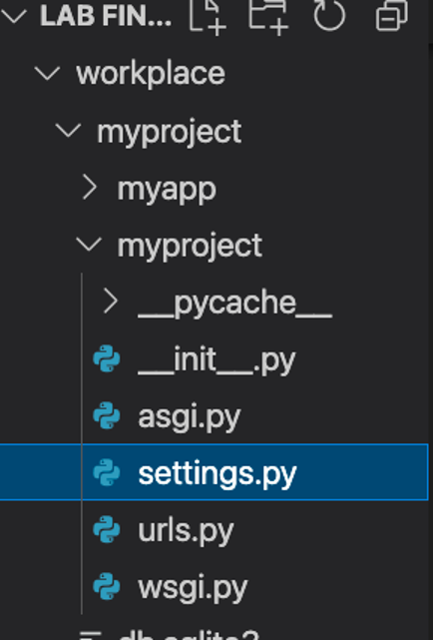

Additionally, you are required to use the command line console inside the terminal of VS Code.

If not open already, go to **Terminal** on the Menu bar at the top of your screen and select **New Terminal**.



You have already built the project named **myproject** and added an app inside the project called **myapp**.

Follow the instructions below and ensure you check the output at every step.

**Steps**

**Step 1:**  In the terminal, run the command that will enable access to **mysql** and enter the **mysql** shell by passing the **-u** and **-p** flags that will enable the MySQL console prompting for password.

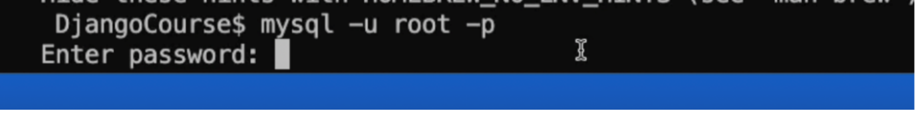

**Note:** The default password set for **mysql** here will be blank/empty. This means that when you receive a prompt for entering the password, simply press the **Enter** key on your keyboard.

**Step 2:**  Once inside the **mysql** file, add the command to show the databases present already.

**Step 3:**  Create a new database with the name **feedback** by running a MySQL query.

**Step 4:**  Run the show database command and ensure the **feedback** database is present already.

**Note:** The **mysqlclient** is already installed as the MySQL database connector.

**Step 5:**  Run the command to exit the **mysql** shell

**Step 6:**  Inside your Django project, open the **settings.py** file and go to **DATABASES** option.

**Step 7:**  Select the values assigned to it by default and replace them with the following code:

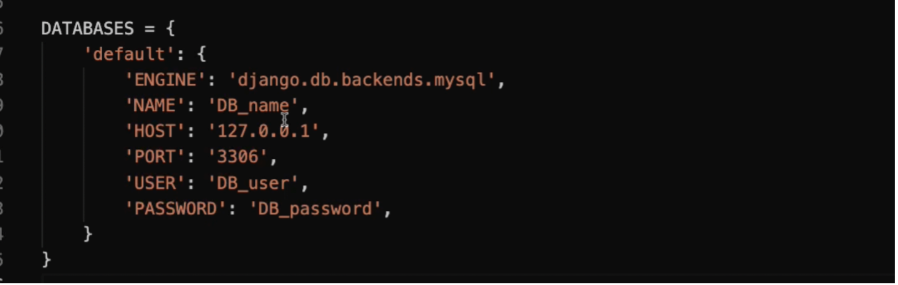

**Step 8:**  After you enter the values, and your code is the same as seen in the screenshot above, replace the values for the following:

| **NAME:** | **'feedback'** |
| --- | --- |
| USER: | 'root' |
| PASSWORD: | '' |
| ENGINE | 'django.db.backends.mysql' |

Save the **settings.py** file.

**Step 9:**  In the terminal, run the command to make migrations.

Make sure you are inside the directory that contains the **manage.py** file.

**Note:** No visible migrations will be performed after the first command is entered.

**Step 10:**  Run the command to perform the migration.

**Concluding Thoughts**

In this lab, you practiced connecting to a MySQL database.

# Solution: Connecting to a Database

## Solution

**settings.py**

# Database

# https://docs.djangoproject.com/en/4.1/ref/settings/#databases

DATABASES = {

    'default': {

        'ENGINE': 'django.db.backends.mysql',

        'NAME': 'feedback',

        'HOST' : '127.0.0.1',

        'PORT' : '3306',

        'USER' : 'root',

        'PASSWORD' : '',

    }

}

INSTALLED\_APPS = [

    'myapp.apps.MyappConfig',

    'django.contrib.admin',

    'django.contrib.auth',

    'django.contrib.contenttypes',

    'django.contrib.sessions',

    'django.contrib.messages',

    'django.contrib.staticfiles',

]

**Commands for running migrations:**

python3 manage.py makemigrations

python3 manage.py migrate

**Commands used inside MySQL:**

1. mysql -u root -p

2. SHOW DATABASES;

3. CREATE DATABASE feedback;

4. exit

# Additional resources

The following resources will be helpful as additional references in dealing with different concepts related to the topics you have covered in Database Configuration.

[Databases – Django official](https://docs.djangoproject.com/en/4.1/ref/databases/)

[MySQL notes – Django official](https://docs.djangoproject.com/en/4.1/ref/databases/#mysql-notes)

[Installing MySQL Client](https://docs.djangoproject.com/en/4.1/ref/databases/#mysql-db-api-drivers)

[Installing MySQL on MacOS](https://dev.mysql.com/doc/refman/5.7/en/macos-installation.html)

[Installing MySQL on Windows](https://dev.mysql.com/doc/refman/5.7/en/windows-installation.html)

[Installing and configuring MySQL with Django](https://docs.djangoproject.com/en/4.1/ref/databases/#mysql-notes)

# V1.1(mod4)

# Template Examples

In this reading, you will be introduced to simple template code examples covering variables and filters. More in-depth explanations and examples are provided in a later lesson.

## HTML response

Django’s view function returns a **HttpResponse** whose content-type header is " **text/html**" by default. So, if it enters a string, it is rendered as HTML on the browser. The string itself may have certain HTML tags embedded in it. Accordingly, the browser interprets the tags and renders them.

Look at the following view function. It returns a string with Hello World tucked between **<h1>** and **</h1>** tags.

from django.http import HttpResponse

def index(request):

return HttpResponse("<h1>Hello, world. </h1>")

Let’s say that the app is properly configured and that it is included in the **INSTALLED\_APPS**, and the function is mapped to the **appname/** URL in the **urls.py** file, you’ll get the **Hello World** message in the H1 tag.

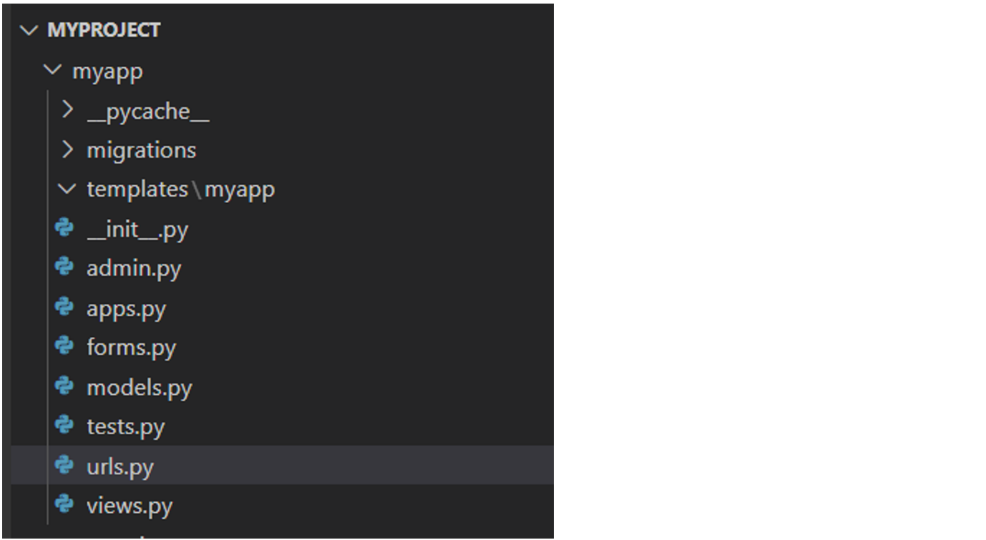

You can write the entire web page script in a string and use it as an argument to the **HttpResponse**. But what if there is some variable information in between the static HTML?

For example, let's reference the code block above.

What happens if you want to say **Hello** to a person whose name appears in the URL as a parameter? You can use Python’s string substitution and pass it as a response.

from django.http import HttpResponse

def index(request, name):

return HttpResponse("<h1>Hello, {}. </h1>".format(name))

Generating HTML from Python code takes time and can be complicated.  It needs frequent escaping, especially if there are many variables.

Introducing certain conditional logic will be more difficult. That's when you use the templates.

A template is an HTML file with placeholders for variable data marked by a special syntax. Django uses its own template language called Django Template Language (DTL). Just the HTML, the DTL has its own tags that control how the variable part is filled.

To replace the **Hello World**, create a **hello.html** file and place it in the templates folder in the Django project’s **BASE\_DIR**.

<html>

<head>

<title>My django website</title>

</head>

<body>

<h1>Hello World</h1>

</body>

</html>

## Rendering a Template

In the view function, import the loader class from the **django.template** module and obtain the template object from **hello.html**. You can now render it as the **HttpResponse**.

from django.http import HttpResponse

from django.template import loader

def index(request):

    template = loader.get\_template('hello.html')

    context={}

    return HttpResponse(template.render(context, request))

If it seems slightly complicated, Django provides a shortcut method called **render()**. It eliminates the **HttpResponse** and loader classes.

from django.shortcuts import render

return render(request, 'hello.html', {})

## Variable tag

In the above code, the **render()** function’s third parameter is an empty dictionary object. It is called the template context. You should pass the path parameter as a context to **hello.html**.

from django.shortcuts import render

def index(request, name):

    context={"name":name}

    return render(request, 'hello.html', context)

Modify the **hello.html** file by replacing **World** with the Django variable syntax. Put the key of the context dictionary **name** inside double curly brackets as in **{{ name }}**.

<html>

<body>

<h1>Hello {{ name }}</h1>

</body>

</html>

You can use **{% if %}** tag of DTL to implement a conditional logic inside the template. Similarly, with **{% for%}**and**{% endfor %}** tags, a looping construct can be built in the template, which may be useful to display records from a database table on the web page. Django’s Template Language has many more tags. You’ll explore this in a subsequent lesson.

### Filters

Another important part of Django Template Language is the filters. While tags may be considered similar to keywords in a programming language, the filters merely represent the temporarily modified value of a template variable. The filter is applied to a variable by the**|**(known as Pipe) symbol, such as:

{{ variable\_name | filter\_name }}

Here are some filters in action. The **index()** view in the above examples receives a name parameter, and it is rendered in the template with the **{{ name }}** expression tag. If you apply the upper filter to it, the name will be rendered in uppercase.

{{ name | upper }}

As a result, if the path parameter passed to the view is **John**, it will be rendered as **JOHN**.

Likewise, the **lower** filter converts the string to its lowercase, the **title** filter renders a string so that the first letter of each word in a multi-word string appears in uppercase. Therefore, the string “**simple is better than complex**” becomes “**Simple Is Better Than Complex**”.

The **length** filter works with a list and returns the number of items in it. The view passes a list as a context to the template: **nums=[1,2,3,4]**

The **template** filter **{{ nums | length }} outputs 4**

The **wordcount** filter is similar. It tells you how many words are present in the template variable that has to be a string. For example:

**String = 'Simple is better than complex'**

**is passed a context,**

**{{ string | wordcount }} returns 4.**

The **slice** filter resembles Python’s slice operator, which separates a part of the given list object. So, if:

**nums = [1,2,3,4,5,6,7,8]**

**Is passed in the context,**

**{{ nums | slice[1:2] }}**

It returns **[2,3]** and then you can iterate over it.

The **first** and **last** filters return the first and last item in the list.

Like the tags, Django also has a large number of filters. You'll learn more about these tags in a forthcoming lesson.

**Exercise: Creating Templates**

Open Lab

**Instructions**

**Goal**

* The learner will practice using Templates in Django

**Objectives**

* The learner will create views for Menu and About page
* The learner will create respective templates for the two views
* The learner will pass the dictionary and other static content such as images inside the webpages created

**Introduction**

In this lab you will create a template for the **Menu** and **About** pages of the Little Lemon website using the functionalities such as the **render()** function, Dynamic Template Language (DTL), and practice rules for creating templates.

**Scenario**

The Little Lemon website prototype is progressing well. Now the owners feel it's time to focus on the user interface and have asked you to re-design the **About** and **Menu** pages using a basic HTML template.

At this point, they do not want to use any advanced HTML or CSS code, as it will be added later.

Your task is to use your existing knowledge of the **render()** function, dictionaries, and Django templates to display a basic HTML template in the browser containing some text and images.

**Learner Instructions**

Initial Lab Instructions:

This lab will require you to modify the following files:

* **settings.py**
* **views.py**
* **templates/menu.html**
* **templates/about.html**

Additionally, you are required to use the command line console inside the terminal of VS Code.

If not open already, go to **Terminal** on the Menu bar at the top of your screen and select **New Terminal**.

**Note:**

You have already built the project named **myproject** and added an app inside the project called **myapp**.

Follow the instructions below and ensure you check the output at every step and update the necessary files to create different views.

**Steps**

**Step 1:**

Expand the **myproject** folder on the left-hand side menu and open the **settings.py** file and set the value of **DIRS** option to **'templates'** inside the **TEMPLATES** list.

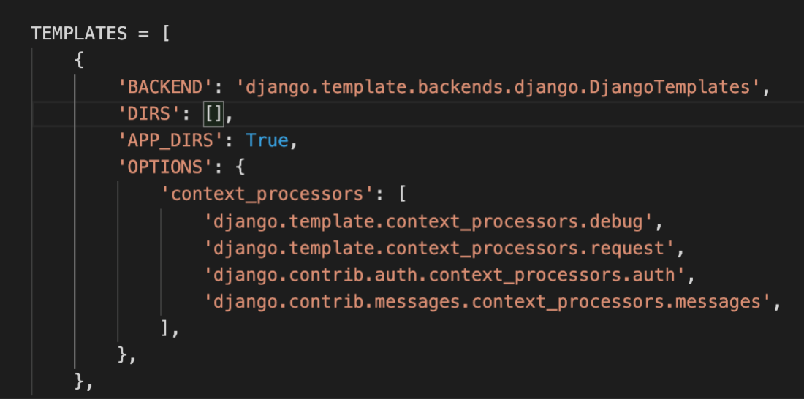

**Step 2:**

Open the**views.py** file and create two view functions:

* **Menu**
* **About**

**Tip:** Make sure to pass the request object as an argument inside both function declarations.

Inside the body of the About function, create a variable called **about\_content** and assign it to a dictionary with the following key-value pair:

{'about': "Little Lemon is a family-owned Mediterranean restaurant, focused on traditional recipes served with a modern twist. The chefs draw inspiration from Italian, Greek, and Turkish culture and have a menu of 12–15 items that they rotate seasonally. The restaurant has a rustic and relaxed atmosphere with moderate prices, making it a popular place for a meal any time of the day."}

**Tip:** To tun on the feature for word wrap, use the keyboard shortcut **ALT+Z**.

**Step 3:**

Add the return statement with the **render()** function and pass the following arguments:

**render(request, 'page.html', {'content':variable\_content})**

* Replace **page.html** with the name of the HTML page you want to render.
* In the dictionary, replace **variable\_content** with the name of the variable you created in the view function.
* Make sure to import the **render()** function for use

**Step 4:**

Create a folder called **templates** at the root project-level directory.

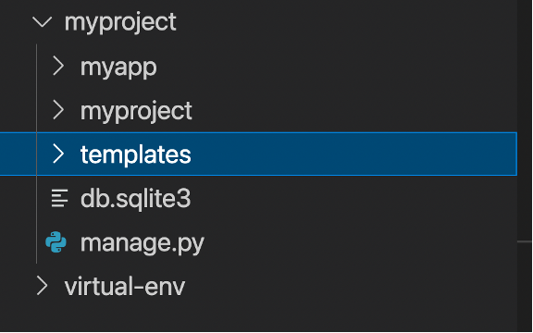

**Step 5:** Inside the templates folder, create two files with the following names

* **menu.html**
* **about.html**

**Step 6:** Add the contents of the HTML code provided below to both the **about.html** and **menu.html** files:

<!DOCTYPE html>

<html lang="en">

<head>

<meta charset="UTF-8">

<meta http-equiv="X-UA-Compatible" content="IE=edge">

<meta name="viewport" content="width=device-width, initial-scale=1.0">

<title>Document</title>

</head>

<body>

<!-- Add heading code -->

<!-- Add paragraph code -->

<!-- Add image code -->

</body>

</html>

**Step 7:** Inside the code, you just pasted, locate the line with the comment **<!-- Add heading code -->**. Below this line, add the following code and replace <Enter page name> with the name of the page.

**menu.html**

<!-- Add heading code -->

<h1 style="color: #495E57"> <Enter page name and remove these surrounding angled brackets> </h1>

**about.html**

<!-- Add heading code -->

<h1 style="color: #495E57"> <Enter page name and remove these surrounding angled brackets> </h1>

**Step 8:** In the terminal run the command to run the server and launch the browser at the localhost URL.

**Step 9:** In the browser, navigate to the following URLs:

**https:127.0.0.1:8000/about**

**https:127.0.0.1:8000/menu**

**Step 10:** Once you have confirmed that both the URLs display the expected output, open the about.html page in the templates folder, and add the following code below the HTML comment: **<!-- Add paragraph code -->**.

<!-- Add paragraph code -->

<p><Enter text> </p>

In the code above, replace the contents of **<Enter text>** with a DTL variable to display the dictionary that has about as the key.

**Tip:** Make sure you have added Django-specific syntax **{ }** surrounding the key.

**Tip:** Recall the object we have passed to the template and access the variable present inside it.

**Step 11:** In VS Code, save the **about.html** file. In the browser, refresh the **about.html** page and check that it displays the contents of the dictionary passed.

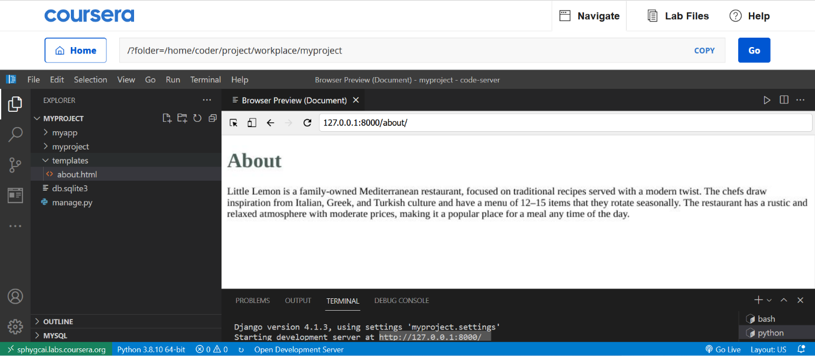

**Static files**

The next part of this lab will explore another useful component of Django: Adding static files to the website.

The static image **dessert.jpg** that you will use is already added inside the app directory under the **myapp/static** folder and you can use it once you configure the settings.

**Step 12:** Open the **settings.py** file, and add a declaration for the list called **STATICFILES\_DIRS** with the following value:

**'myapp/static',**

**Tip:** Make sure you add a comma **,** after the string.

**Step 13:** In the left explorer pane of VS Code inside the myapp folder, expand the **static** folder. Expand the **img** folder and notice that an image file with the name **dessert.jpg** is present.

Open the **menu.html** file and add the following code below **<!-- Add image code -->**

<!-- Add image code -->

<img src="{% static 'img/dessert.jpg' %}">

**Tip:** To place an image from the static folder inside a Django template file, make sure to place the following code at the beginning of the HTML file that references the static content.

**{% load static %}**

**Tip:** To place an image from the static folder inside a Django template file, use the HTML <img> tag, and inside the **href=""** attribute, place the Django **{% static %}**and specify the path the image you want to load.

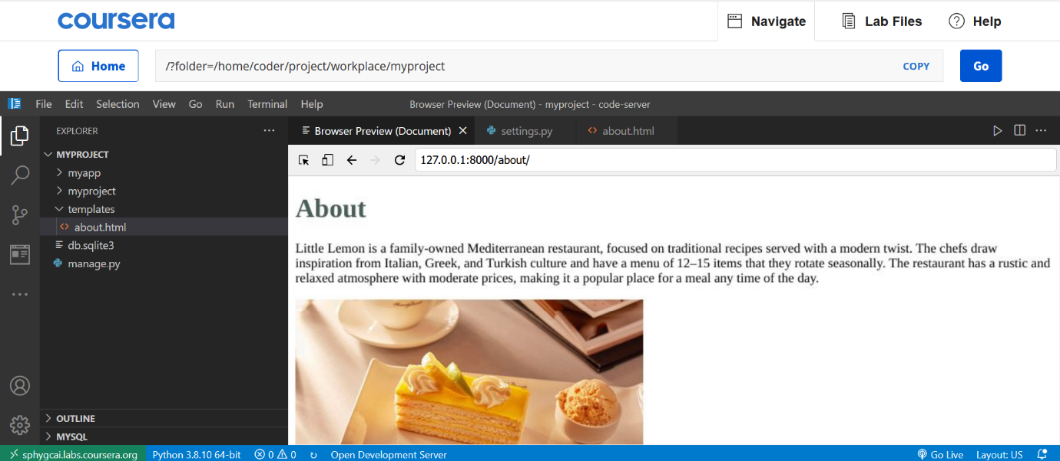

**Concluding Thoughts**

In this lab, you practiced creating a template and updating it with dynamic content.

# Solution: Creating Templates

## Solution

templates/menu.html

{% load static %}

<!DOCTYPE html>

<html lang="en">

<head>

    <meta charset="UTF-8">

    <meta http-equiv="X-UA-Compatible" content="IE=edge">

    <meta name="viewport" content="width=device-width, initial-scale=1.0">

    <title>Document</title>

</head>

<body>

    <!-- Add heading code -->

    <h1 style="color: #495E57"> Menu </h1>

    <!-- Add paragraph code -->

    <!-- Add image code -->

    <img src="{% static 'img/dessert.jpg' %}">

</body>

</html>

templates/about.html

<!DOCTYPE html>

<!DOCTYPE html>

<html lang="en">

<head>

    <meta charset="UTF-8">

    <meta http-equiv="X-UA-Compatible" content="IE=edge">

    <meta name="viewport" content="width=device-width, initial-scale=1.0">

    <title>Document</title>

</head>

<body>

    <!-- Add heading code -->

    <!-- Add heading code -->

    <h1 style="color: #495E57"> About </h1>

    <!-- Add paragraph code -->

    <p> {{content.about}} </p>

    <!-- Add image code -->

</body>

</html>

Relevant code for settings.py

TEMPLATES = [

    {

        'BACKEND': 'django.template.backends.django.DjangoTemplates',

        'DIRS': ['templates'],

        'APP\_DIRS': True,

        'OPTIONS': {

            'context\_processors': [

                'django.template.context\_processors.debug',

                'django.template.context\_processors.request',

                'django.contrib.auth.context\_processors.auth',

                'django.contrib.messages.context\_processors.messages',

            ],

        },

    },

]

STATIC\_URL = 'static/'

# Default primary key field type

# https://docs.djangoproject.com/en/4.1/ref/settings/#default-auto-field

STATICFILES\_DIRS = [

    'myapp/static',

]

views.py

from django.shortcuts import render

# Create your views here for menu.

def about(request):

    about\_content = {'about': "Little Lemon is a family-owned Mediterranean restaurant, focused on traditional recipes served with a modern twist. The chefs draw inspiration from Italian, Greek, and Turkish culture and have a menu of 12–15 items that they rotate seasonally. The restaurant has a rustic and relaxed atmosphere with moderate prices, making it a popular place for a meal any time of the day."}

    return render(request, "about.html", {'content': about\_content})

def menu(request):

    about\_content = {'about': "Little Lemon is a family-owned Mediterranean restaurant, focused on traditional recipes served with a modern twist. The chefs draw inspiration from Italian, Greek, and Turkish culture and have a menu of 12–15 items that they rotate seasonally. The restaurant has a rustic and relaxed atmosphere with moderate prices, making it a popular place for a meal any time of the day."}

    return render(request, "menu.html", {'content': about\_content})

# v3.1

# Template Language and Variable Interpolation

In this reading, you will further explore the templating language and how it can be used to create markup.

This reading will also showcase the use of variables and how they can be dynamically passed in a template to render out different content.

Introduce learners to the template language with variables, filters and tags."

## Template Engine

Modern web frameworks use a web template system to merge a data source with static HTML to generate dynamic web pages.

A web template is an otherwise static HTML script interspersed with placeholder blocks of template language code. The template engine takes one set of data from any source, such as a database table, substitutes in placeholders and renders the generated content to the client browser.

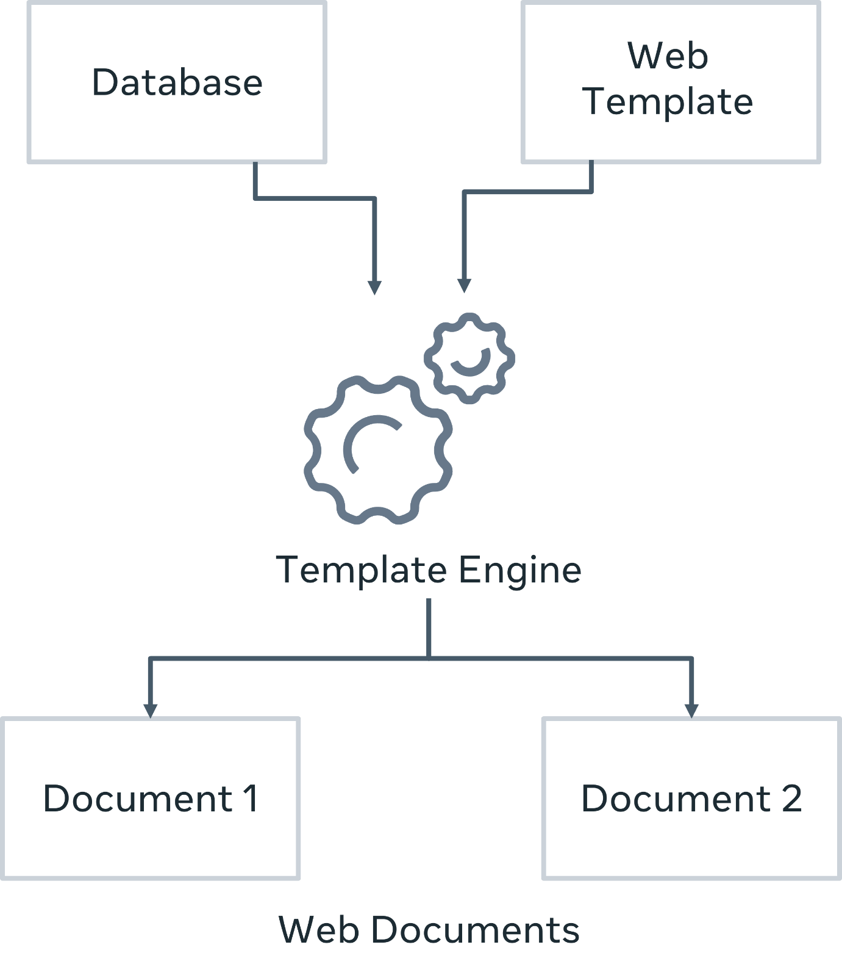

Django’s template engine uses its own Django Template Language. The default project template is configured that way. However, you may choose to use any other template language such as **jinja2**.

Django Template Language has three important components: variables, tags, and filters.

## ****Template variable****

As you have previously learned, templates are HTML pages. The **DIRS** attribute of the **TEMPLATES** variable in the **settings.py** file points to the folder in which the templates are stored. Generally, the templates folder is in the root project folder.

The easiest way to display a template web page is by calling the **render()**function from within a view function. Its three parameters are the HTTP request object, the page itself, and a context dictionary.

Assuming that the client URL is <http://localhost:8000/myapp/Novak>, the following view function receives the path parameter from the URL dispatcher and passes it as context to the template:

def index(request, name):

    context={'name': name}

    return render(request, 'index.html', context)

**The keys in the context dictionary are available to the template as a variable.**

When put inside double curly brackets, the value is substituted at runtime.

Put the following statement in the body of **index.html**.

<h2>Welcome {{ name }}</h2>

As a result, if the view receives Novak as the parameter, **Hello Novak** is rendered.

The value of any key in the context may be a singular object (string, integer), a list or a dictionary.

A certain view passes a ‘person’ dictionary as a context.

person={'name':'Roger', 'profession':'Teacher'}}

return render(request, 'person.html', person)

Inside the template, you can access the value associated with each key with the dot (**"."**) operator just as the attributes of an object are used. For example:

Name: {{ person.name }}

Profession: {{ person.profession }}

This will render the following output on the browser.

* Name: Roger
* Profession: Teacher

## Template tags

Just as there are HTML tags, the Django template language defines several tags. You can think of the tags as the keywords in a traditional programming language. You place the tags inside **{% tag %}** symbols.

The **if** and **for** tags are important because they add processing logic to the web page.

### {% if %}

With the **if** tag, the template variable is checked against a Boolean expression and a block of HTML is rendered conditionally.

{% if expression == True %}

HTML block 1

{% else %}

HTML block 2

{% endif %}

Even though the syntax of **if** (and **for**) is very similar to Python, Django template language (DTL) doesn't use uniformly indented blocks. Hence, for every **if** tag, there is an **endif** tag.

A simple example of Django’s **if** tag is as follows:

The following view passes **{'user':'admin'}** dictionary as context to the template.

def index(request):

    context={'user':'admin'}

    return render(request, 'index.html', context)

The conditional block in the template should be as follows:

{% if user == "admin" %}

<h2>Welcome {{ user }}</h2>

{% else %}

<h2>Welcome Guest. You dont have admin access</h2>

{% endif %}

### {% for %}

You can construct a looping construct inside the template with **{% for %}** and **{% endfor %}** tags. It is used to traverse any Python iterable such as a list, tuple or string.

In the following example, you pass a list to the template as its context.

def myview(request):

    langs = ['Python', 'Java', 'PHP', 'Ruby', 'Rust']

    return render(request, 'langs.html', {'langs':langs})

Inside the template, the **for** loop is constructed, much like in Python to render the names of languages as unordered list.

<h1>List of Languages</h1>

<ul>

    {% for lang in langs %}

    <li>{{ lang }}</li>

    {% endfor %}

</ul>

If the value of a context variable is a dictionary, you can traverse the key–value pairs using the for syntax.

{% for key, value in data.items %}

    {{ key }}: {{ value }}

{% endfor %}

### DTL has a number of helper variables to be used within the loop:

**forloop.counter**: The current iteration of the loop

<ul>

    {% for lang in langs %}

    <li>{{ forloop.counter }} : {{ lang }}</li>

    {% endfor %}

</ul>

Output:

**List of Languages**

* 1: Python
* 2: Java
* 3: PHP
* 4: Ruby
* 5: Rust

**forloop.revcounter**: The number of iterations from the end of the loop (1-indexed)

<ul>

    {% for lang in langs %}

    <li>{{ forloop.revcounter }} : {{ lang }}</li>

    {% endfor %}

</ul>

Output:

**List of Languages**

* 5: Python
* 4: Java
* 3: PHP
* 2: Ruby
* 1: Rust

**forloop.first**: True if this is the first time through the loop

<ul>

    {% for lang in langs %}

    <li>{{ forloop.first }} : {{ lang }}</li>

    {% endfor %}

</ul>

Output:

**List of Languages**

* True: Python
* False: Java
* False: PHP
* False: Ruby
* False: Rust

**forloop.last**: True if this is the last time through the loop

<ul>

    {% for lang in langs %}

    <li>{{ forloop.last }} : {{ lang }}</li>

    {% endfor %}

</ul>

Output:

**List of Languages**

* False: Python
* False: Java
* False: PHP
* False: Ruby
* True: Rust

**forloop.parentloop**: For nested loops, this is the loop surrounding the current one.

If you pass the following dictionary object as context:

dct = {'digits': ['One', 'Two', 'Three'],'tens': ['Ten', 'Twenty', 'Thirty']}

The template has nested loops as follows:

<h1>Nested loops</h1>

    {% for key, values in dct.items %}

    <p>{{ forloop.parentloop.counter }}:{{ key }}</p>

    <ul>

    {% for value in values %}

    <li> {{ value }}</li>

    {% endfor %}

</ul>

{% endfor %}

Output:

1:digits

One

Two

Three

2:tens

Ten

Twenty

Thirty

### {% comment %}

Everything between **{% comment %}** and **{% endcomment %}** is ignored. An optional note may be inserted in the first tag.

{% comment "Optional note" %}

    <p>Commented out text </p>

{% endcomment %}

### {% block %}

Defines a block that can be overridden by child templates. This tag will be discussed when you learn about template inheritance.

### {% csrf\_token %}

This tag is used in a form template as protection to prevent **Cross Site Request Forgeries (CSRF)**. This tag generates a token on the server-side to make sure to cross-check that the incoming requests do not contain the token. If found, they are not executed.

### {% include }%

Loads a template and renders it with the current context. This is a way of "including" other templates within a template. The template name can either be a variable or a hard-coded (quoted) string, in either single or double quotes.

{% include "sample.html" %}

### {% with %}

This tag sets a local variable that is available between **{% with %}**and **{% endwidth %}** tags.

{% with rate = 5 %}

   Interest = {amt}\*{{ rate }}

{% endwith %}

## Filters

The filters modify the representation of the variable used in the template code. The modified value of the variable is rendered in the **{{ }}** tags. The filter is applied with the **|** (known as Pipe) symbol. The general form of using filter is:

{{ variable | filter\_name }}

**DTL has defined a number of filters. Here are some of the most frequently used:**

### default

Django view passes a variable to the template. In the code below, **value** is a template variable. If it has been initialized in the view, it is set to the specified default, which in this case is **nothing**.

{{ value|default:"nothing" }}

If the value is an empty string, the output will be nothing.

### join

This tag is similar to Python’s **str.join(list)** method. It joins the items in a list with the given separator.

For example:

{{ words|join:" \_ " }}

If the view passes a list **[' Django ', 'Template', 'Language']**, the output will be the string **"'Django\_ Template\_Language'"**.

### length

When applied, this filter returns the length of the sequence received from the context. This works for both strings and lists.

{{ name|length }}

If **name** is **"John"**, the output will be **4**. It returns 0 for an undefined variable.

### first

Returns the first item in a list. Assuming that the list from the view function is **['a', 'b', 'c']**.

{{ list|first }}

The output will be **'a'**.

### last

If value is the list **['a', 'b', 'c', 'd']**, the output will be the string **"d"**.

### lower

Converts a string into all lowercase.

### upper

**upper** converts a string into all uppercase.

### title

**title** converts a string into title case by making words start with an uppercase character and the remaining characters lowercase.

For example:

string = **"django template language"**, the output will be **"Django Template Language"**.

{{ string|title }}

### length

Returns the length of string or a list.

For the above string variable, the output will be **21**.

{{ string|length }}

### wordcount

**wordcount** works on a string variable only and returns the number of words. For the above string variable, the output will be **3**.

{{ string|wordcount }}

In this reading, you explored the elements of Django Template Language, variables, tags and filters.

**Exercise: Creating Dynamic Templates**

Open Lab

**Instructions**

**Goal**

* The learner will practice using Dynamic Templates in Django

**Objectives**

* The learner will fetch dynamic content from the model inside the view
* The learner will update view created for Menu with dynamic content
* The learner will pass the dynamic content to the template and run a loop to fetch item values.

**Introduction**

In this lab you will use templates to create a webpage containing static HTML content. You will then load dynamic content on the Menu page from a model, and then pass this as an object to the template.

**Scenario**

The Little Lemon website is set up to use Django templates.

Before more advanced templating is implemented, Mario has asked you to perform a test to extract some data from the database and display it on a page.

Using your existing knowledge of Models, Views, Dictionaries, and the Django Template language, your task is to display some dynamic content using a template.

**Learner Instructions**

Initial Lab Instructions:

This lab will require you to modify the following files:

* **views.py**
* **templates**/**menu.html**

Additionally, you are required to use the command line console inside the terminal of VS Code.

If not open already, go to **Terminal** on the Menu bar at the top of your screen and select **New Terminal**.

You have already built the project named **myproject** and added an app inside the project called **myapp**.

**Note:**

Follow the instructions below and ensure you check the output at every step and update the necessary files to ensure the view is rendered.

**Steps**

**Step 1:** Open the **models.py** file and notice the two attributes present inside the Model.

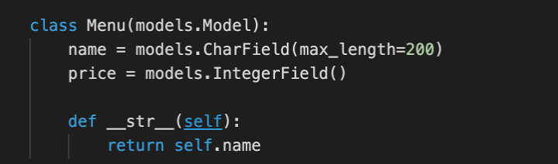

**Step 2:**

Open the **views.py** file in the project directory and create a view function for the menu.

**Tip:** Remember to import the **HttpResponse()** object from **django.http** .

**Step 3:**

Inside the **views.py** file, import the Menu model from the models file present inside the same app folder.

**Step 4:**

Now in the **views.py** file, and in the view function called **menu**, pass the **request** object. Inside the menu view function body, perform the following steps:

1. Create a variable called **menu\_items** and assign it the value of the function: **Menu.objects.all()**
2. Create a new dictionary called **items\_dict** that will have one key-value pair. The key for this dictionary will be a string **"menu"** and the value for it will be the variable **menu\_items**
3. Return the **render()** function from the view, where you will first pass the request object, followed by the template value of **menu.html**. And finally, the dictionary stored in the variable **items\_dict** that you created earlier.
4. In the terminal, run the code to perform the migrations to ensure the model objects are updated.

**Note:** The URL configuration files are already updated for the view.

**Note:** The migrations for the models are already performed before the URLs and views are configured for the lab. You will not see not see any changes detected on running migrations.

**Step 5:** Open the template file **menu.html** already in place and you must add a few lines of code to update the template as per the instructions below:

Using the syntax for Django Template Language (DTL) create the code for the following steps:

1. Add a condition to check if the **menu** dictionary is present.
2. Underneath, create the code to run a **for** loop with the condition to iterate over all the items inside the **menu** dictionary.
3. Inside the body of the **for** loop, use DTL to display the two attributes present inside the **menu** dictionary. **Tip:** Use **item.name** and **item.price** inside the appropriate DTL syntax and add a colon **:** in between the two values as a separator.
4. Add an HTML tag for line break using the **<br>** tag.
5. Create the code to end the **for** loop.
6. Underneath, create the code to specify the else condition using the appropriate DTL syntax.
7. Inside the else condition, add the string: **'No items to display'**
8. Create the code to end the **if** condition.

**Note:** The settings for templates, inside the **settings.py** file, are already updated.

**Step 6:**

In the terminal and run the command to start the development server. Open the browser and navigate to the following URL:

**http://127.0.0.1:8000/menu**

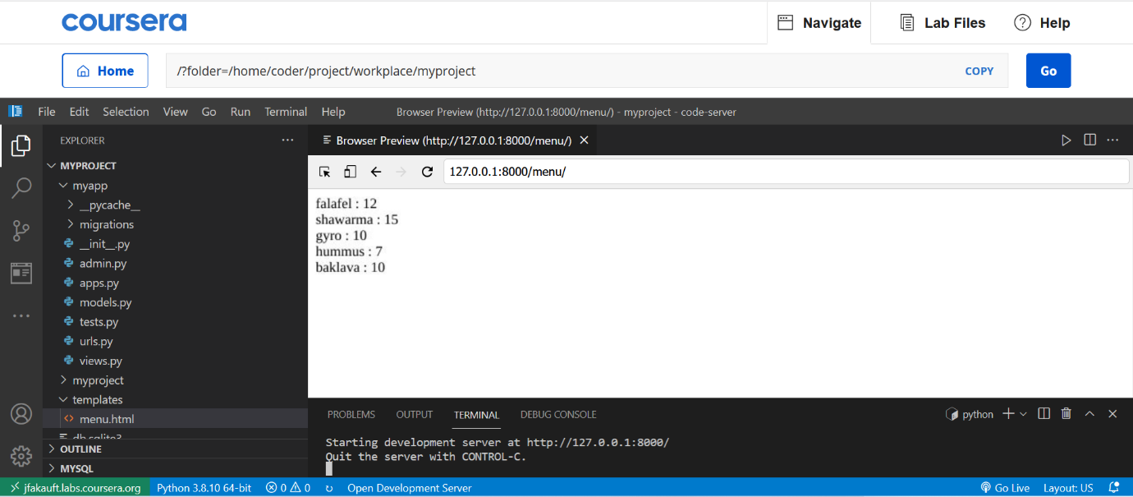

Make sure the values present inside the model are displayed correctly.

**Additional Step:** Create a superuser and add an entry inside the database table for **Menu** model to see if the entries can be updated.

**Concluding Thoughts**

In this lab, you practiced creating a template and updating it with dynamic content retrieved from the model.

# Solution: Creating Dynamic Templates

**templates/menu.html**

{% if menu %}

{% for item in menu %}

{{ item.name }} : {{ item.price }}

<br>

{% endfor %}

{% else %}

<p> No items to display !</p>

{% endif %}

**views.py**

from django.shortcuts import render

from django.http import HttpResponse

from .models import Menu

# Create your views here.

def menu(request):

    menu\_items = Menu.objects.all()

    items\_dict = {"menu": menu\_items}

    return render(request, "menu.html", items\_dict)

**v6.1**

**More on Template inheritance**

This reading introduces template inheritance, along with its main features.

You will learn how template inheritance can be used inside a standard HTML page and how child templates can override blocks inside it. Additionally, you will explore the concept of static files in Django.

**Inheritance in Django Template Language**

The term inheritance is associated with the principle of object-oriented programming. It refers to the mechanism of a child class inheriting the properties of its parent class, and if required, extending or overriding them.

The question is how is the term inheritance used in relation to the template language?

There are many view functions defined in a Django application. Each view renders a different template (or the same with a different context). Ideally, you want all the web pages to look consistent. For example, elements such as the header, footer, and the navigation bar, must appear similar across all pages.

**Structure of parent template**

Let us assume that you’re building a three-page web application with a home page, a registration page, and another for logging into the application. Each page should have a main header, a footer, and a sidebar with links to the pages. The corresponding content of each page should appear to the right of the sidebar and between the header and footer.

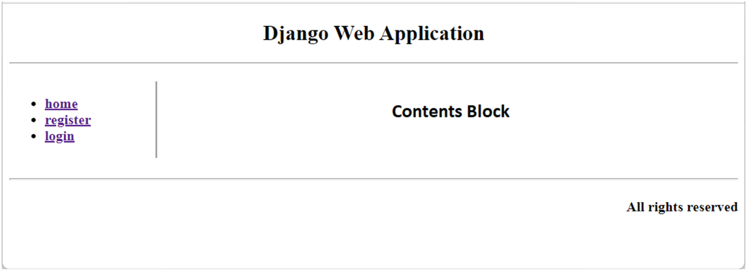

**{% block %} tag**

Template inheritance helps to implement this structure and it’s similar to the one in object-oriented programming. It is a very powerful, yet equally complex feature of Django Template Language. Template inheritance is implemented with the **{% block %}** and **{% endblock %}** tags.

{% block name %}

  ...

{% endblock %}

The block is identified by the given name to be overridden in the child template.

First, identify the components that are required because these will be used across all the web pages. Include those that show variable content on each page. Use the block tags to mark the code blocks with variable content as a dummy block or with no contents.

## Base template

For the above skeletal structure, the header is represented by the following HTML:

<!--header-->

<div style="height:10%;">

<h2 align="center">Django Web Application</h2>

<hr>

</div>

The middle part of the page has two sections, represented in two **<div>** tags of 20% and 80% width. The one on the left is a sidebar.

<!—side bar-->

<div style="width:20%; float:left; border-right-style:groove">

<ul>

<b>

<li><a href="#">home</a></li>

<li><a href="#">register</a></li>

<li><a href="#">login</a></li>

</b>

</ul>

</div>

For now, let us add dummy links to the menu items.

The remaining part of the page is where the contents of each page will be displayed. Once again, mark this as a dummy block with no text between the block tags.

<!--contents-->

<div style="margin-left:21%;">

<p>

{% block contents %}

{% endblock %}

</p>

</div>

Now, address the footer of the page.

<!--footer-->

<hr>

<div>

<h4 align="right">All rights reserved</h4>

</div>

Put the above code blocks in a **base.html** file and save it in the **templates** folder. Note that this file will never be rendered as is but the templates for **home**, **register,** and **login views** will inherit it.

## Add views

Now, add the view functions for the three operations planned for the applications. Open the **views.py** file and add the following code:

def home(request):

    return render(request, "home.html", {})

def register(request):

    return render(request, "register.html", {})

def login(request):

    return render(request, "login.html", {})

You also need to update the URL pattern of the app.

urlpatterns = [

. . .,

. . .,

    path('home/', views.home, name='home'),

    path('register/', views.register, name='register'),

    path('login/', views.login, name='login'),

]

Next, replace the dummy hyperlinks in the sidebar with the URLs registered above.

<!—side bar-->

<div style="width:20%; float:left; border-right-style:groove">

<ul>

<b>

<li><a href="/myapp/home/">home</a></li>

<li><a href="/myapp/register/">register</a></li>

<li><a href="/myapp/login/">login</a></li>

</b>

</ul>

</div>

## Child templates

Writing the templates for the **views** is straightforward because the structure is already defined in the **base.html**. The **{% extends %}** tag imports the base template components in the child template. Create a new file named **home.html** in the **templates** folder and add the following line.

{% extends "base.html" %}

We intend to keep the same header, the sidebar, and the footer defined in the base template and put the relevant code inside the **contents** block. Now, add the following lines in **home.html** and save it.

{% block contents %}

<h2 align="center">This is Home page</h2>

{% endblock %}

At this stage, start the server and visit **/myapp/home/** URL. Since this path is mapped to the **home()** view, you should get the following page:

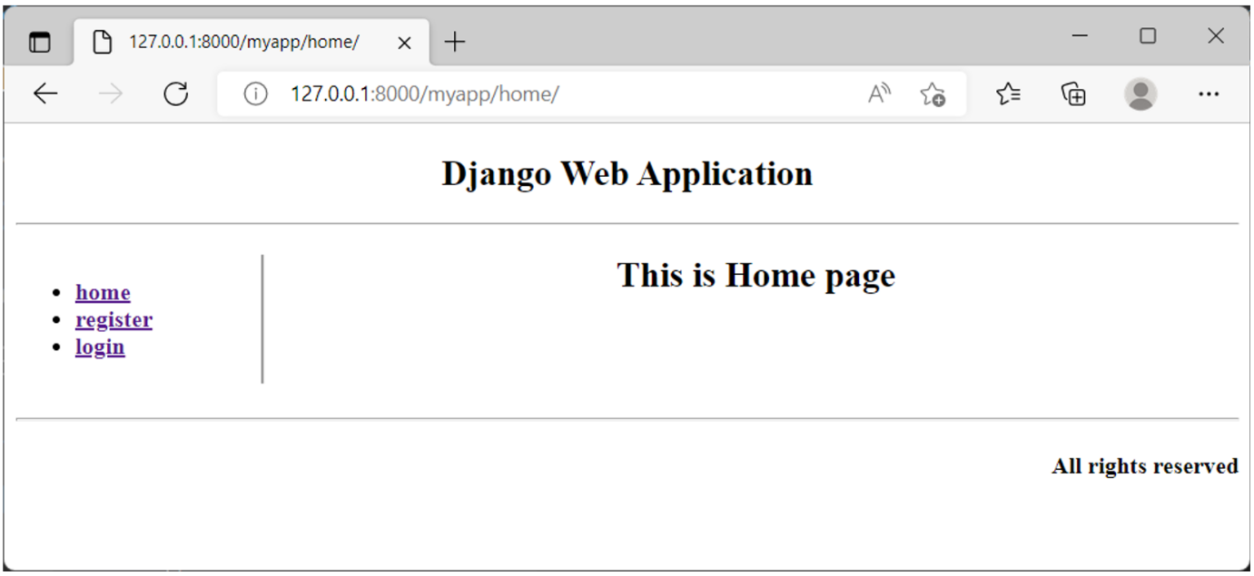

Similarly, create **register.html**and put it in the templates folder.

{% extends "base.html" %}

{% block contents %}

<h2 align="center">Registration Form appears here</h2>

{% endblock %}

The **/myapp/register/** URL invokes the **register()** function. It renders the registration page as below:

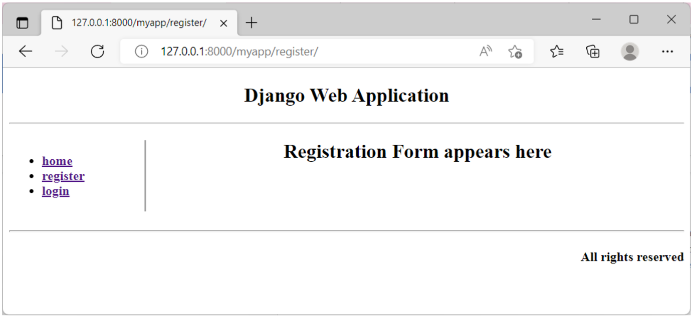

Before creating the login page, let us make some changes to the base template. You’ll want the login page to display some additional text in the footer. For that, the footer is placed in the block tag. Open the **base.html** and change the footer to:

<!--footer-->

<hr>

{% block footer %}

<div>

<h4 align="right">All rights reserved</h4>

</div>

{% endblock %}

Now, save the **login.html** template with the following code:

{% extends "base.html" %}

{% block contents %}

<h2  align="center">Login Form appears here</h2>

{% endblock %}

{% block footer %}

{{ block.super }}

<h4 align="right">Designed By: Alexa Designs Ltd</h4>

    {% endblock %}

Notice that the **{% block.super %}** tag has been used. It is similar to Python’s **super()**function whereby you access the parent class methods in a child class. In the same way, the contents of the footer block will be rendered on the login page. Now, include additional text in the block as a part of the header, for the login page.

So, we have a "**base.html**" and three child templates – "**home.html**", "**register.html**" and "**login.html**" - in the templates folder.

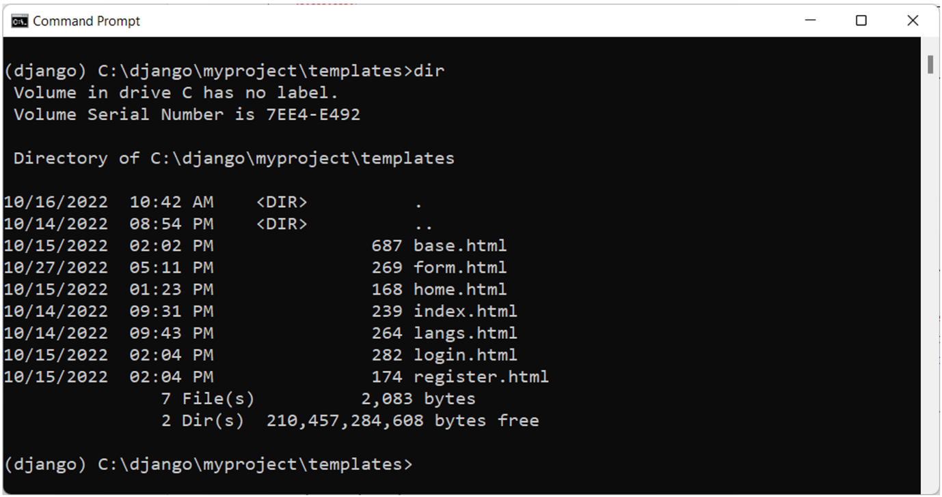

The**/myapp/login/** URL displays the following output with the modified footer.

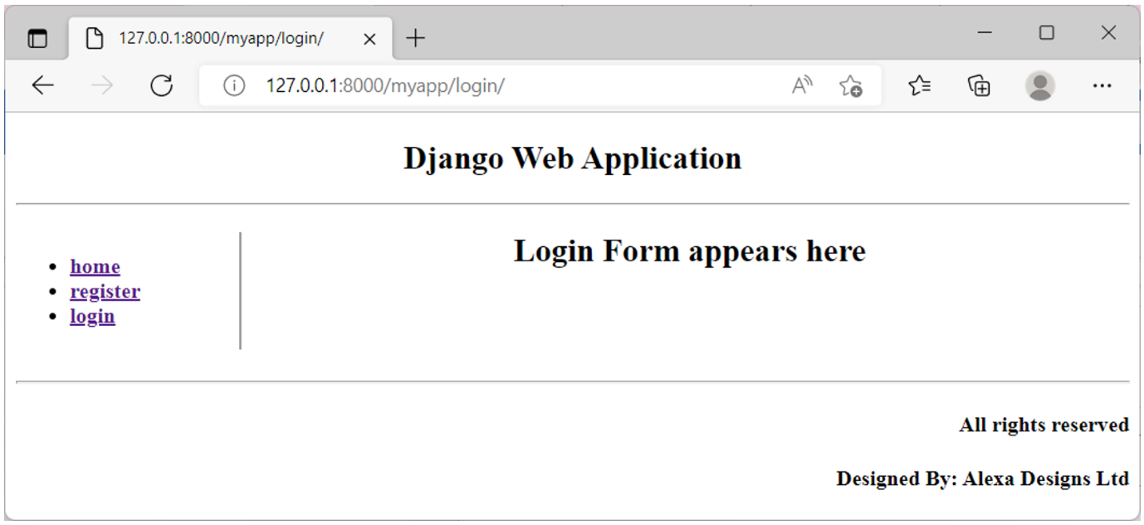

**Static files**

In addition to the dynamic content, a web application needs to serve certain static content to the client. It may be in the form of images, JavaScript code, or style sheets. Django’s default project template includes **django.contrib.staticfiles** in **INSTALLED\_APPS**.

The project’s settings file (**settings.py**) has a **static\_url**property set to **'static/'**. All the static assets must be placed in the **myapp/static/myapp** folder as the **static\_url** refers to it.

While rendering an image from this static folder, load it with the **{% static %}** tag. HTML provides the **<imgsrc>** tag. Instead of giving the physical URL of the image to be rendered, use the path that is relative to the defined **static\_URL**.

{% load static %}

<img src="{% static 'my\_app/example.jpg' %}">

In this reading, you learned how to use the template inheritance technique to build multiple templates with a consistent layout. You were also introduced to the mechanism of serving static assets.

**Exercise: Working with Templates**

Open Lab

**Instructions**

**Goal**

* The learner will practice using partial Templates in Django

**Objectives**

* The learner will use partial templates using keywords include and extends

**Introduction**

In this lab you will be using the template inheritance property of Django to extend the functionality of a given template. The lab consists of commonly used example of header information within a partial template.

**Scenario**

The pages on little lemon have the required web pages designed in order but have a missing element which is the Menu bar used as navigation. Mario, who is overlooking the details realizes that the use of the Django framework in addition to the static HTML may be a better approach at this point and needs learners' help to achieve that.

Your task is to use your existing knowledge of template inheritance to build header information such as a Menu bar and some other footer information that will be common across all the web pages.

**Learner Instructions**

Initial Lab Instructions:

This lab will require you to modify the following files:

* **templates/base.html**
* **templates/book.html**
* **templates/menu.html**
* **templates/index.html**
* **templates/about.html**
* **templates/partials/\_header.html**
* **views.py**
* **settings.py**

Additionally, you are required to use the command line console inside the terminal of VS Code.

If it isn't already open, go to **Terminal** on the Menu bar at the top of your screen and select **New Terminal**.

**Note:**

You have already built the project named **myproject** and added an app inside the project called **myapp**.

Follow the instructions below and ensure you check the output at every step and update the necessary files to create different views.

**Steps**

**Step 1:**

Open the 'settings.py' file, and make sure the declaration for the configuration list called **STATICFILES\_DIRS** is updated with the value of  **'myproject/static'** inside the list.

**Tip:** Make sure there is a comma (**,**) after the string.

**Step 2:**

Open the **views.py** file and create four view functions: Home, Menu, About, and Book with the same respective view names.

Add the return statement with the **render()** function and pass the following arguments:

**render(request, 'page.html')**

**Tip:** In the code above, replace **'page.html'** with the name of the HTML page you want to render.

**Tip:** Make sure to import the render function for use:

**from django.shortcuts import render**

**Step 3:** Expand the folder called **templates** at the root project-level directory. Create a folder called **partials** inside the templates folder.

**Step 4:** Inside the **partials** folder, create a file called **\_header.html**.

**Step 5:** Add the contents of the HTML code provided below to the **\_header.html** file:

 <!-- Add code to load static content-->

<header>

  <img src="{% static 'img/logo.png' %}" />

</header>

<nav>

  <ul>

    <li><a href="{% url 'home' %}">Home</a></li>

    <li><a href="{% url 'about' %}">About</a></li>

    <li><a href="{% url 'menu' %}">Menu</a></li>

    <li><a href="{% url 'book' %}">Book</a></li>

  </ul>

</nav>

**Step 6:**

Inside the code, you just pasted, locate the line with the comment **<!-- Add code to load static content-->**. Below this line add the following code:

**load static**

Complete this code by placing the surrounding Django template language syntax for tags.

**Step 7:**

Next open the file **about.html** and locate the line with the comment **<!-- Add code to extend base.html file -->**.

Underneath this line, replace with the code that will extend the **base.html** file using the extends keyword surrounded by the Django template language syntax for tags.

**Step 8:**

Next, open the file **index.html** and fill in the code below. Locate the lines with the comments.

The three comments are as follows:

1. **<!-- Add code to extend base.html file -->**

**Tip:** Make use of the extend keyword followed by the file name in string format.

Add code that will extend the base.html here below this line with the extends keyword and surrounding by the template language syntax for tags.

1. **<!-- Add code to load static content -->**

Add the same code that you have used to load static content as in Step 7

1. Replace the two lines commented with the respective code for beginning and ending a block.

<!-- Begin block content -->

 <p\> About Us</p>

 <p\> This is an About page for Little Lemon </p\>

 <!-- End block content -->

**Tip:** Make sure you have syntax for template language tags in place surrounding this code.

**Step 9:** Repeat the previous steps for the remaining three HTML pages: **Menu**, **About**, and **Book**. Make sure you also replace the keywords present inside the paragraph tags and replace it with the page name such as **Menu** or **Booking**.

**Step 10:** Inside the **templates** folder, open the **base.html** file and locate the comment:

**<!-- Add include tag -->**

In the line underneath, use the include tag in DTL for the file **\_header.html** present inside the partials folder. Make sure you add the relevant surrounding tags for the Django template language.

**Tip:** This can be done with the help of the include keyword followed by the file name to be included **\_header.html**. Remember that the file **\_header.html** is present inside the **partials** directory, so make sure you add the correct relative path to it.

**Step 11:** Locate the HTML tag **<main>** and the comment

In the line underneath, add the tags to begin and end the block content.

**Step 12:** In the terminal run the command to run the server and launch the browser at the localhost URL.



**Step 13:**

In the browser, navigate to the following URLs:

https:127.0.0.1:8000/about

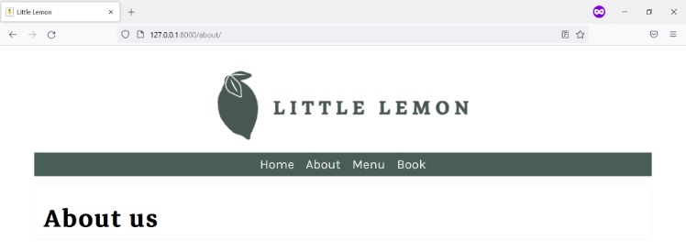

https:127.0.0.1:8000/menu

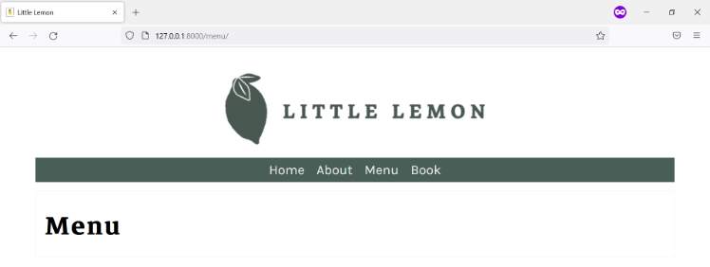

https:127.0.0.1:8000/book

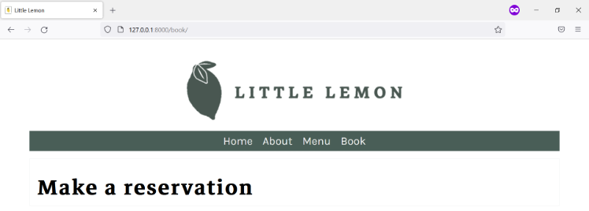

https:127.0.0.1:8000/

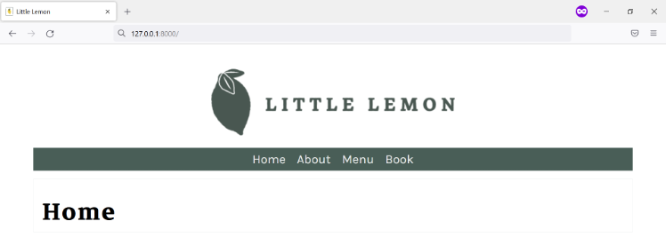

**Concluding Thoughts**

In this lab, you practiced adding an HTML menu to your web pages using Template Inheritance.

# Solution: Working with Templates

Relevant code for settings.py

STATIC\_URL = 'static/'

STATICFILES\_DIRS = ["myproject/static",]

templates/menu.html

{% extends 'base.html' %}

{% load static %}

{% block content %}

<p> Menu</p>

<p> This is a Menu page for Little Lemon </p>

{% endblock %}

templates/index.html

{% extends 'base.html'%}

{% load static %}

{% block content%}

<p> Home</p>

<p> This is the Home page for Little Lemon </p>

{% endblock %}

templates/book.html

{% extends 'base.html' %}

{% load static %}

{% block content %}

<p> Book</p>

<p> This is a Booking page for Little Lemon </p>

{% endblock %}

templates/about.html

{% extends 'base.html' %}

{% load static %}

{% block content %}

<p> About Us</p>

<p> This is an About page for Little Lemon </p>

{% endblock %}

Relevant code for templates/base.html

    <!-- Add include tag -->

    {% include 'partials/\_header.html' %}

    <main>

        <!-- Begin block content -->

        {% block content%}

        {% endblock %}

        <!-- End block content -->

    </main>

templates/partials/\_header.html

{% load static %}

<footer style="background-color: #EE9972; "></footer>

<header>

  <img src="{% static 'img/logo.png' %}" />

</header>

  <nav>

    <ul>

      <li><a href="{% url 'home' %}">Home</a></li>

      <li><a href="{% url 'about' %}">About</a></li>

      <li><a href="{% url 'menu' %}">Menu</a></li>

      <li><a href="{% url 'book' %}">Book</a></li>

    </ul>

  </nav>

views.py

from django.shortcuts import render

# Create your views here.

def home(request):

    return render(request, 'index.html')

def about(request):

    return render(request, 'about.html')

def menu(request):

    return render(request, 'menu.html')

def book(request):

    return render(request, 'book.html')

# v9.1

# Sub-classing Generic Views

In this reading, you’ll learn about the **class\_based** generic views.

You can implement the view layer with function or class-based views in a Django application. You declare a class by extending the **django.views.View** class and define **get()** and **post()** methods inside it to handle the HTTP requests. The URL pattern connects the path to the class with the **as\_view()** method of the View class.

A quick example of class view:

from django.views import View

class NewView(View):

    def get(self, request):

        # View logic will place here

        return HttpResponse('response')

The URL pattern in **urls.py**is updated as below:

#urls.py

from myapp.views import NewView

urlpatterns = [

    path('about/', NewView.as\_view()),

]

Django provides class-based generic views to make the development process much easier and faster. In this reading, you’ll discover how the generic views are implemented.

The most frequently used generic views are:

* TemplateView
* CreateView
* ListView
* DetailView
* UpdateView
* DeleteView
* LoginView

## Difference between Function View and generic view

Let's take a simple example of rendering a Hello world template. You should render the template as the HTTP response – the return value of the function. The view function for this purpose would be as follows:

from django.shortcuts import render

from django.http import HttpResponse

def index(request):

    template = loader.get\_template('myapp/index.html')

    context={}

    return HttpResponse(template.render(context, request))

As you may have already learned, the app package folder exists inside the project's outer container folder. The **myapp** app is created in the Django project named **myproject**.

In the **myapp/urls.py**, define the URL pattern:

path('/', views.index, name='index')

You can include the URL definitions of **myapp** in the project's URL configuration:

urlpatterns = [

    . . . ,

    path('myapp/', include('myapp.urls'))

]

Use a **TemplateView** class instead. Simply define a class extending it and set the **template\_name** attribute.

from django.views.generic.base import TemplateView

class IndexView(TemplateView):

    template\_name = 'index.html'

The corresponding URL pattern should incorporate this:

path('/', IndexView.as\_view(), name='index')

## Advantage of function-based views

* Simple to implement.
* Easy to read.
* Explicit code flow.
* Straightforward usage of decorators.
* good for one-off or specialized functionality.

## Disadvantages of function-based views

* Hard to extend and reuse the code.
* Handling of HTTP methods via conditional branching.

## Advantages of Class-based views

* Code reusability.
* DRY — Using CBVs help to reduce code duplication.
* Code can be extended to include more functionalities.
* class with different methods for each http request instead of conditional branching statements inside a single function-based view.
* Built-in generic class-based views.

## Disadvantages of Class-based views

* Harder to read.
* Implicit code flow.
* Use of view decorators require extra import or method override.

## Requirements of a generic view

* If the view needs a model to be processed, it should be set as the value of model property of the view.
* Each type of view looks for a template name with **modelname** suffixed by the type of generic view. For example, for a list view processing employee model, Django tries to find **employee\_list.html**.
* The generic view is mapped with the URL with **as\_view()** method of the View class.

Let's now build a subclass for each of the respective generic view classes to perform CRUD operations on the Employee model:

class Employee(models.Model):

    name = models.CharField(max\_length=100)

    email = models.EmailField()

    contact = models.CharField(max\_length=15)

    class Meta:

        db\_table = "Employee"

## CreateView

The **CreateView** class automates the creation of a new instance of the model. To provide a create view, use the sub-class of **CreateView**:

from django.views.generic.edit import CreateView

class EmployeeCreate(CreateView):

    model = Employee

    fields = '\_\_all\_\_'

    success\_url = "/employees/success/"

A model form based on the model structure is created by this view and passed to the **employeeCreate.html** template:

<form method="post">

{% csrf\_token %}

<table>

    {{ form.as\_table }}

</table>

    <input type="submit" value="Save">

</form>

The URL path is updated by mapping the **"create/"** path to the **as\_view()** method of this class:

from .views import EmployeeCreate

urlpatterns = [

    . . .

    path('create/', EmployeeCreate.as\_view(), name = 'EmployeeCreate')  ,

]

When the client visits this URL, they are presented with the form. The user fills and submits the employee details, which are saved in the Employee table.

## ListView

Django's **django.views.generic.list** module contains the definition of **ListView** class. Write its sub-class to render the list of model objects.

 The **EmployeeList** class is similar to the **CreateView** sub-class except its base class.

from django.views.generic.list import ListView

class EmployeeList(ListView):

    model = Employee

    success\_url = "/employees/success/"

The template required for this view must be named **employee\_list.html**. Django sends the model object in its context. Using the DTL loop syntax, you can display the list of employees:

<ul>

        {% for object in object\_list %}

        <li>Name: {{ object.name }}</li>

        <li>Email: {{ object.email }}</li>

        <li>contact: {{ object.contact }}</li>

        <br/>

        {% endfor %}

</ul>

If the user visits [http://localhost:/8000/employees/list](http://localhost/8000/employees/list), the browser lists all the rows in the employee table.

## DetailView

The generic DetailView is found in the **django.views.generic.detail** module. Now, create its sub-class, **EmployeeDetail** (much the same way as **EmployeeList**). Note that this view shows the details of an object whose primary key is passed as an argument in the URL. So, add the following path in the app's URL pattern:

path('show/<int:pk>', EmployeeDetail.as\_view(), name = 'EmployeeDetail')

Again, the View object fetches the model instance and passes it as a context to the **employee\_detail.html** template, which displays its attributes with template syntax as follows:

<h1>Name : {{object.name}}</h1>

    <p>Email : {{ object.email }}</p>

    <p>Contact : {{ object.contact }}</p>

Assuming the URL visited is **/employees/1**, the Employee record with primary key=1 will be displayed.

## UpdateView

This is another generic view, defined in **django.views.generic.edit** module. It renders a form in which the new values of the model attributes can be submitted. Set the fields attribute to **'\_\_all\_\_'** or to a list of updatable fields.

from django.views.generic.edit import UpdateView

class EmployeeUpdate(UpdateView):

    model = Employee

    fields = '\_\_all\_\_'

    success\_url = "/employees/success/"

Since this view is intended to update the data of a given model instance, its URL path must be configured accordingly:

path('update/<int:pk>', EmployeeUpdate.as\_view(), name = 'EmployeeUpdate')

The example URL that invokes this view is **/employees/1**.

The UpdateView class renders the template with its name having **update\_form**as suffix:

#employee\_update\_form.html

<form method="post">

{% csrf\_token %}

<table>

    {{ form.as\_table }}

</table>

    <input type="submit" value="Save">

</form>

## DeleteView

Lastly, the generic view performs thedelete operation on a model's given instance. It is present when editing the sub-module of **django.views.generic** module:

from django.views.generic.edit import DeleteView

class EmployeeDelete(DeleteView):

    model = Employee

    success\_url = "/employees/success/"

You need to pass the primary key of the Employee model to this. So, the URL path is set as:

path('<delete/int:pk>', EmployeeDelete.as\_view(), name = 'EmployeeDelete')

The **employee\_confirm\_delete.html** template asks for confirmation from the user before removing the model instance.

<form method="post">

{% csrf\_token %}

    <p>Are you sure you want to delete "{{ object }}"?</p>

    <input type="submit" value="Confirm">

</form>

In this reading, you got to know about the class-based generic views to perform CRUD operations. Generic views are much easier to write than the **function\_based** view, although both have their own advantages and disadvantages.

# Additional resources

Here is a list of resources that may be helpful as you continue your learning journey.

[Testing in Django official](https://docs.djangoproject.com/en/4.1/topics/testing/)

[Testing overview – Django official](https://docs.djangoproject.com/en/4.1/topics/testing/overview/)

[Django Advanced Testing topics](https://docs.djangoproject.com/en/4.1/topics/testing/advanced/#advanced-testing-topics)

[Django META header](https://docs.djangoproject.com/en/4.0/ref/request-response/#django.http.HttpRequest.META)

[Add unit testing to your Django project](https://docs.djangoproject.com/en/4.1/internals/contributing/writing-code/unit-tests/)

[Adding Django apps – Extended information](https://docs.djangoproject.com/en/4.1/ref/applications/)

**Design and build a simple Django app**

Open Lab

**Instructions**

**Introduction**

Congratulations on coming this far in your journey with working in Django!

This graded assessment is one of your final steps to test the skills and understanding you acquired with the Django framework.

While the difficulty level is subjective to a learner based on many factors, patience and perseverance are key to working with any back-end framework. Good luck!

**Goal**

The Course Assessment will require learner to build the two pages of the web app and be split majorly into two parts:

1. Create the Menu page
2. Create the Menu Item page

**Scenario**

By now you are fairly familiar with the aspirations of the owners Mario and Adrian in providing the best experience to their customers.

While Little Lemon is a local neighborhood bistro, both the owners have long understood the importance of digital presence as a means of convenience and connection for their visitors.

So far, you have helped Little Lemon by building a prototype of their website using the Django framework.

You have been instrumental in testing different website components, from creating views to dynamic templates and building models and forms.

It is now time to bring it all together and help finish the website already under construction by completing the most critical aspect of a food restaurant website, its Menu page!

**Learner Instructions**

The Little Lemon website will consist of five pages:

* Home
* About
* Booking
* Menu
* Menu Item

To complete this graded assessment, you will need to modify the following files:

* **settings.py**
* **urls.py** (app-level)
* **models.py**
* **views.py**
* **admin.py**
* **templates/menu.html**
* **templates/menu\_item.html**
* **templates/partials/\_footer.html**

**Supporting files**

Additionally, it's important to know that the following files already consists some of the code added in support of your work:

* **views.py**
* **urls.py** (project-level)
* **urls.py** (app-level)
* **forms.py**
* **models.py**
* **templates/about.html**
* **templates/index.html**
* **templates/book.html**
* **templates/partials/\_footer.html**

It's also important to know that the project contains supportive files for static images and CSS styling.

While working on the project, it is always a good practice to understand the code present.

Other than the template language tags, there is HTML code added in place to support the page, which along with CSS, has helped build the webpage UI.

During the project, you will run the commands inside the VS Code terminal.

To open, go to **Terminal** from the Menu bar at the top of your screen and select **New Terminal**.

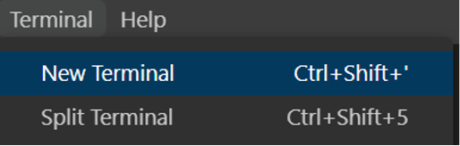

Throughout the lab exercises, you worked with the names **myproject** for the project and **myapp** for the app.

In this assessment, the names are more suitable for a real-world scenario. The project is named **littlelemon** , and the app inside the project is named **restaurant**. And these are already created.

**Steps**

**Part 1 – Create the Menu page**

**Step 1:**

Open the **models.py** file and create a class called Menu with the following attributes:

**Menu**

| **Attribute** | **Field type** | **Arguments** |
| --- | --- | --- |
| name | CharField | max\_length = 200 |
| price | IntegerField |  |

**Note:** The class called Booking is already in place.

Additionally, define a **dunder method** **\_\_str\_\_()** inside this model class such as:

def \_\_str\_\_(self):

       return self.name

**Step 2:**

Open the **admin.py** and register the Menu model.

**Tip:** Ensure you have imported the model from the **models.py** file.

**Step 3:**

Now that the code for the Menu model is complete, run the two commands in the command line to make and perform migrations.

**Tip:** Ensure you are present inside the directory containing the file **manage.py**.

You can step inside a directory by typing the change directory command, for example, **cd abc**. You can step out of a directory by typing the command **cd ..**

Successful migrations should display like the following:

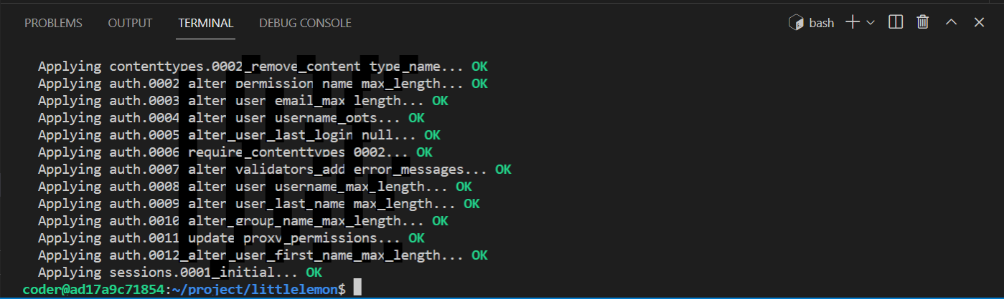

**Step 4:**

Open the project-level and app-level **urls.py** files to ensure the URL path configurations are in place. The app-level **urls.py** should have the URL configurations for the pages Home, About and Booking.

**project-level urls.py**

from django.contrib import admin

from django.urls import path, include

urlpatterns = [

    path('admin/', admin.site.urls),

    path('', include('restaurant.urls')),

]

**app-level urls.py**

from django.urls import path

from . import views

urlpatterns = [

    path('', views.home, name="home"),

    path('about/', views.about, name="about"),

    path('book/', views.book, name="book"),

]

**Step 5:**

You must now add data to the model you created using the Django admin panel.

Inside the terminal, first run the command to create a superuser with the following details:

* Username: bistroadmin
* Email address: admin@littlelemon.com
* Password: lemon@786!

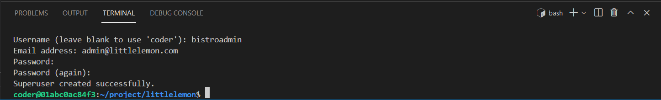

**Step 6:**

Still inside the terminal, add the command to run the server.

Open the Browser with the **Browser Preview** button in the left menu in VS Code and paste the localhost URL generated after running the server.

Next, add the suffix **/admin** to the URL and press Enter.

Enter the credentials for the superuser you created and log in to the Django admin panel.

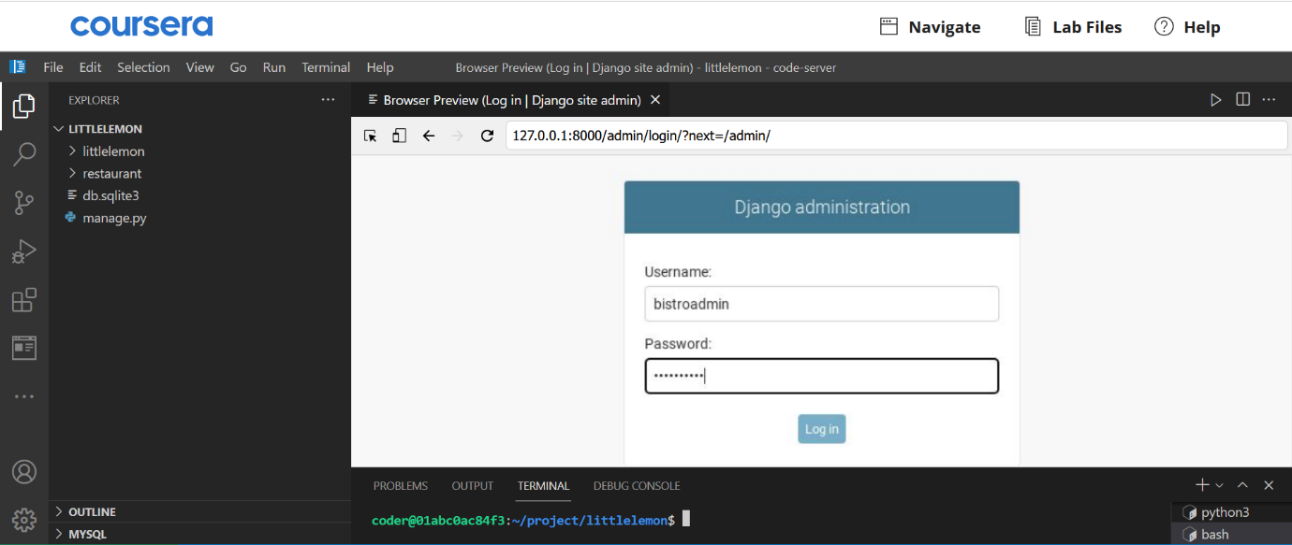

**Step 7:**

Inside the Django admin panel, locate the **Menu model** under **Restaurant**, which is the app's name.

[Menu items](https://d3c33hcgiwev3.cloudfront.net/j_3rGlqdRR6xbwCZwsV1sA_314cca151c314e0aa360fa802bdc24f1_Menu-items.zip?Expires=1693094400&Signature=Lrnb-K30--iGuWs03qpsTexNbLz-9nYXNRnzhq2BS2y7zZDb8uz5CvI3OJgIbtipz8LGdwvsL9Isf7i7y5B063BWgr8oYMDfQ6RlvYklRUPE0MNLUvczxIjbA9lpjR7Vcj6Z7TMTP8mVjM94QMaIQJkLi~pJCM103coZSgoYgdE_&Key-Pair-Id=APKAJLTNE6QMUY6HBC5A" \t "_blank)

[ZIP File](https://d3c33hcgiwev3.cloudfront.net/j_3rGlqdRR6xbwCZwsV1sA_314cca151c314e0aa360fa802bdc24f1_Menu-items.zip?Expires=1693094400&Signature=Lrnb-K30--iGuWs03qpsTexNbLz-9nYXNRnzhq2BS2y7zZDb8uz5CvI3OJgIbtipz8LGdwvsL9Isf7i7y5B063BWgr8oYMDfQ6RlvYklRUPE0MNLUvczxIjbA9lpjR7Vcj6Z7TMTP8mVjM94QMaIQJkLi~pJCM103coZSgoYgdE_&Key-Pair-Id=APKAJLTNE6QMUY6HBC5A" \t "_blank)

Next, open the **Menu**, click on **Add Menu**, and enter the details provided inside the zip file containing the text for the Menu items.

Once you have completed adding all the menu items, the menu model should have the following data:

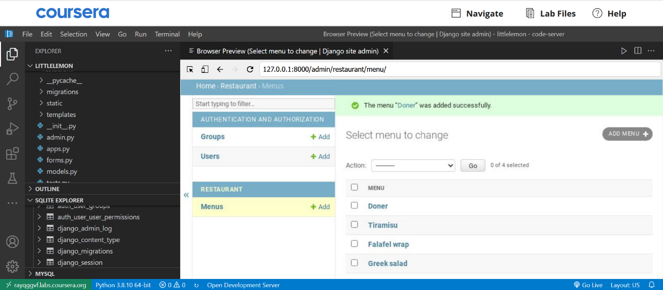

**Step 8:**

Back in VS Code, open the **views.py** file. Notice that the code for the view functions for **home()**, **about()**, and **booking()** are already in place.

**Note:** The necessary packages are already imported. Make sure to remove the comments for all the imported packages.

**Step 9:**

Create a view function for the menu page called**menu()** and pass the request argument.

**Step 10:**

Add the following view logic inside the **menu()** view function:

* Create a variable called **menu\_data** and assign it the value of **objects.all()** which is called over the Menu model class.
* Create a variable called **main\_data** and assign a dictionary that contains the following key-value pairs:

| **Key** | **Value** |
| --- | --- |
| **"menu"** | **menu\_data** |

* Return the **render()** function from the view with the following arguments passed inside it in this order:

**The code for the menu view is complete for the first part. Make sure you review the code to ensure that it contains no errors.**

**Step 11:**

Open the app-level **urls.py** file and add the URL path for the menu view function using the **path()** function.

**Step 12:**

Expand the app-level directory **templates** in the explorer panel and observe the different HTML files created for building the web page.

**Step 13:**

Create a file called **menu.html** and add the following starter code inside it:

{% extends 'base.html' %}

{% load static %}

{% block content %}

<h1>Menu</h1>

<!--Begin col-->

<div class="column">

   <!-- Step 14: Create for loop -->

   <p>

      <!-- Step 14: Add DTL variable for name -->

      <span class="menu-price">

         <!-- Step 14: Add DTL variable for price -->

      </span>

   </p>

   <!-- Step 14: End or loop -->

</div>

<!--End col-->

{% endblock %}

**Step 14:**

Now that you have the starter code in place follow the instructions below to add Django Template Language (DTL), which will replace the comments.

**Note:** All the instructions below represent the code in DTL and require appropriate syntax for template tags.

Create a for loop that will iterate over the menu object using a temporary iterator such as item.

Between the enclosing paragraph tags **<p>** and **</p>** , print the name attribute in the item variable.

Between the enclosing HTML span tags **<span>** and **</span>** , print the price attribute present inside the item variable.

To add the currency symbol and the price formatting, prefix the opening curly bracket with the **$** symbol and suffix the closing curly brackets of the **DTL variable** with **.00** as below.

**<span class="menu-price">${{ DTL variable }}.00</span>**

**The First part of the project is complete, and you are ready to run the development server.**

Open the terminal and add the command to run the server.

Copy the URL [**http://127.0.0.1:8000**](http://127.0.0.1:8000/) generated, press the **Browser Preview** button in the left explorer panel of VS Code and paste it into the browser window.

The homepage of the Little Lemon website should load.

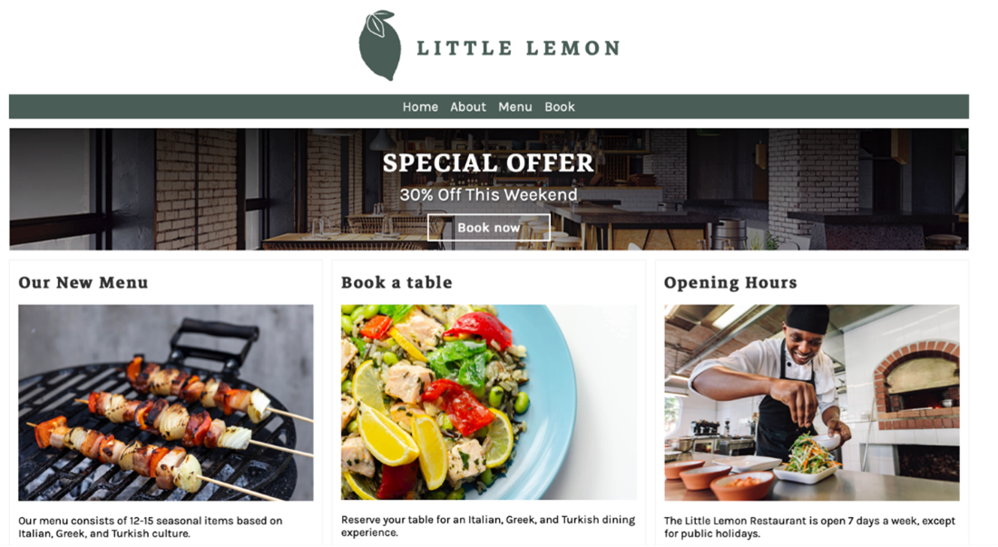

**Step 14:** If you have time, feel free to check that the other hyperlinks are working.

**Part 2 – Create the Menu item page**

**Menu item page**

The menu item page will display the entire contents of data stored in the **menu\_item** table for each menu item. The page will be accessed via a dynamic link from the menu page. It will use URL parameters to query the database.

**Step 1:** Open the file **models.py** and update the **Menu** model with the attributes below in addition to the ones already present:

| **Attribute** | **Form field type** | **Arguments** |
| --- | --- | --- |
| description | TextField | max\_length=1000, default='' |

Once the code in the **models.py** file is updated, run the commands to perform the migrations.

**Step 2:** Open the Django admin using the credentials created earlier and update menu items already added with the description provided in the zip file.

Once inside the Django admin panel, select the **Menu** under **Restaurant**, which will then display the list of **Menu items** present, such as below:

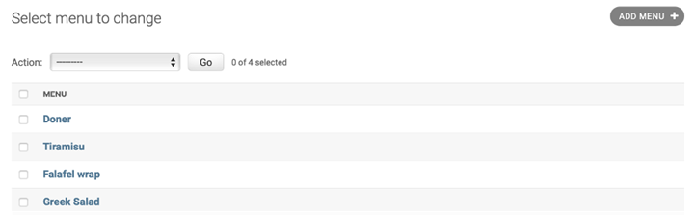

Select a specific item from the list to edit. It will open a page such as below:

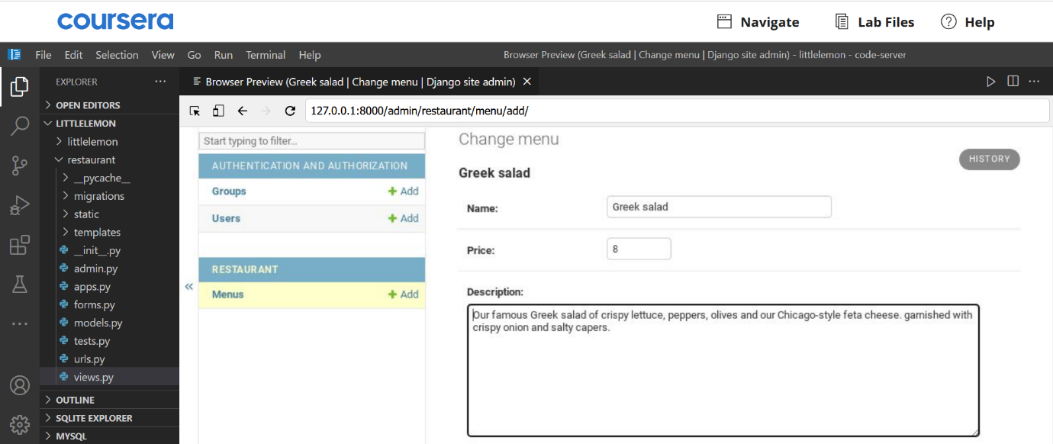

Update the description with the details provided in the zip folder.

**Step 3:**

Open the **views.py** file and create a view called **display\_menu\_items** with two arguments passed inside it:

* request
* **pk** with value **None**

**Step 4:**

Add the code by following the pseudo code example below to define the view logic for the view **display\_menu\_items**:

| **Pseudo code** |
| --- |
| **if pk**:  Create a variable **menu\_item** and assign it the value of **objects.get(pk=pk)** which is called over the Menu model class.  **else**:  Assign an empty string to the variable **menu\_item** |

Return the **render()** function from the view with the following arguments passed inside it:

* The request object
* The template name **'menu\_item.html'** as a string
* A dictionary object with a string value **"menu\_item"** as the key and a variable **menu\_item** as its value

**Step 5:**

Open the app-level **urls.py** file and add a **path()** function inside the **urlpatterns** list as below:

path('menu\_item/<int:pk>/', views.display\_menu\_item, name="menu\_item"),

**Step 6:**

Before you configure the new menu item page, open the file **menu.html** and update the code as below:

Look for the template code added while designing the menu page:

**{{ item.name }}**

Surround the code such as:

<a href="<Replace with DTL code>">

{{ item.name }}

</a>

Select the complete string inside the **href** attribute beginning with **<** and ending with **>** and replace it with the code below:

**{% url 'menu\_item' pk=item.pk %}**

**Note:** The code replaced must not remove the enclosing quotes **(" ")** for the string. The code will generate a link for the Menu item page, which you will configure next.

**Step 7:**

Create a file called **menu\_item.html** inside the templates directory present inside your app called **restaurant**.

**Step 8:**

Add the below starter code inside **menu\_item.html** page:

{% extends 'base.html' %}

{% load static %}

{% block content %}

<section>

    <article>

        <h1>Menu item</h1>

        <span>

            <a href="{% url 'home' %}">Home</a> /

            <a href="{% url 'menu' %}">Menu</a>/

            <!-- Step: Replace code here -->

        </span>

        <!--Begin row-->

        <div class="row">

            <!--Begin col-->

            <div class="column">

                <h2>

                    <!-- Step: Replace code here -->

                </h2>

                <p>

                    <!-- Step: Replace code here -->

                </p>

                <p>

                    <!-- Step: Replace code here -->

                </p>

            </div>

            <!--End col-->

            <!--Begin col-->

            <div class="column">

                <img src="<!-- Step 9: Replace code here -->" alt="{{ menu\_item.name}}" />

            </div>

            <!--End col-->

        </div>

        <!--End row-->

    </article>

</section>

{% endblock %}

**Step 9:**

Follow the steps below to replace the code matching the HTML comments such as:

**<!-- -->**

with the matching steps below:

**Note:** All the code replacements must have the appropriate Django template language syntax.

* Add a **name** attribute present inside the **menu\_item** object
* Add a **name** attribute present inside the **menu\_item** object
* Add a **menu\_item\_description** attribute present inside the **menu\_item** object
* Add price attribute present inside the menu\_item object
  + Prefix the opening curly bracket ({) with:**Price: $** and
  + Suffix the closing curly brackets of the DTL (}) with**.00**
  + **Note:** Ensure the changes are inside the enclosing **<p> </p>** tags.
* Replace the comment **<!-- Step 9: Replace code here -->** inside the **<img>** tag with:

**/static/img/menu\_items/{{menu\_item.name}}.jpg**

**Note:** The code above must be added inside the enclosing strings (" ")

Save the **menu\_item.html** file. Make sure all the other file changes are saved.

**Step 10:**

In the terminal, run the two commands to perform migrations to enable the changes we have performed over the models.

**Step 11:**

Add a command to run the server. Copy the localhost URL, open the browser from the Browser Preview and paste the URL **http://127.0.0.1:8000/menu** in the address bar.

**Step 12:**

The same page displayed earlier will load with minor changes as below:

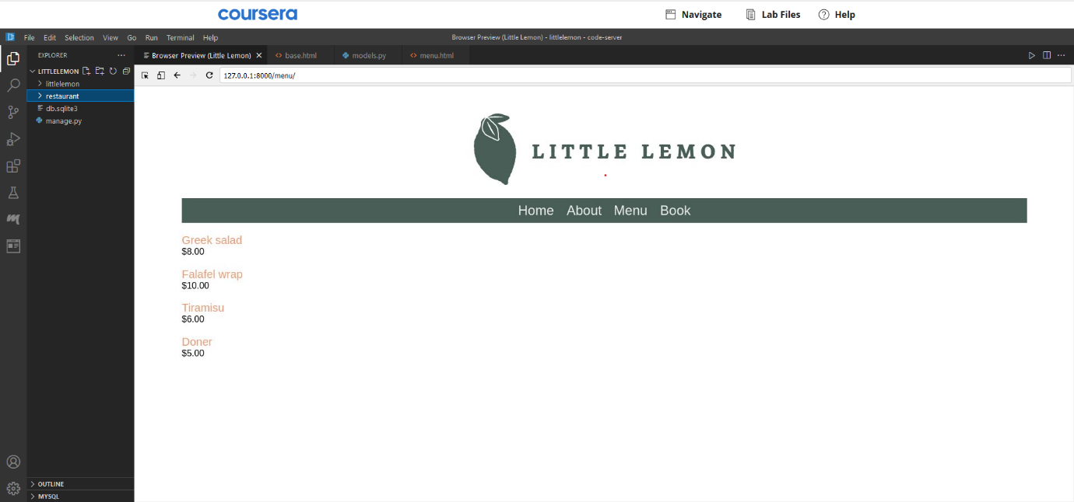

**Step 13:**

Click on the link **Greek salad** that is displayed in orange color to look at the menu item page.

**Step 14:**

The menu item page for **Greek salad** will appear as below:

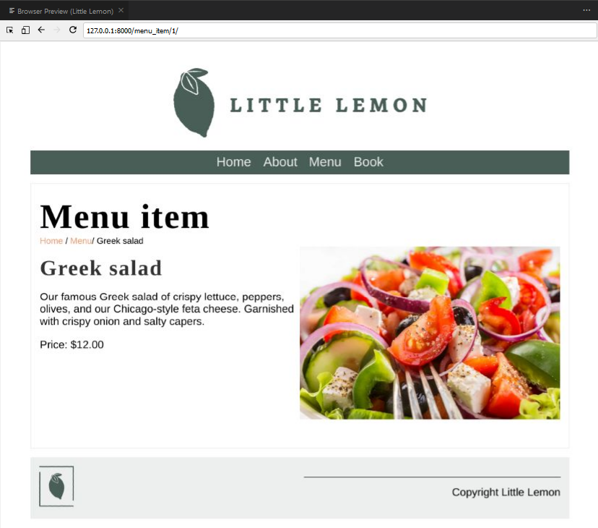

**Step 15:**

Feel free to navigate the Little Lemon website to different pages and compare it with the code inside the VS Code for better understanding.

**Part 3 – Create the footer template**

**Step 1:**

Open the file **\_footer.html** already in place and paste the following code inside it:

{% load static %}

<footer>

  <article>

        <img src="<Replace with DTL code for adding static image for footer logo>" />

  </article>

  <article>

    <p>Copyright Little Lemon </p>

  </article>

</footer>

**Step 2:**

Replace the code inside angled brackets present inside the img tag with:**{% static 'img/logo\_footer.png' %}**

**Note:** Make sure you also remove the angled (**< >**) brackets.

**Step 3:**

Open the file **base.html** and search for a comment: **<!--Footer content-->** On the line below, add a DTL tag that will include the relative path of the **footer.html** file.

# ****Additional Steps****

**Step 1:**

On the Little Lemon website you have built, click on the tab **Book**

Enter the details under **Make a reservation** as below:

* Enter your initials as the First and Last name
* Enter the number of guests and some comments for your preferences at the bistro.

Press on the **Submit** button

**Step 2:**

Go to VS Code and right click on **db.sqlite3**. Select **Open Database** from the options. **SQLITE EXPLORER** option will be generated at the bottom. of the file menu in VS Code

**Step 3:**

Click on **SQLITE EXPLORER** to expand and further expand **db.dqlite3** under it. Scroll down to the table **restaurant\_booking** in the list of tables that populate.

Click on the **'play'** icon displayed on hover. You should be able to see the reservation form data you had updated.

# Solution code

Here is the completed solution code for the course assessment to create the menu pages for the Little Lemon website built with the Django framework.

## Shell commands

**Making migrations**

python3 manage.py makemigrations

python3 manage.py migrate

**Running the server**

python3 manage.py runserver

**Creating a new super user in Django admin**

python3 manage.py createsuperuser

## Additional commands

For directory called sample: Stepping inside the directory

cd sample

**Stepping out of the directory**

cd ..

**Clear the shell terminal window**

clear

**List contents of directory**

ls

## Django files

**models.py**

from django.db import models

# Create your models here.

class Booking(models.Model):

   first\_name = models.CharField(max\_length=200)

   last\_name = models.CharField(max\_length=200)

   guest\_number = models.IntegerField()

   comment = models.CharField(max\_length=1000)

   def \_\_str\_\_(self):

      return self.first\_name + ' ' + self.last\_name

class Menu(models.Model):

   name = models.CharField(max\_length=200)

   price = models.IntegerField(null=False)

   def \_\_str\_\_(self):

      return self.name

**admin.py - First update**

from django.contrib import admin

from .models import Menu

from .models import Booking

# Register your models here.

admin.site.register(Menu)

**views.py - First part: Creating view for Menu**

#Menu Function

def menu(request):

    menu\_data = Menu.objects.all()

    main\_data = {"menu": menu\_data}

    return render(request, 'menu.html', {"menu": main\_data})

**menu.html - First part: Creating template for Menu**

{% extends 'base.html' %}

{% load static %}

{% block content %}

<h1>Menu</h1>

<!--Begin col-->

<div class="column">

    {% for item in menu.menu %}

    <p>

        {{ item.name }}

        <span class="menu-price">

            ${{ item.price }}.00

        </span>

    </p>

    {% endfor %}

</div>

<!--End col-->

{% endblock %}

**models.py - Second part: Menu item page**

from django.db import models

# Create your models here.

class Booking(models.Model):

   first\_name = models.CharField(max\_length=200)

   last\_name = models.CharField(max\_length=200)

   guest\_number = models.IntegerField()

   comment = models.CharField(max\_length=1000)

   def \_\_str\_\_(self):

      return self.first\_name + ' ' + self.last\_name

# Add code to create Menu model

class Menu(models.Model):

   name = models.CharField(max\_length=200)

   price = models.IntegerField(null=False)

   menu\_item\_description = models.TextField(max\_length=1000, default='')

   def \_\_str\_\_(self):

      return self.name

**urls.py - App level**

from django.urls import path, re\_path

from . import views

from django.conf import settings

from django.conf.urls.static import static

urlpatterns = [

    path('', views.home, name="home"),

    path('about/', views.about, name="about"),

    path('book/', views.book, name="book"),

    path('menu/', views.menu, name="menu"),

    path('menu\_item/<int:pk>/', views.display\_menu\_item, name="menu\_item"),

]

**views.py - Second part: Creating view for Menu item**

def display\_menu\_item(request, pk=None):

    if pk:

        menu\_item = Menu.objects.get(pk=pk)

    else:

        menu\_item = ""

    return render(request, 'menu\_item.html', {"menu\_item": menu\_item})

**menu.html - Second part: Update template for Menu**

{% extends 'base.html' %}

{% load static %}

{% block content %}

<h1>Menu</h1>

<!--Begin col-->

<div class="column">

    {% for item in menu.menu %}

    <p>

        <a href="{% url 'menu\_item' pk=item.pk %}">

            {{ item.name }}

            </a>

        <span class="menu-price">

            ${{ item.price }}.00

        </span>

    </p>

    {% endfor %}

</div>

<!--End col-->

{% endblock %}

**menu\_item.html - Second part: Creating view for menu item**

{% extends 'base.html' %}

{% load static %}

{% block content %}

<section>

   <article>

      <h1>Menu item</h1>

      <span>

         <a href="{% url 'home' %}">Home</a> /

         <a href="{% url 'menu' %}">Menu</a>/

         {{menu\_item.name}}

      </span>

      <!--Begin row-->

      <div class="row">

         <!--Begin col-->

         <div class="column">

            <h2>

                {{ menu\_item.name }}

            </h2>

            <p>

                {{ menu\_item.menu\_item\_description }}

            </p>

            <p>

                Price: ${{ menu\_item.price }}.00

            </p>

         </div>

         <!--End col-->

         <!--Begin col-->

         <div class="column">

            <img src="/restaurant/static/img/menu\_items/{{menu\_item.name}}.jpg" alt="{{ menu\_item.name}}" />

            /restaurant/static/img/{{menu\_item.name}}.jpg

        </div>

         <!--End col-->

      </div>

      <!--End row-->

   </article>

</section>

{% endblock %}

**\_footer.html**

{% load static %}

<footer>

  <article>

    <img src="{% static 'img/logo\_footer.png' %}" />

  </article>

  <article>

    <p>Copyright Little Lemon</p>

  </article>

</footer>

**base.html - include footer**

<!--Footer content-->

    {% include 'partials/\_footer.html' %}